a guidebook for facilitators of

Free Inside

prison programming

A Guidebook for Facilitators of Free Inside Prison Programming
Text and design copyright © 2005, updated 2014, by Elizabeth (Betsy) Duncombe, LCSW.
Yoga illustrations copyright © 2005 by Lila Roo Duncombe-Lieber.
Class photographs copyright © 2004 by Bron Hollingshead.
Cover image Pablo Picasso Le Visage de la Paix (1950) © 2005 Estate of Pablo
Picasso / Artists Rights Society (ARS) New York.
Permission to use their words or images was granted by those inmates quoted or appearing in photographs.

Matsuo Basho poem from Anthology of Japanese Literature: From the Earliest Times to the Christian Era edited by Keene, copyright © 1955. Used by kind permission of Grove/Atlantic, Inc.
Ezra Pound poem from Personae, copyright © 1926 by Ezra Pound.
Reprinted by kind permission of New Directions Publishing Corp.
Ernesto Cardenal lines from To Live is To Love by Ernesto Cardenal, copyright © 1972.
Used by kind permission of Gwendolyn Herder, Crossroads Publishing.
Jalal al-Din Rumi poem from The Essential Rumi, translated by Coleman Barks, copyright © 1995. Used by kind permission of Coleman Barks, Maypop Books.
C.S. Lewis line from The Problem of Pain, copyright © by C.S. Lewis Pte. Ltd. 1944.
Extracts used by kind permission.
Pema Chodron lines from When Things Fall Apart by Pema Chodron, copyright © 1997. Used by kind permission of Shambala Publications.
Lao Tzu lines from Tao te Ching: the New English Version by Lao Tzu, translated by Stephen Mitchell, copyright © 1988. Used by kind permission of HarperCollins Publishers.
"Du Dunkelheit, aus der .../You, darkness, of whom ...," from Rilke's Book of Hours: Love Poems to God by Rainier Maria Rilke, translated by Anita Barrows and Joanna Macy, copyright © 1996 by Anita Barrows and Joanna Macy. Used by kind permission of Riverhead Books, an imprint of Penguin Group (USA) Inc.
Joan Halifax line from Shaman: The Wounded Healer by Joan Halifax, copyright © 1982 Thames & Hudson, Ltd., London. Reprinted by kind permission of Thames & Hudson, Ltd.
M.C. Richards line from Centering: In Pottery, Poetry, and the Person, by M.C. Richards, copyright © 1962. Used by kind permission of Wesleyan University Press.
Thich Nhat Hanh lines reprinted from Being Peace by Thich Nhat Hanh, copyright © 1987. Used by kind permission of Parallax Press, Berkeley, California. www.parallax.org; and his meditation drawn from Peace Is Every Step; The Path of Mindfulness in Everyday Life, copyright 1992; Bantam.
Excerpt from Pedagogy of the Oppressed by Paulo Freire. Copyright © 2970, 1993 by the author. Used by kind permission of The Continuum International Publishing Group.
"If Each Day Falls" by Pablo Neruda from Sea and the Bells, edited by O'Daly, copyright © 1988. Used by kind permission of Copper Canyon Press.
Deng Ming-Dao lines from 365 Tao by Deng Ming-Dao, copyright © 1992. Used by kind permission of HarperCollins Publishers.
Epictetus lines from A Manual for Living; Epictetus, translated by Sharon Lebell, copyright © 1994. Used by kind permission of HarperCollins Publishers.
Thomas Merton lines from Contemplation in a World of Action by Thomas Merton, copyright © 1973. Used by kind permission of The Merton Legacy Trust.
Segal, William & Teasdale meditation drawn from Mindfulness-Based Cognitive Therapy for Depression, copyright 2002; The Guilford Press.

acknowledgements.
Many people contributed to the development of this teaching guide. My parents, David and Sally Duncombe, instilled in me as a child the values of simplicity, scholarly curiosity, and an overarching sense of responsibility to help others. A dozen yoga and chi gung masters led me, as an adult, further toward self healing and inner peace. The Maui Community Correctional Center Warden, Alan Nouchi, and Director of Offenders Services, James Hirano, opened their facility doors to Free Inside with faith, before research supported it, that the program would effect positive change in inmates. And to the men and women who, as inmates, gave in myriad ways to this program, and my learning and spirit as we worked together, I am ever and forever grateful. Evaon Wong-Kim, Ph.D., of California State University, East Bay, provided research supervision and enthusiastic belief in this program from its start. And the editorial eye and quantitative research wisdom of Winston Turner, Ph.D., of University of Maine, Orono, have provided invaluable clarity. Lila Roo Duncombe-Lieber, my daughter, gave her soulful yoga drawings to this guide. My other daughter Elle Azul, and my husband Scott Ladd Mills, gave their patience to me as I wrote it. To these people, and to so many others who have helped me and Free Inside to grow: I thank you.

All rights reserved.
Though freely offered for download and use by facilitators themselves, no part of this manual may be used or reproduced for commercial, for-profit purposes without my written permission.
For permission to quote from this manual, for request of the full research study mentioned in the text of the manual, or to simply talk about this program or introducing one like it yourself, please address the author at:
elizabethduncombe@gmail.com / www.elizabethduncombelcsw.com
or (from May through October) at: 806 Coastal Road, Brooksville, Maine 04617

free inside. Though its teachings are non-denominational, the roots of the Free Inside program reach from ancient and global spiritual traditions. The program is comprised of classes in yoga, meditation, and chi gung practice techniques, sequenced in each class to model and encourage tolerance for diverse ethnic traditions and, in their variety, to provide "something for everyone." These practices can be loosely described as forms of stretching, breathing, self massage, and guided or silent inner reflection. They are age-old, cost free, and easily learned techniques which have been shown to strengthen and repair physical bodies, to soothe extreme emotions, to provide stress and anger management, to relieve substance addiction, and to enhance compassion and empathy for other people. Prison, oddly, provides ideal time and opportunity in which to incorporate such techniques into daily practice.

table of contents.

orientation: 7
program intro. 8
program goals. 9
precedent. 10
background. 11
time frame. equipment. 13
rewards and challenges. 14
week by week class intro. 21
week one. 25
week two. 35
week three. 43
week four. 53
week five. 61
week six. 70
week seven. 80
week eight. 89
week nine. 96
week ten. 106
week eleven. 112
week twelve. 118

table of contents, cont.'d

sustainability. 124
appendices.
A global wisdom and verse.
B recommended readings.
C past client and staff testimonials.
D sample posters and certificate.
E program photographs.
F program philosophy article.
G week-by-week workings article.
H condensed research findings article.
I audio discs: sample classes.

this is a practical guide, whose purpose is to outline Free Inside classes and practices for those who would like to teach it.
Program philosophy, background, and therapeutic, historic, and scientific precedent are covered in other writings, which are included in the appendices.

Before launching into the week-by-week, twelve-unit program description, however, I'll paint a brief picture for those new to Free Inside. My intention here, and throughout this teaching guide, is to keep things very simple and straightforward. The goals and practices of Free Inside are based in nature and essential humanness which are themselves beautifully simple.

I have found that many questions, which may arise as you read of practices to teach, will answer themselves as you experience them for yourself, and as you witness the experience of them in your clients. I will overlay this, your own experiential information source, with a list of recommended readings, in Appendix B. These aren't necessary to program teaching, though they'll provide depth for those interested. And I add to this the invitation to contact me, the author of Free Inside, by any of the means following:

Elizabeth(Betsy)Duncombe LCSW, 806 Coastal Road, Brooksville,
Maine 04617 USA or by email: elizabethduncombe@gmail.com or via my website: www.elizabethduncombelcsw.com

program intro. Free Inside is a prison program aimed at encouraging self healing, inner peace, and compassion in all of its participants.

Every human has the birthright and ability to be his or her own best healer. Body healing generates more balanced mind and emotions, and this 'inner peace' produces empathy for others. Ancient cultures worldwide understood this, and their teachings provide tools we can use today.

The exercises presented in class and outlined here have been drawn from such traditional sources. They are non-denominational and fully respectful of each inmate's personal religion or belief system. They can be done anywhere, by people of all ages and stages of health or infirmity, and need no equipment at all. Each technique should engage every participant in the exhilaration of self healing, in both their physical and emotional selves. Because this work is non-verbal for the participant, sensation for them is heightened and immediate, and their new understandings deep.

Each technique should also familiarize participants with their reserves of compassion, awakened when movement is begun between the inside and outside of their bodies, and universal interconnectedness becomes tangible. In their global ancestry, in their immediacy, in their interactive energy, these exercises convey unity to us as we practice them. Respect for the offerings of ethnically diverse cultures is part of the program intention.

Other ways to describe the therapeutic goals of this program are these: self healing is also health improvement; inner peace is also stress and anger management, and substance abuse recovery; and compassion is also victim empathy and societal responsibility.
program goals. Practical, expected achievements of Free Inside programming reach from the economic to the humanistic, from self healing to family and community healing. These include:

 lowered recidivism rates for released inmates; (increased public safety; lowered corrections costs to taxpayers);

 more successful community reintegration for released inmates; (increase in mutually beneficial relationships between employers, family, and inmates);

 improved physical health and lowered prison medical costs for inmates;

 improved mental health, including stress reduction, anger management, and substance abuse recovery for inmates;

 increased empathy and compassion for others, and sense of social responsibility in inmates;

 improved prison behavior among inmates (decreased aggression, increased empathy);

 overall stress reduction and lowered job turnover rates for staff;

 with the inclusion of staff classes, improved physical and mental health for corrections officers and administrators.

precedent. History is replete with scholarly and everyday examples of the achievement of compassion -- the antidote to destruction of self and others -- through a sequencing of attention to body, mind, and spirit. The science of clinical trials supports the ability of many ancient practices, yoga, chi gung and meditation among them, to provide this sequencing.

Insight into the historic and scientific precedent for the use of Free Inside practices to achieve the ultimate program goal of compassion, as well as the tangential increase of physical and mental wellness, may be found in several published writings provided in the appendices.

Program philosophy, description of week-to-week workings and challenges, and a condensation of the research findings on Free Inside efficacy to meet its goals may be found in Appendices F, G and H.

The full research report itself, including analysis of both quantitative data (questionnaire scores) and qualitative data (interview dialogue), may be requested by contacting me by any of the means offered on page 7 of this guidebook.

background. Begun in 1999, Free Inside has evolved through use in a homeless shelter, a chemical dependency program, and both jail and prison settings.

The program was successfully used for three years at Ka Hale A Ke Ola Homeless Resource Center, in Maui, Hawaii, where it was open to its 250 member population as an elective 'life skills' course, and where it was a requirement for clients in its residential chemical dependency program. Classes were weekly, averaged 25 to 35 in size, and were held in an outdoor courtyard on the grass and cement. Client and staff testimonials to its efficacy are available in Appendix C.

Free Inside ran concurrently at the Maui Community Correctional Center, an overcrowded facility housing 400 inmates, where a research study accompanied its implementation and was conducted for a full year. Classes were mandatory for male offenders nearing the end of sentences for property and violent crimes, as well as for the male members of the Drug Court dorm, and the female Drug Court dorm members. Male classes averaged 20 to 30 in size; female averaged 8 to 12; all were held in the dorms aisles or cafeterias where each group was housed. We made good use of very little space. Class photographs are available in Appendix E.

For years after Hawaii, Free Inside was run at two Maine correctional facilities. Weekly classes at Hancock County Jail in Ellsworth were attended voluntarily by between 6 and 10 male inmates, and held in a small meeting room. Weekly classes at Downeast Correctional Facility in Bucks Harbor included up to 20 male inmates, likewise were voluntary, and were held in a gymnasium.

As a handful of wonderful people bought the full paper/audio version of the Free Inside Guidebook initially, and as the full text is now available for free download on my website, it is no doubt used in various interpretations and in various settings globally. Several locales I have been told of over the years include a Canadian military base, and prisons in Germany, Venezuela, England and various US states. I admit to being a horrible secretary, due in part to my move two years ago onto a sailboat (to honor my husband's profession) based in the deep Caribbean for half of each year. Thus I offer consultation via email to anyone interested in the program. And when on land in port there, I use Free Inside practices in my volunteered counseling with adults struggling with mental illness and addiction, and with special needs children. When back in Maine the second half of each year, I weave many Free Inside practices into my clinical social work / counseling job with inmates at Hancock County Jail.

time frame.

This guide charts a course of twenty-four one hour classes, ideally to be held bi-weekly over twelve weeks total. Some facilities may decide upon ongoing classes, and these could be a continuing re-cycling of the twelve week course.

Because in many corrections settings the inmate population shifts unpredictably, this repeated cycle would offer regular program introductions to newcomers, and serve to deepen understanding both in continuing inmate students, and in you, the program facilitator. I have practiced the same daily routine, much like that introduced here, for twenty-six years now. The nuance in depth reached keeps it ever-interesting.

(lack of) equipment needed.

Materials needed are what the facility has already: a grassy lawn or clean floor on which to practice, a six by four foot space allotment for each participant, a reasonably quiet area in which to focus, and loose clothing on participants. Inmates may bring towels to class (to lie or sit on) if prison policy allows this, though this isn't necessary.

Freedom from material needs (in this case, props and equipment) is part of the empowerment which Free Inside encourages. It's important that the inmates can repeat what they learn in class on their own, even if in solitary, empty cells, It also better serves prison facility needs for less programming hassle and control of potential contraband, which any outside props might represent.
rewards and challenges. These will be yours to discover, but here I suggest a few possibilities, both to bolster your anticipation and waylay your fears of what may be a new experience for many of you.

rewards. Here are just a few glimpses, in the words of inmate participants, of the many shifts which occurred for them in the course of Free Inside. For a fuller look, see the research report, Appendix H, and the client testimonials, Appendix C):

When asked How do you feel about this world?, and Do you feel you can help it?, one inmate moved from feeling, pre-program: "helpless inside" to this, post-program: "I feel I could pass on all of the knowledge that I've gained to others, especially the youths, our future."
Another inmate from:" feel(ing) helpless to help anything outside," to helping "… by doing good things, and showing love to everyone."

When asked: Do you feel connection with or separation from most other people, including strangers?, one inmate, stating pre-program that he felt "separate," moved to post-program insight that he feels "Connected with meditation…I feel instead of my mind running on and on, I can pick out the important gestures, body languages, and words, more collectively, and have a better feel of people."

Post-intervention outlook on self healing showed increased confidence in, and knowledge and practice of, this concept.
When asked: When you feel sick, where do you turn for healing? , several asthmatic inmates who in pre-program interview answered "doctors" and "… there's no way around that. I have a chronic disease, asthma …," answered post-program, respectively:
"Yeah, the breathing would help me cause I got the asthma. Help me plenty. .. I no use the pump. Use pump less now? I no use 'em already. I don't use 'em already." " Meditation …One thing positive about 'em was my asthma -- I get to breathe a little more easier now. That is new. I thought it was very impossible at first. But I found out later on .. that it was ok… I mean I could. It was for real."
A third inmate said:" I've done ice for twenty plus years, and I know how it affects your lungs, And …even …your kidneys … you empty out that which is your batteries. But with that (chi gung throat exercise), I find myself with more energy. Even like leaving here I'm energized, which is really good cause before, exercising was not really in the vocabulary …"

When asked: What did you learn about inner peace?, inmates answered:" That really we control our own mind. It's a simple thing, really … It's really how we look at the world. Just that (meditation), when we think of our favorite place … how much my attitude changes when I think of that … and how simple that was."
" I feel more peace now than before I started this class ... peace inside that I never did have when I was on the outside."

When asked, post-program: What did you learn about compassion?, one answer was:" That's really a state of your mind, of your attitude, about yourself. It starts with that. With yourself, and then you like … others. And then that brings compassion. And that's hard … cause you (don't find) the compassion for somebody when you're not happy with yourself, when you're not at peace with yourself. You don't feel like being nice to your roommates when you don't feel nice at all."

When asked: When someone is inconsiderate or hurtful to you, what do you do?, growth through the program was revealed by many. One inmate said: " Before I couldn't tell the guy how I feel. Hold 'em in, hold em in, explode on the innocent." and yet he said that program practices " … help me relax and stay calm instead of hurting him or she back." Another said: " I know that even if someone comes upon you negative, you can always turn it into positive. I think with more so breathing … and sometimes you're in a situation that you're not in control of, but just breathing and taking the deeper breaths you tend to lower down your blood level. … To understand yourself is to understand somebody else."

When asked: Do you feel able to carry your inner discoveries into life outside upon release? , one inmate answered: "If it's doing good for me here, why shouldn't it work for me on the outside? … I remember couple times I ask you information… like for my wife --- she has a lot of health problems … and you told me something about the face exercise -- rubbing the face. I've told her too, and she tried it, and it worked. So we both doing it now….A bond for couples … Yeah, she's the one even brought it up at first -- she told me "How's the inner peace doing?" "It's doing good, how bout you?" And we both talking about it, and it's good. I intend to, when I get back out there, she's my partner in getting me staying over and done with … It's working for us."

Taken from the letters and notes that often are written to me by inmate and homeless shelter participants are the following words:

… I cannot heal the world, yet I can heal myself and myself is part of the world. One corner at a time brings many pieces together to make a whole.

.. .No one person has served me better as a mentor and a peaceful friend that calms the rough waters of life and reminds all of us to "mellow out" and find the peace within…. You have confirmed the good in all of us and made such a positive difference in my life. …

… I can honestly say that (Free Inside) has helped to bring about a total change in my attitude about my own recovery from hopelessness to confidence in myself… a willingness in me to want to participate in my own health and well being where I once had given up .

… Your class has and is helping my health, concentration, and patience with myself. It is the best hour I spent in my week. …

… Thank you for thinking of us that society shuns away …
challenges. Here are a smattering of hurdles I met in implementing and teaching the program at a medium sized prison. For a fuller, more conversational look at some of these potential situations, see my article discussing the week-by-week workings of Free Inside in Appendix G. I also kept a running journal during my first year of prison programming, and this provides additional detail I am happy to talk about if you choose to contact me personally.

prison protocol. Our effectiveness inside depends upon our smooth relationship with all prison staff. Prison procedures and rules must be followed carefully and consistently. Every prison has a code of rules, often spelled out in a volunteer or program handbook.
Interactions with corrections officers (guards) and administrators alike should be polite and genuine. Patience and flexibility around often-changing prison schedules are important. Remember, compassion is spread by emanating it ourselves.
It is never wise to interfere with interactions between corrections officers and inmates, no matter what our perception of them may be. There is a place for verbal and legal inmate advocacy, but it is not here within this program. Free Inside provides the living advocacy of self empowerment to inmates and interconnectedness to the entire prison. This should help relations between staff and inmates, rather than antagonize them.

initial skepticism. Corrections officers, and the inmates themselves (if assigned to class participation), may show doubt or cynicism about, or open hostility for, the program as it is first begun. This I believe is to be expected. For the staff, programming may represent 'coddling' the inmates whom it is their job, historically, to punish. They may also have experienced disrespectful behavior from the very inmates who are in class, and they may perceive kind treatment of them to be 'naïve.'
For the inmates, many of whom have been labeled 'trouble' or 'loser,' both by society and by the fact of their incarceration itself, kind treatment may be perceived as 'fake.' For many, kindness is either foreign, or is only a front for manipulation, and so is initially suspect. I have found that time and experience with Free Inside solve all types of skepticism in both inmates and staff. In fact, inmates who feel better after class and staff who witness improved inmate behavior are likely to become fans of the program.

inmate confidentiality. Whether or not prison protocol acknowledges this, I believe it is our ethical duty to maintain inmate confidentiality within legal bounds. This means not sharing inmate information with anyone outside of class, unless it is asked for by prison staff, or it contains threat of injury to self or others. Please don't tell inmate or class stories to your friends outside. Unless consent forms have been signed by inmates allowing your communication of such stories and dialogue (as they were for my research study), it is vital to respect the vulnerability of your inmate students by honoring their right to privacy.

pressure to compromise public safety. Inmates may want to use you either to carry messages between them and the outside, or to 'take their side' against prison staff on issues unrelated to class. Both should be avoided, as they compromise your own and other people's safety, and may alienate staff, thus jeopardizing the program.
You can do more good here by assuring the staff's complete comfort with Free Inside. Even for social workers and educators in corrections, pubic safety must be everyone's primary concern. Many prisons have a volunteer handbook or training which should be helpful to you in describing potential situations to avoid.

perceived religious conflicts. A handful of inmates through time have come to me after the first class with fear that ethnically diverse practices may interfere with their religious path, particularly in the case of fundamentalist Christian and Muslim believers. Several more may be concerned that the mention of human spirit in course description may necessitate a religious belief that they don't have. Both fears should be easily assuaged in class one with a clear statement about the distinction between Free Inside practices and any formal religion or worship. One might mention that in the ancient times in which these practices originated, spiritual matters were completely integrated with daily life; however, spirituality and religion are two different things. Free Inside will support an inmate's religious path if he has one (as compassion lies in the original heart of every spiritual tradition), and will not push anyone toward a religion she doesn't want.

class hecklers. As with skepticism, there's bound to be some active heckling while class is underway. Free Inside, besides teaching practices in tolerance, non-violence, and respect, should exemplify this. We facilitators can effectively model calm strength by simply ignoring the jokes or rude comments coming invariably from a back corner of the room and by continuing smoothly with class. I have found that two things help in this situation. The first is frequent eye contact with the heckler, with a look that is free of judgment or anger. The second is having a little talk with the heckler before the next class in which you praise his power and charisma in swaying the other students, and ask, person to person, for his help in using that power to sway his buddies toward support of the class. Instead of demanding something you are asking for something, and this may be very rare in that inmate's life and prison experience. Following a conversation I had like this, one inmate turned from a litany of interruptions and complaints to helping his classmates with yoga postures.

inmates' spouses' concerns. In a time when contact with the opposite gender is largely prohibited, wives of male inmates may be concerned about a class taught by a female facilitator. Likewise husbands of female inmates may worry about attachments to a male teacher. I've found effective three policies: one, I encourage inmates to share the full content of classes with spouses, as a means of strengthening their partnership, by phone or letter. Two, I invite the spouses to write to me via the facility warden with any questions or concerns; I extend this invitation through the inmates on the first day. Three, I wear baggy clothing of thick fabric, with my hair (as a female) pulled tightly back, to minimize any potential sexual objectification.

missed prison opportunities. Occasionally, an inmate's assignment to class overrides a former work duty. In my experience this meant to several inmates that they forfeited some pay and what they felt was community respect in working outside prison gates, on that day. These are important concerns to acknowledge. I suggested to these inmates that through local media, I would try to gain community-wide coverage of the program and goals so that, upon release, the Free Inside completion certificate they held would represent their increased reliability to potential employers. This, I hoped, would more than repay their losses from missed work furlough. Similarly, if it is 'rec' time that must be forfeited for class, I suggest that the benefits in feeling good and increasing overall wellness might equal or outweigh those of isolated muscle building with weights, or an outdoor smoke, at 'rec' time.

sharing personal details. Though it is tempting to talk about your own life, in the inevitable closeness that grows between you and your inmate students as you work together, I believe that information about your home address and family should not be shared. On the other hand, some details about your personal use of Free Inside-type practices to heal from your own illness, or addiction, or childhood trauma, can provide an immediate bond between you and the inmates, something invaluable to their trust in you.

week by week class intro.
Contents of the twelve week Free Inside class cycle, outlined in subsequent chapters, are best initially taught just as they are presented in these pages. Over time, they surely will be flavored by your own practice experiences, whether these come from your past familiarity with these ancient techniques, or from new discovery as you teach. A few before-class and in-class pointers are these:

your own experience. Before beginning to teach, please immerse yourself in the types of experiences which your inmate students will soon have by practicing each technique yourself. I do believe that the great beauty of these practices lies in their simplicity, and thus their easy universality. Therefore how much you choose to practice on your own is entirely up to you. Even a single prior taste by you of each technique offered will allow you to come from a place of inner experience in your teaching.

review classes. The second class each week (so, twelve out of twenty four in all) should repeat the first, overlaying and deepening its experience for each inmate. I have included a group of global wisdom and verse in Appendix A. These are lines I use to shape the second 'review' class of each week. After each week's outline I suggest one piece which you might use as a jumping off point for class focus.

sample classes. To enliven the written word, I have included two audio discs in Appendix I which capture random Free Inside classes I have taught. Rather than recommending verbatim wording or style, they hopefully will suggest an overall sequencing and pacing for the class. They should also deepen the 'conversation' that you and I are having in sharing this program with inmates, as well as sharing our experiences of teaching it with each other.

combining new and already-learned skills. This guide is set up to introduce different practices to you and your class each week. You are free, and encouraged in fact, to layer new practices on ones already learned. You'll soon hone your ability to gauge your use of the class hour, and to intuit the insertion of past techniques into those newly outlined in these pages.

if feeling nervous. It is normal to feel quite nervous before beginning, whether you're new to prison or new to this kind of teaching. Simply proceed with genuineness and warmth and the inmates will, over time, honor your realness and 'being straight' with them. It helps to make brief eye contact around the room throughout class.

students at many levels of practice. I will often offer modifications of yoga postures, choices for those inmate students who are less flexible to take. There may be moments in class where every student is working on a posture to a different degree of intensity, and even where every student's posture looks quite different. This simply reflects our multi-faceted humanness, and is to be expected and even encouraged. You may notice, in my class photographs (Appendix E), the many variations on one posture which the inmates found. All were good. Where I don't suggest a modification, please feel free to intuit one, and to encourage inmates to do the same.

addressing whole group. When you see an aspect of one inmate's posture or practice that needs correcting, please address the whole group with this suggestion. This style avoids 'singling out' any one student, and the self consciousness or resentment that might arise in that student as a result. Likewise, making a positive example of one student before the rest of the class should be avoided. Human unity, and inner exploration rather than outer performance, are the emphases here.

no touching. It is important, both for the safety concerns of the prison, and for the boundary concerns of inmates and facilitator, that you make no physical adjustments to inmates as they practice. Besides following most prison's rules requiring this distance, it will encourage the inmate self reliance implicit in the program goals. Please stay in one place throughout rather than moving about the room. This allows the inmates greater, undistracted, inner focus.

about talking. The fact that this program, unlike many other prison or therapeutic programs, is not based on talk, or even the inmates' disclosure of their crimes, may be a relief to some participants. Try to keep outer discussion to a minimum so the inner, experiential, work can take over. The times before and after class can be established as the best conversational or question asking time for inmates. Your own steady voice throughout class should provide calm and comfort rather than pressure to perform.

if students sleep. Please let them. This may be the only deep rest they have in their week, and they need it.

if you've already taught yoga. You will notice numerous differences between teaching here and teaching on the outside, touching and using students as examples among them. Please respect these differences, as the priorities here are: a. security and safety (so prison staff feel absolutely comfortable with the program), and b. the inmate's own simple inner experiences (rather than the teachings of any particular yoga, meditation, or chi gung philosophy or school).

foreign-language names. The traditional names of various practices are used in this guidebook to introduce them. English translations or nicknames are also generally given. Feel free to use whichever you are more comfortable with. Once you are familiar with the practices, make up your own nicknames
if you prefer.

non-aggressive, non-competitive practice. Non-aggression, or non-violence, as practiced in our approach toward our own bodies in all stretches, is at the heart of yoga practice. Please help discourage competitiveness, and the over-doing which might result from this, by modeling a humble inner practice yourself. Doing the postures along with the inmates rather than exemplifying them beforehand allows them their own experience without pressure to match your skill. Please refrain from demonstrating advanced yoga even if you are skilled in your practice. The emphasis here is on each inmate's inner experience, and showing off both externalizes things, and makes practice more aggressive and injury-prone.

week one.

introduction of yourself. This should be your first name, or a nickname or middle name if you are more comfortable with that; a made-up name might sabotage inmate trust in you if you ever hesitate or appear unrelated to it when it's used.
Here's a good time to tell your class why it is that you are teaching them. Your reasons may include the use of similar ancient techniques in your own life, to heal some physical or emotional illness or trauma. If you have suffered tragedy or abuse, have been imprisoned yourself in the past, have been drug or alcohol addicted yourself in the past, you can create an immediate connection with your students by mentioning this. If not, you might say why it is that you believe in inmate rehabilitation, and more broadly, universal human potential. Five minutes all told should do it.

introduction of Free Inside. This is probably the first good outline of the program goals and practices the inmates will have. Yet, in keeping with the immediate empowerment for these students of experiencing things for themselves, it is important to keep early description brief. Please try for fifteen minutes here and then a dive right into the practices themselves, which have the power to capture tenuous inmate attention by their ability to make nearly every practitioner 'feel good.' Important to mention here are the following:

 Classes are about self healing (which means getting healthier)
& inner peace (which means feeling better)
& compassion ( or helping other people).

 Self healing, inner peace and compassion are what just about every culture around the world taught its children in the past, and these techniques still exist today because they work so well.

 Our modern culture doesn't promote these techniques yet because they are about empowering people to take care of themselves, which means the medical 'industry' won't make a profit from them.

 Nonetheless, people from around the world have used the tools we will use in class, to heal themselves and to balance their own moods. Those recovering from addictions often feel a 'natural high' from these practices.

 These techniques work because they work with our body, mind and spirit all at the same time.

 This does not mean that they are in any way religious; everything in class is non-denominational, and shouldn't conflict with anyone's own religious path, or ask you to be religious if you're not.

❖ The spirit or spirituality we talk about here is simply the part of you that is in touch with something beyond yourself; this may be your own personal God, or it may be Nature, or it may be just a sense of mystery or the unknown.

 In each class we will be doing some stretching, some breathing, sometimes what's called self massage, and some kind of visualization or inner travel with our mind. I will talk in class to guide us in the practices; for you it will be all about your own experiences, with no need to talk, unless you want to.

 Because you are each your own best healer, please let your own instincts and body knowledge guide what you do in class. If something doesn't feel right or hurts, don't do it. I'm always ready to talk about it after class if you like.

 Non-violence is at the core of this class, starting with non-injury of yourself. There is nothing to prove here -- instead, this class is about exploration of parts of ourselves we may not know yet, parts of our inner selves. The compassion I talked about earlier starts with kindness to yourself.

introduction of yoga.

Yoga stretches (also called postures, or in yoga's native language, "asanas") are part of an Indian tradition which is thousands of years old. Their ancient names are part of the history of these postures, so we'll learn these as well as their American nicknames. Postures were often named after things in Nature as in these ancient times people looked to nature as their teacher and guide.

Yoga postures help us feel how connected we are to Nature, starting with the earth beneath us and the air that we breathe. To maximize this feeling, we work with bare feet or with socks if you prefer. Four basic postures to start with are these:

tadasana (ta-da'-san-a) or "mountain." Stand with your feet hip width and parallel, spreading toes and foot bottoms. Follow your breath, belly deep. From here in your belly send energy to the earth, down long legs. From here rise skyward with a long spine and neck, arms relaxed at your sides. Feel the equal and opposite draw of below and above.

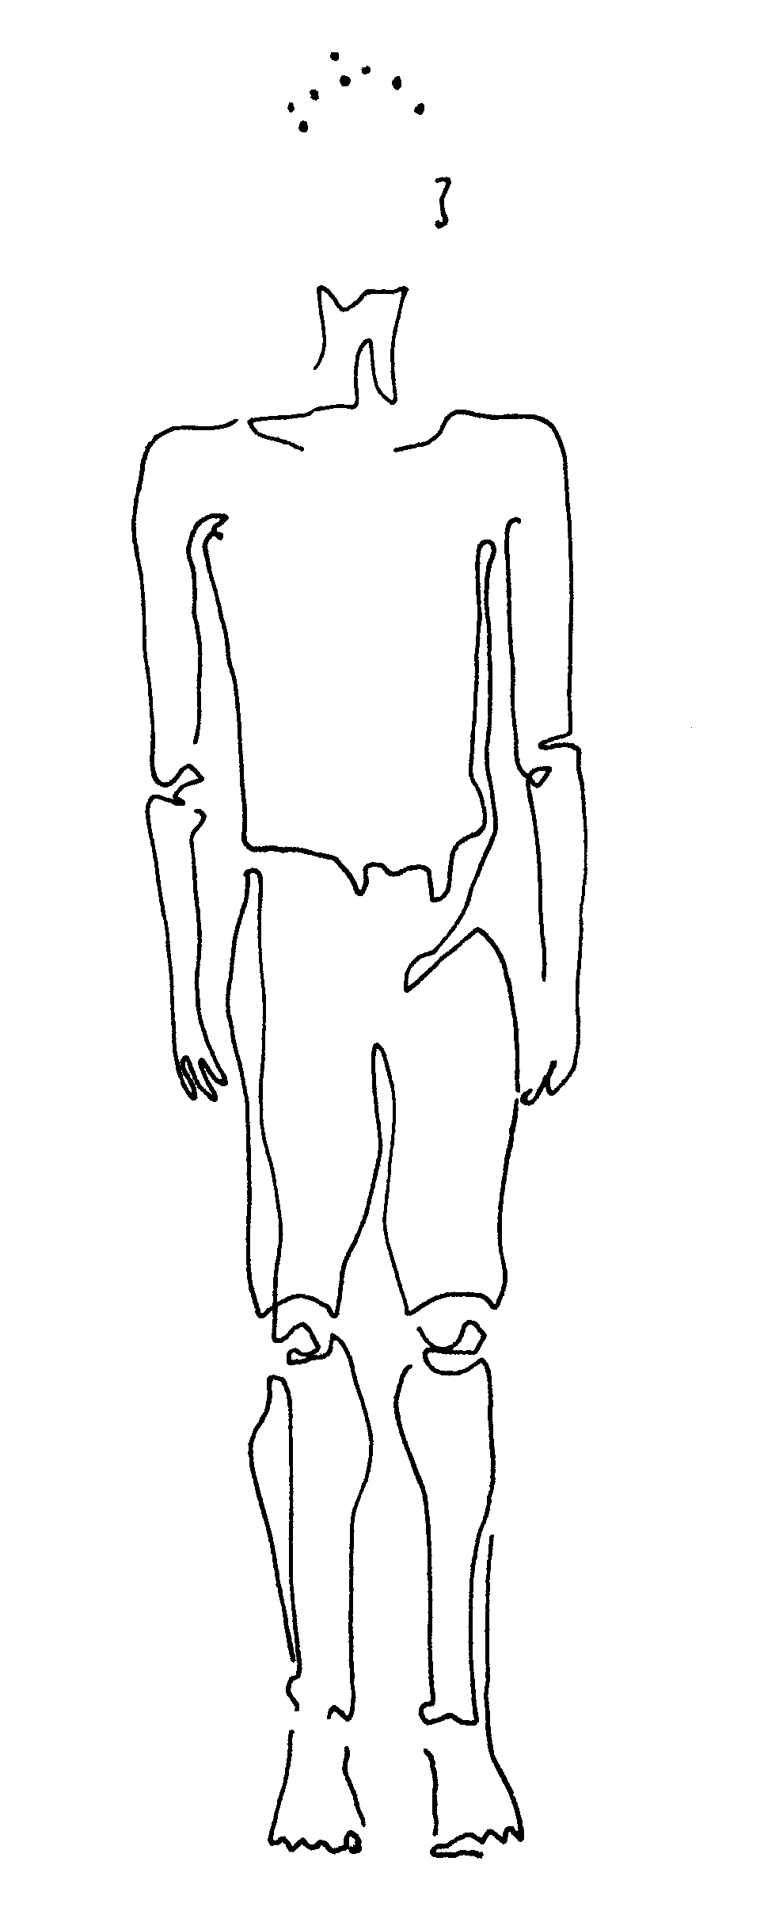

Now feel your belly button, and feel the place in your spine behind it. Stretch your spine below that point downward, and stretch your spine above that point upward. You are making space between the bones, the vertebrae, in your back. You are making yourself taller. And you can relieve back pain, or prevent it, by doing this even outside of class. Try it when you have to wait in line somewhere.
uttanasana (oo-tan-a'-san-a) or "standing forward bend." Stand with feet parallel and hip width. Reach your arms overhead, shoulders low and relaxed, and feel every kink in your body ease out from fingertip to foot sole. Turn your palms to the outside, look up, and bending from the hips, 'cliff dive' forward with your upper body until you gaze past your legs. Feel the squeeze on your stomach, intestines, reproductive organs. Return to standing, and feel how your belly is refreshed.

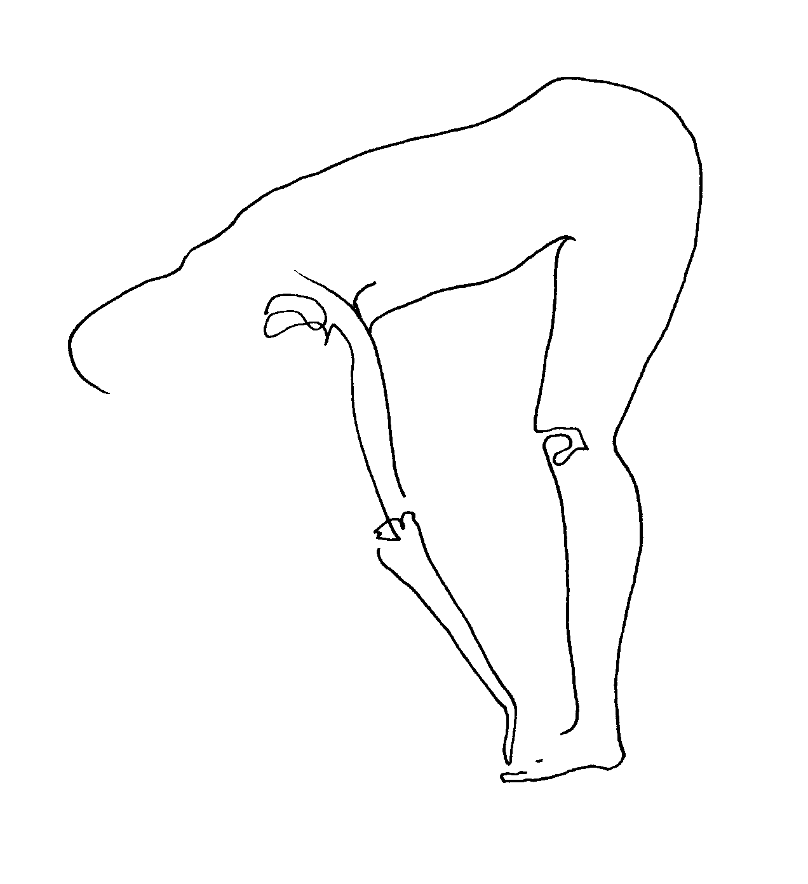
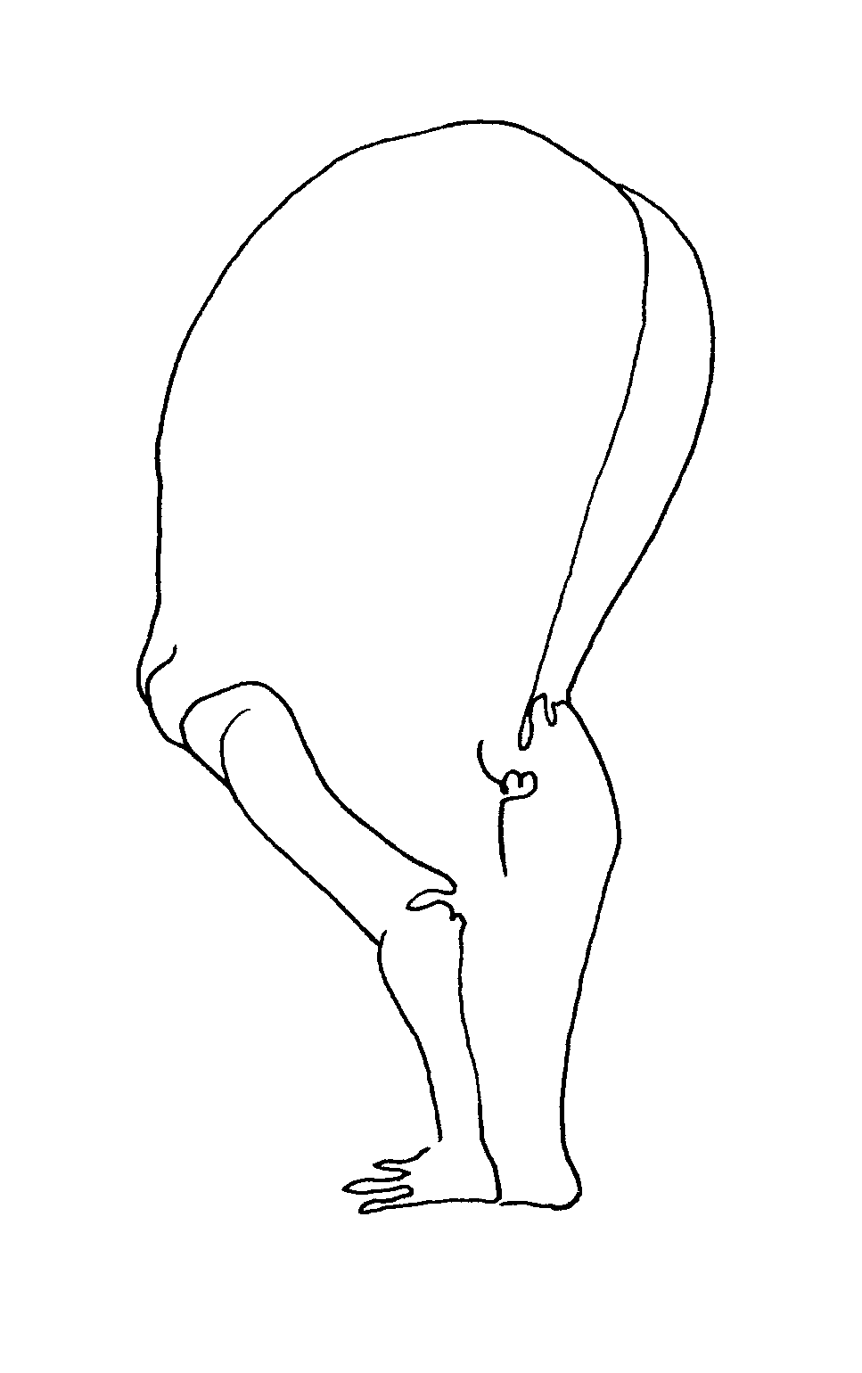
trikonasana (tree-ko-na'-san-a) or "triangle." Stand with feet a leg's length wide; turn both feet to the right. Stretch arms wide, palms down, your body a five-pointed star with limbs and spine long. Reach to the right as far as you can, drop your right hand down onto your thigh, or shin, or ankle. Reach up with your left hand, and turn eyes this way. Chest and belly feel wide open. Breathe. Practice on the other side.

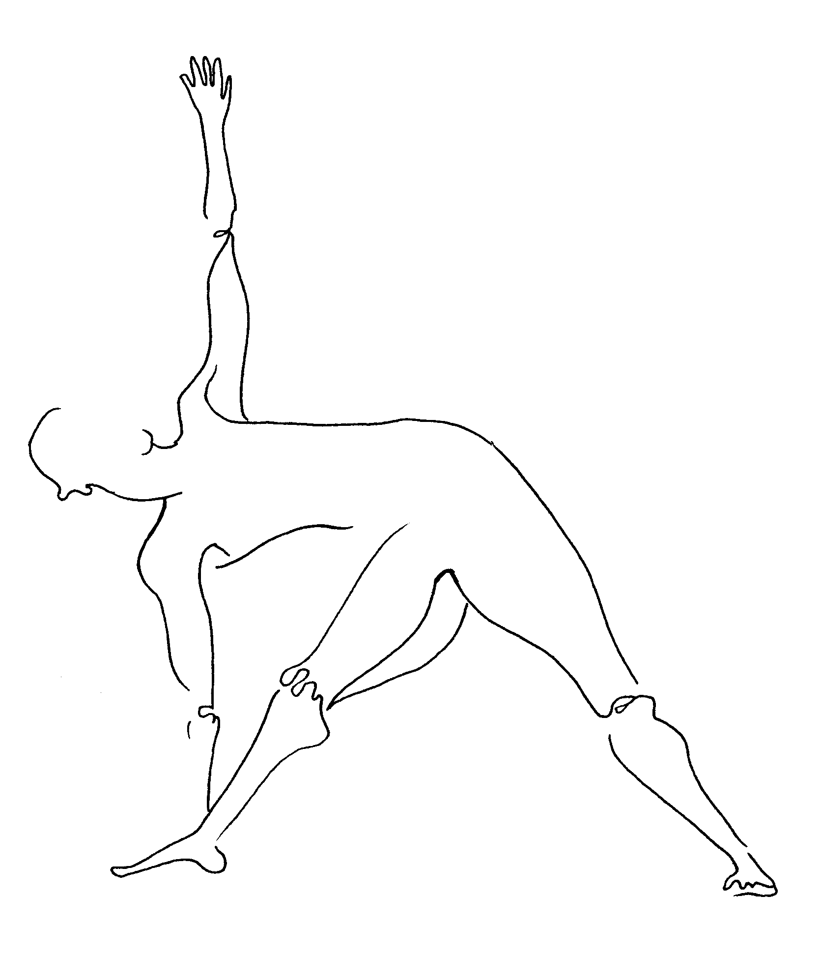

virabhadrasana II (veer-ab-had-ra'-san-a) or "warrior two." Stand with feet wider than a leg's length; turn both feet right. Stretch arms wide, palms down, and consciously, gently, bend right knee until it rests above that ankle. Look beyond right fingertips. This is one posture of the warrior series, preparing for battle or challenge. Gather power from the earth beneath your feet. Breathe. Practice on the other side.

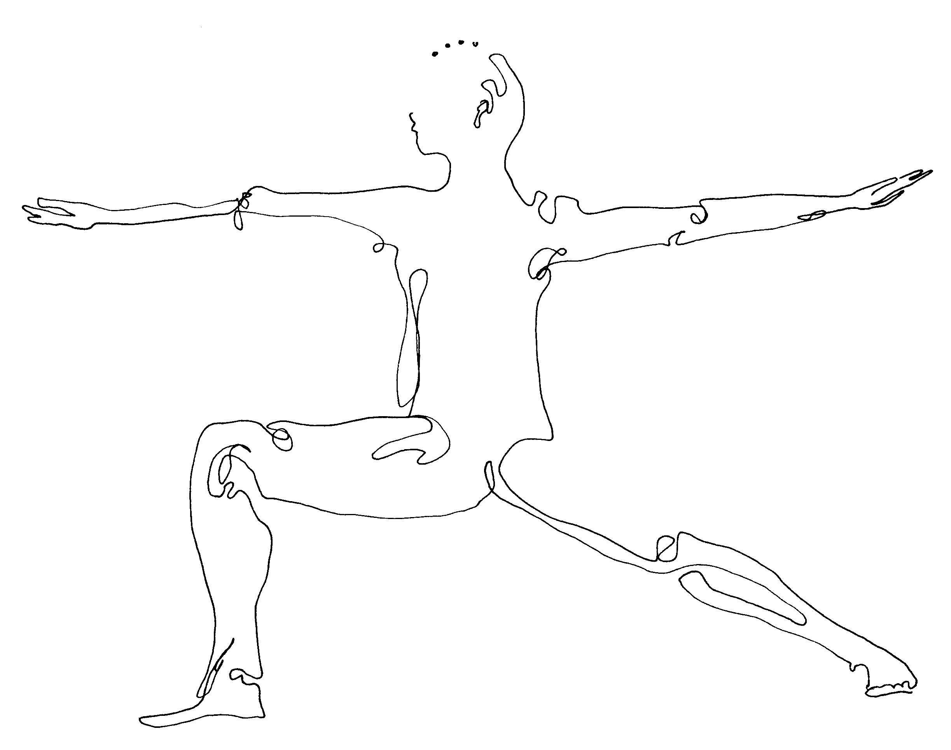

introduction of pranayama.

Pranayama (pra-na-ya'-ma) is a breathing practice and part of traditional yoga practice. Lots of other cultures have ancient breathing practices, and we'll get into some of these in class as well.
Most of this breathing is done sitting, with crossed legs if possible. If you're uncomfortable on the floor please sit in a chair, or fold up your towel beneath you as a cushion. Our spine is long and tall, our chin dropped slightly. Hands rest in our lap, palms cradled and up, or on our legs, palms up. Our most basic practice is this one:

ujjayi (oo-jy-ee') or "mastery breath." Notice your breath and follow it. Breathe so that inhalation fills your belly and exhalation empties it. Now breathe, with mouth open, so that you whisper "ahhh" to yourself on both inhalation and exhalation. Keep that "ahhh," close your mouth, and continue breathing now through your nose. This is ujjayi.
Many nadis (na'-dees) originate in the nasal passages. Nadis are the Indian culture's name for unseen energy channels throughout our body, something like veins, but ones which allow the flow of energy instead of blood. Breathing solely through our nose stimulates these nadis (energy channels), which in turn reach throughout our body to all organs, sending energy to them.
Breathe now as I count, stretching out your breath to fill the whole four counts in, four counts out, that I speak. Repeat twice. Now to the count of five. Repeat twice. Now to the count of six. Repeat twice. Finally to the count of seven. Repeat twice. Then come back to regular breath.

introduction of meditation.

Meditation joins our body, in the present moment, with our usually-wandering mind and spirit. This mind-body-spirit union in itself creates balance, or inner peace. Here's one practice that was taught to me by a Nepalese woman and is very simple. She told me that every child in Nepal learned, very young, to do this every day. She said it helped the people in her country to feel peaceful and be healthy throughout their lifetimes.

You can practice meditation by sitting as we just did for pranayama, with a tall spine, shoulders back, eyes closed. Try sitting against the wall if that feels better. If you really want to lie down for this, please do. Just remember that in meditation we stay alert and aware of our breath and thoughts and feelings. And when we're lying down it's easier to space out or go to sleep!

favorite place meditation. Bring to your mind the image and experience of being in your favorite place. This may be a room or tree nook from childhood; it may be in the ocean, or in the mountains; it may be in the arms of someone you love. Now stay there, feeling, smelling, seeing, and sensing in all ways that place in which you once felt so good. Stay there. If thoughts or distractions lead you away, simply return to that place as soon as you notice you have wandered. Stay in your favorite place for a while. (After five minutes … ) Gently bring yourself back into this room, and slowly open your eyes.

finish class. I finish class with this gesture, which you're welcome to join me in. It's a kind of blessing. Open your arms and breathe in; close your palms together and breathe out. Namaste
(na-ma-stay'). That means to the spirit in each of you, to the spirit in me, to the spirit in everything.

second class that week. Overlay of first class. May use verse as point of focus:

Such stillness --
the cries of the cicadas
sink into the rocks.
(Matsuo Basho, 1644-94, Japan)

Feel how quietness, in the room, or in ourselves, connects us to all in our universe and throughout time.

week two.

more yoga.

Postures (or yoga asanas) take our modern human dilemma of outer softness and inner hardness and reverses it. Outer softness is something we see everywhere in this world: in physical illness or obesity, and in surface sentimentality like caring more about soap opera characters than real people who suffer in our communities. And inner hardness is something which we also see: in severe emotions like hatred, and in hardened arteries or tumors that are so prevalent today. What comes about in practicing these postures is a growing outer firmness (in muscle and courage) and a growing inner softness (in emotional flexibility and empathy for other people, and also in our pliant, healthy organs).
Any time we feel our stomach or lungs squeezed or stretched by our yoga posture, we are softening those organs. Soon in class we will work on the health of our inner organs, one by one. This class might begin with several of the postures learned last week, say tadasana (mountain), followed by virabhadrasana (warrior) II.

virabhadrasana I (veer-ab-had-ra'-san-a) or "warrior one." Come into virabhadrasana (warrior) II, facing right. Swing your left arm from behind you forward, to meet your right, palm to palm. Swing your palms, together, upward, and let your eyes follow; your legs stay the same. Again, gather and feel power as a warrior would. Draw energy from the sky, moon, sun. Breathe. Other side.

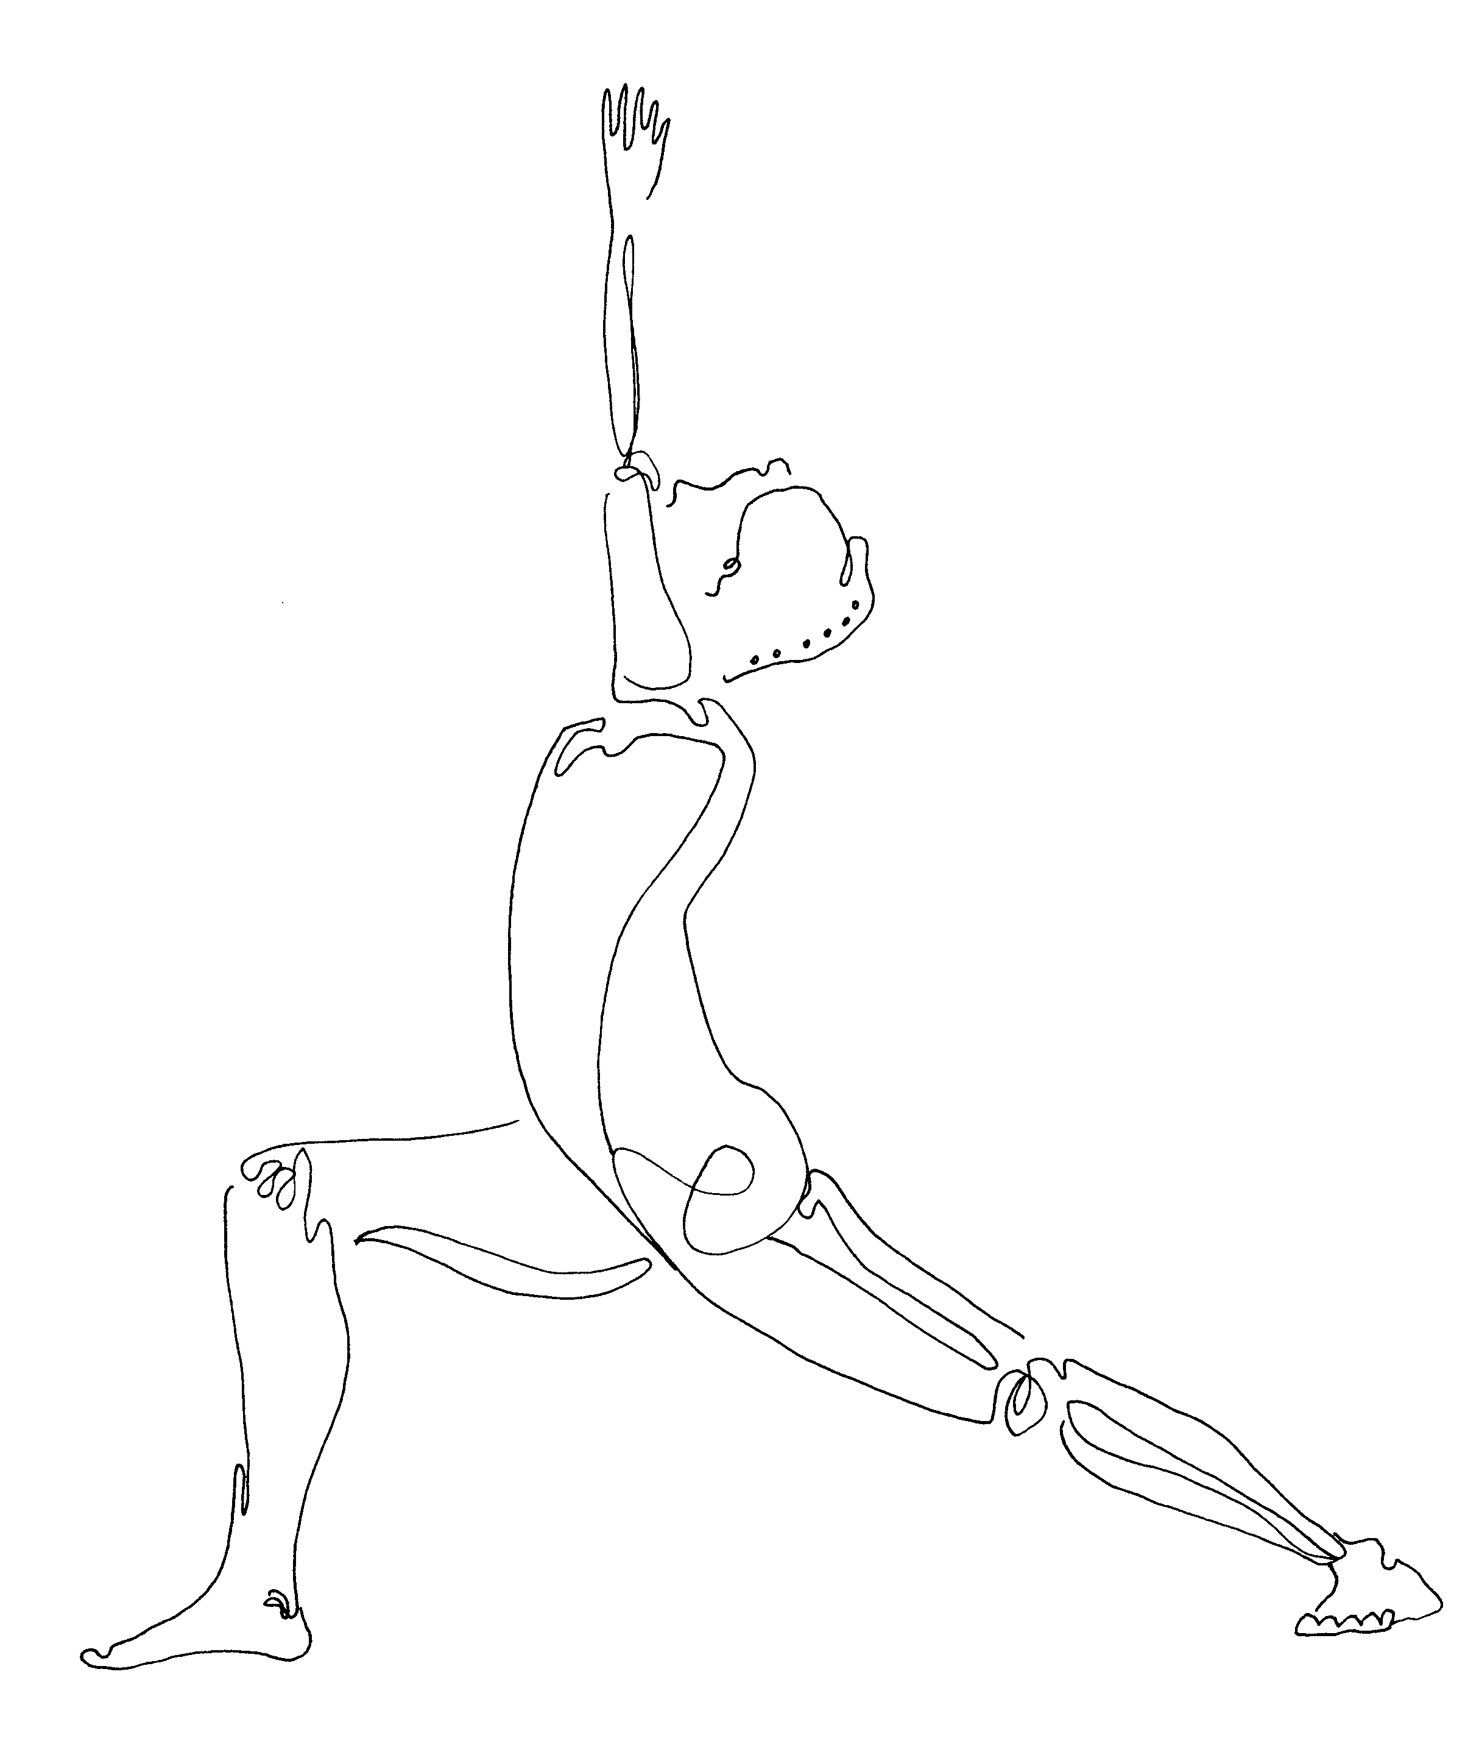

parsvakonasana (parsh-va-ko-na'-san-a) or "side angle stretch." Come back into virabhadrasa (warrior) II facing right. Keeping your legs just as they are, stretch your right arm as far as you can in that direction, letting it pull your whole torso that way. You may then bend that right elbow and prop that forearm on your thigh, or you may drop that right hand down to the ground, palm alongside the little toe side of your foot. The left hand stretches over your head, creating one, long, diagonal line from your left foot to your left hand. Left palm faces down, then back. Feel the skin between your ribs stretch. Breathe into any tightness. Other side.

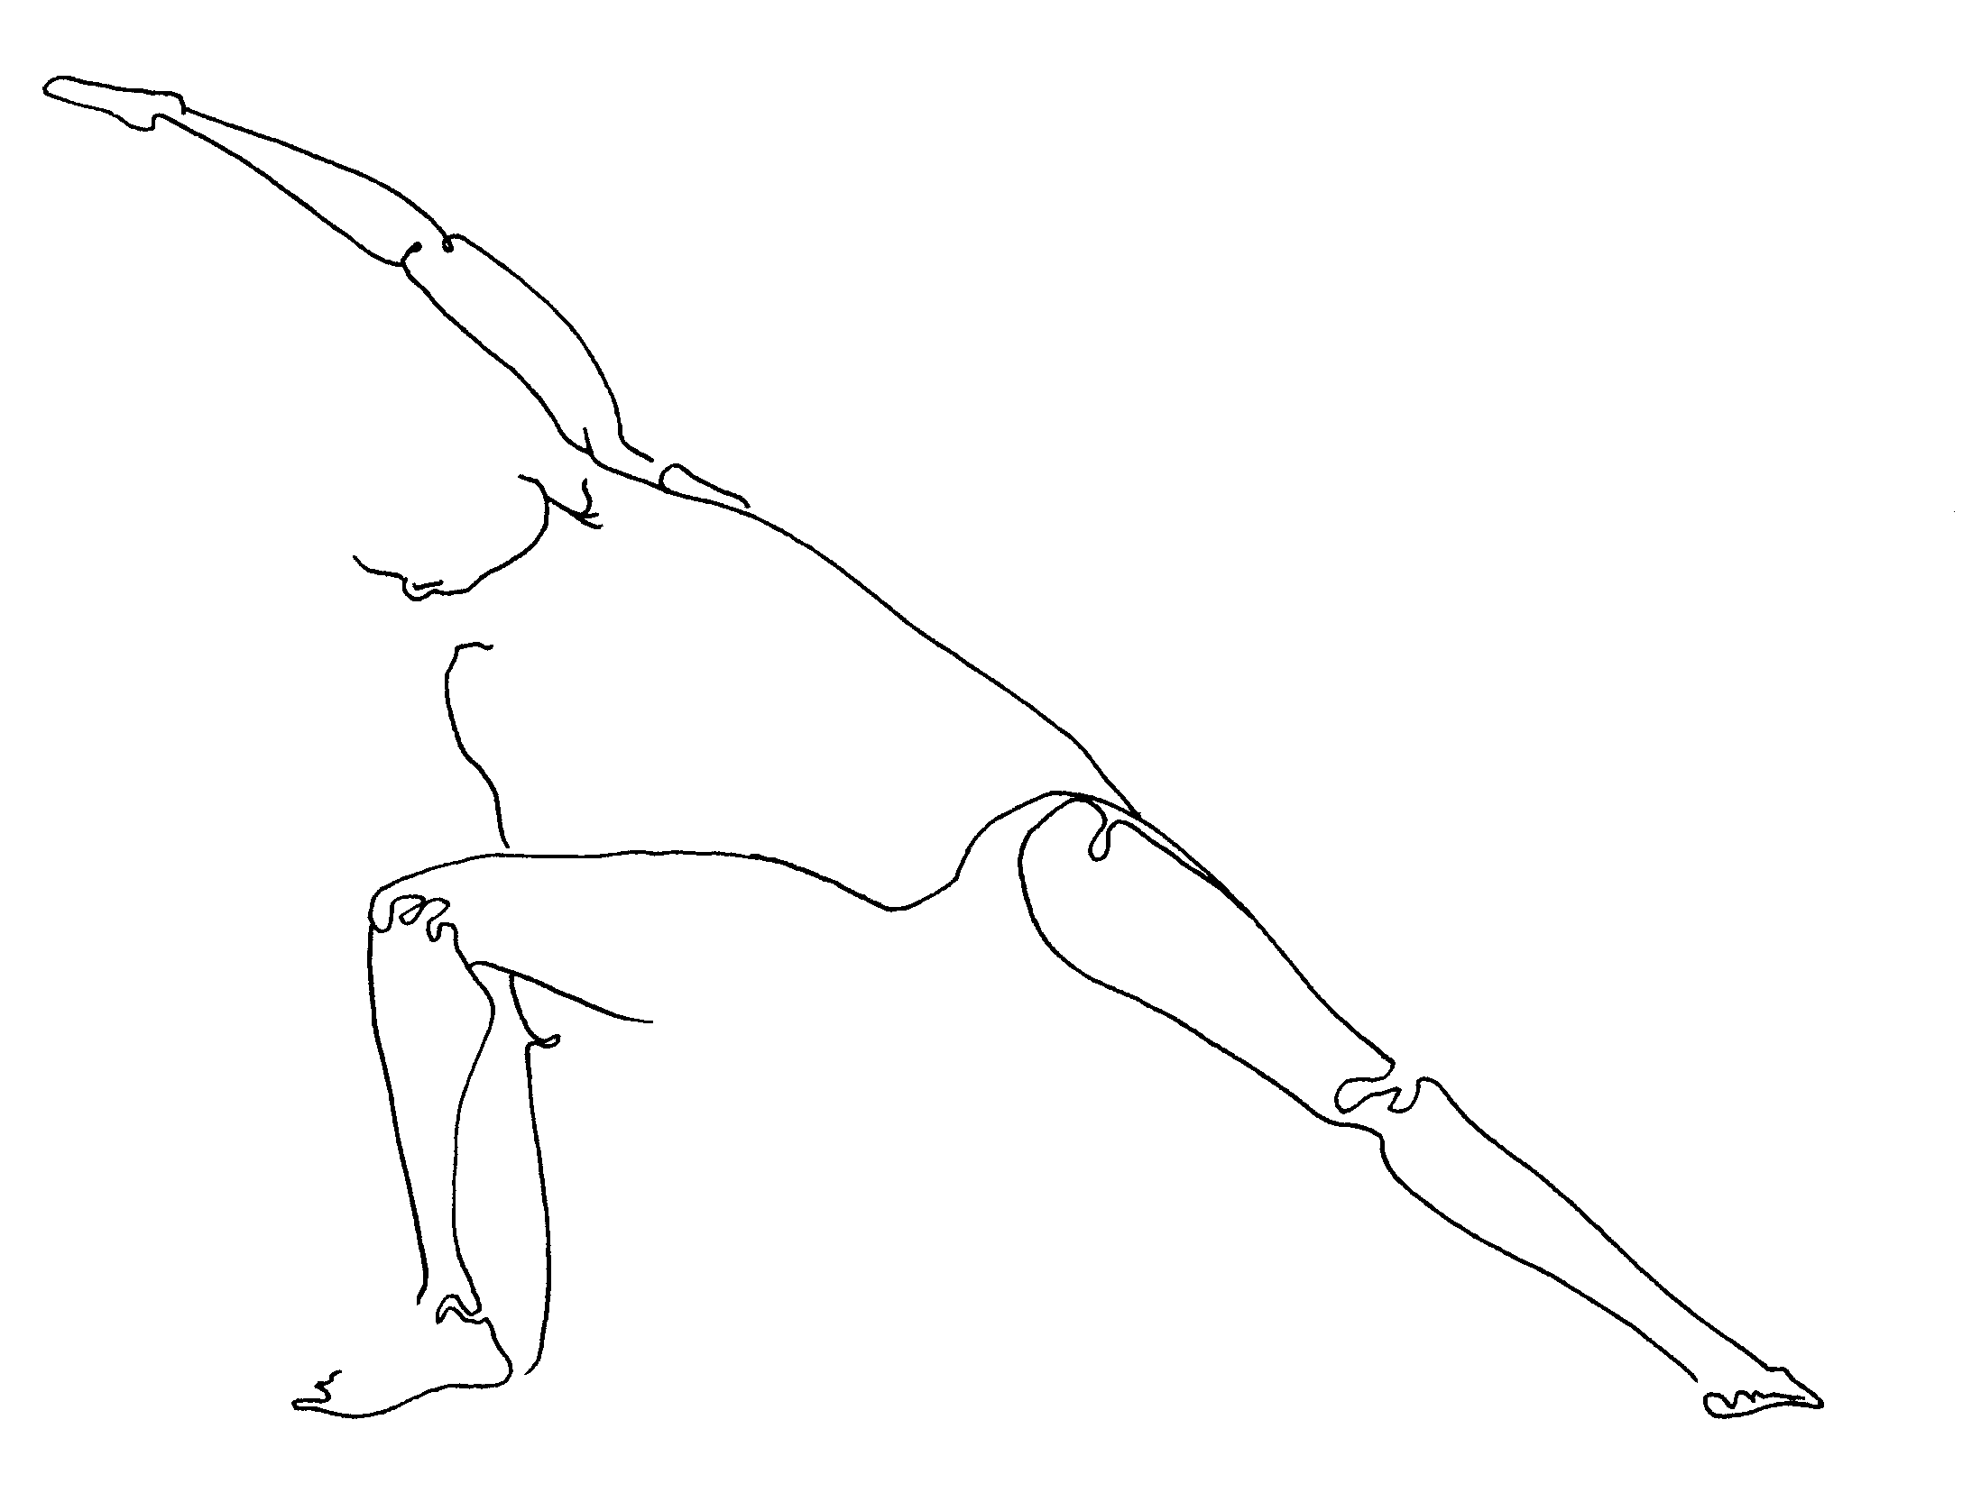

janu sirsasana (ja'-noo sheer-sa'-san-a) or "head to knee bend." Sit with your legs forward and bend your right knee outward, and back as far on the floor as you comfortably can. Arch left sideways, bringing your left forearm onto or inside your left leg, with your right arm arcing overhead, reaching toward that left foot. Open your chest; gaze up. Feel the heat of this intensity, and let it melt your stiffness. Breathe warmth. Now untwist, with legs remaining as they were. Reach with a long back toward that outstretched foot or leg, then fold from your hips forward. Breathe now a coolness that soothes. With brain and heart resting forward let their activity slow. Stay for a while. Then practice on the other side.

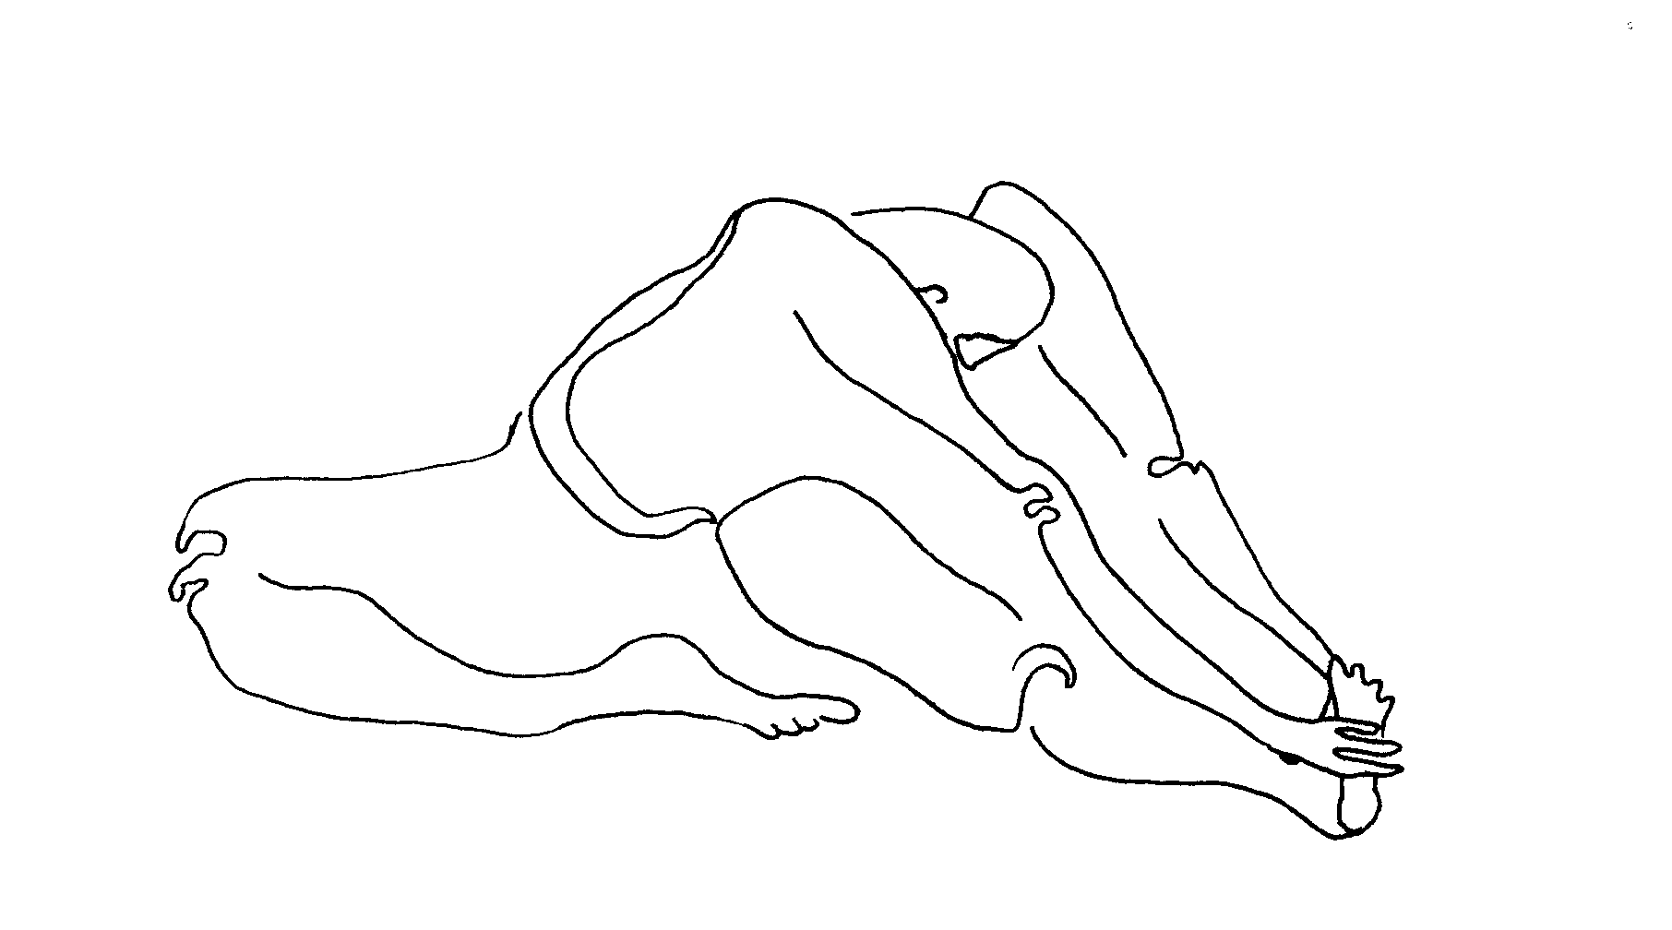

more pranayama.

kumbhaka (koom-bak'-a) or "holding breath." This takes our basic ujjayi breath and adds to it. Using ujjayi (mastery) breath, breathe in slowly to my count of six. Hold the breath for six. Then let your breath go. Repeat 3x.
Now breathe in quickly, breathe out slowly to the count of six, hold for six, back to regular breath. Repeat 3x.
When your breath is held with full lungs, feel how the oxygen feeds your blood and cells. When your breath is held with empty lungs, feel how ready those lungs are, preparing to absorb new, rich air.

more meditation.

body travel (through our bones). This visualization comes from the Burmese tradition. These days it is becoming widely known as part of the practice of Mindfulness, or present-moment awareness. Mindfulness is related to centering, which we will learn more about in upcoming classes. For Body Travel right now, begin by lying on your back, relaxed, with eyes closed.

Now bring your mind, your focus, to the tips of your toes on the right foot. Simply feel them. (You may imagine you feel warmth there, or that you feel them tingling, or even that you bring your breath there. Please let your instinct guide you on this.)

Now feel the arch of your right foot. And your right heel. Now travel into your ankle, and then up your right calf. Through your knee. Up your thigh, to your right hip.

Travel across your pelvis bone to your left hip. Feel it deep inside. Move down your left thigh to that knee. Now down that calf, through your ankle, and into your heel. Feel the arch of your left foot. And move into your toes.

Move to the tips of your left fingers, and across the palm of that hand. Feel your wrist. Travel up your lower arm, into your elbow, and then up your upper arm. Go deep into your left shoulder. Move into your shoulder blade on your back.

And travel over into your right shoulder blade. Then into your shoulder joint. And down your upper right arm, through your elbow, down that lower arm, into your wrist. Feel the palm of your right hand. Feel your fingertips.

Drop down into your tailbone, the bottom tip of your spine. And then travel slowly up your spine, vertebra by vertebra, bone by bone. Feel your lower back, your lumbar curve. Move up through your middle spine, the part at the center of your chest, your thoracic spine. And travel into your neck, up through your cervical spine.

Then feel your whole skull. Feel your jaw. Feel your nose. Feel your ears, even deep within your skull. Feel your eyes, deep within your skull. Feel your brain.

Finally, imagine that there is an open space at the very top of your head, as there is in baby's skulls when they are first born. Imagine that you can breathe in and out of this space like a whale does. Take several breaths this way. And then return to your regular breath. And, slowly, open your eyes.

finish class. Please take whatever part of class, even if it's a single yoga posture or one type of breath, and practice it on your own during the week. An entire practice is something each of us can create and customize for ourselves (and by the end of this program you'll have many tools to choose from for this). But more important than a whole routine is your recognition of something here and there that you're really drawn to, and can use in your daily life. (Closure same as last, and every, week).
Namaste (to the spirit in all of us).

second class that week. Overlay of first class. May use verse as point of focus:

In the Station of the Metro
The apparition of these faces in the crowd:
Petals on a wet, black, bough.
(Ezra Pound, 1916, England)

Think of the oneness of people and nature, and the importance of seeing this connection every instant, even in the city or prison.

week three.

lifeforce. It is time to introduce the concept of "lifeforce," or the energy that pervades everything in our universe, from people to flowers to rocks to the air. I should say re-introduce, because most of us were very aware of this when we were young children. The air we breathe is one way in which this energy travels into and out of our bodies all day long. Another way is absorption through our skin, especially through the soles of our feet and the palms of our hands. Another is through the food that we eat, where it is especially rich in plants grown in the earth.
Lifeforce goes by many other names, and every ancient culture had their own word for it. Some of those we use in class are: "prana" (pra'-na, from India), "mana" (ma'-na, from Pacific Island cultures like Hawaii), "chi" (chee, from China), and "ki" (kee, from Japan). Those of you who have practiced any martial arts will be familiar with chi.
We can become aware of lifeforce throughout our day, and Free Inside class is an opportunity to practice that awareness. I will talk about it, and you may notice or feel it, when we practice yoga, chi gung, and pranayama.
Last week I talked of inner softness being one goal here. We become ill in parts of our body that are somehow hard and stuck, in places where energy cannot freely flow. We can help soften our inner organs, and dissolve stuck places inside us, by helping move this lifeforce around within us. Practices we learn in class will show us how.

more yoga.

parivrtta trikonasana (par-vree'-ta tree-ko-na'-san-a) or "reverse triangle." Stand with feet a leg's length wide; turn both feet to the right. Stretch arms wide, palms down. Now twist your body until your left hand is reaching over and beyond your right leg. Reach in this direction as far as you can, then drop your left hand down onto your right thigh, or shin, or ankle. Reach up with your right hand. Most of us will keep our eyes on the ground, as this helps us balance at first. Later, we'll turn our eyes up to look beyond our hand that reaches upward. Chest and belly feel wide open. Breathe. Practice on the other side.

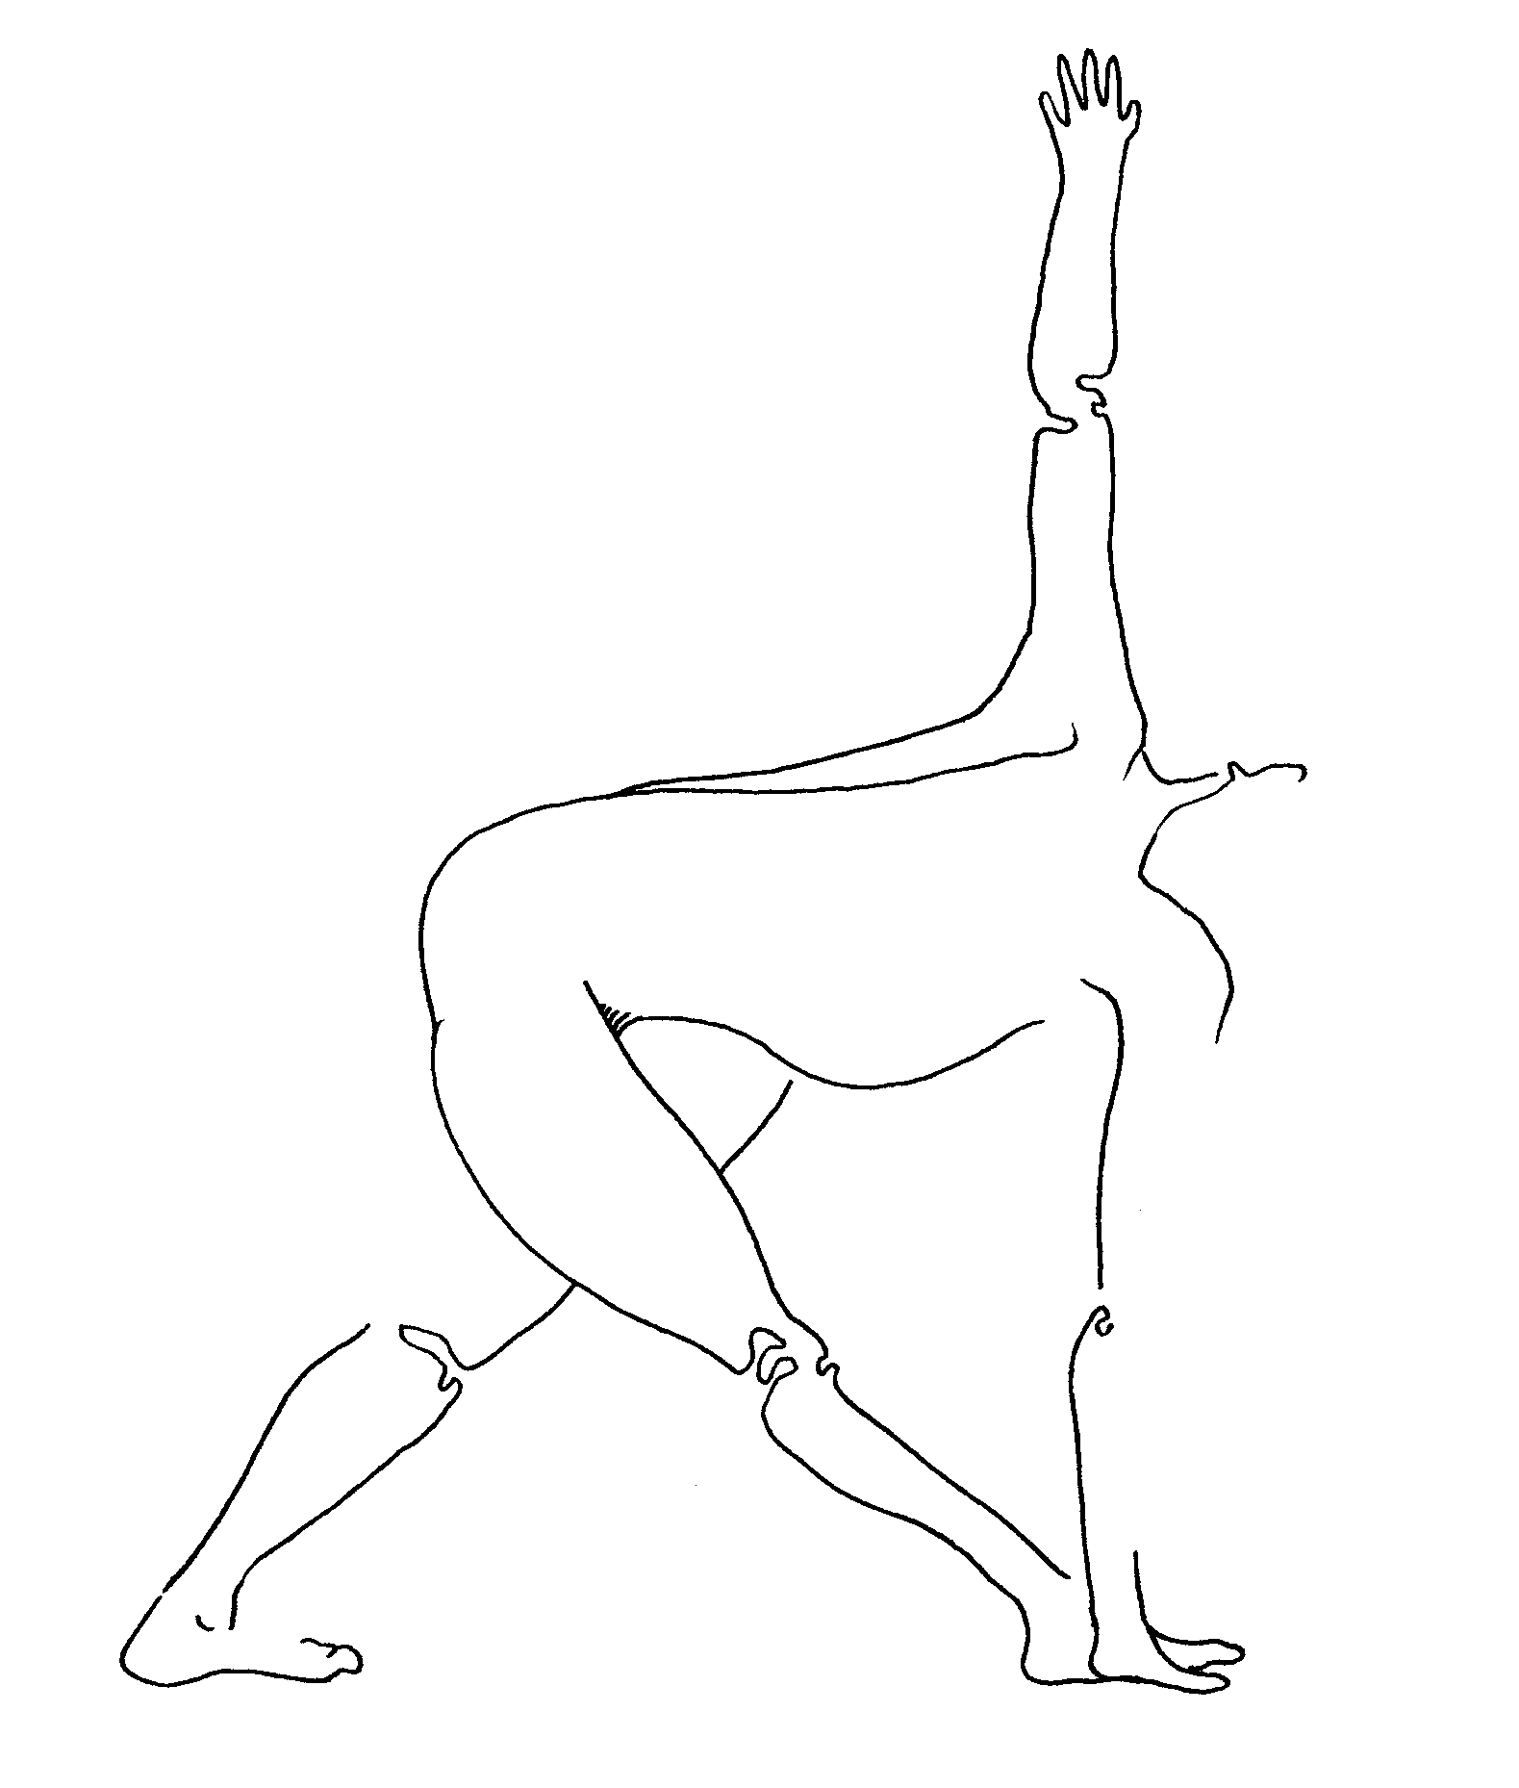
virabhadrasana III (veer-ab-had-ra'-san-a) or "warrior three." Come into virabhadrasana (warrior) II, with your body and eyes facing right. Swing your left arm from behind you forward, to meet your right, palm to palm. Reach with your joined palms toward a point in the distance in front of you. Look steadily at that point, maybe a line in the wall, or a tree outside the window. This steady gaze is called a drishti (dris'-tee), and helps give us balance. You can imagine that this gaze is like a mountain climber's rope that your eyes send out to catch onto something strong, to hold your body in place.
Now shift your weight forward until your back foot, your left foot, comes off the ground. This is plenty for most people, but to go further you simply allow your reaching hands to pull you forward, and your back leg to be raised higher. Ultimately, your entire body, arms, and back leg are parallel to the ground. Everything feels long and stretched. Breathe. Other side.

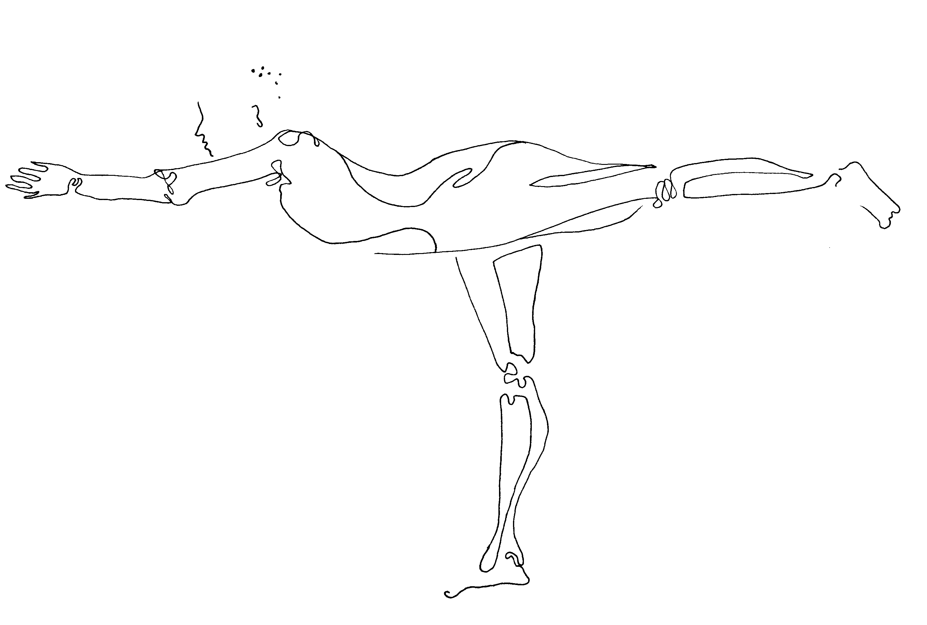
dandasana (dan-da'-san-a) or "staff." Sit with your legs outstretched in front of you, the inner edges of them touching, your toes facing up. Put your palms on the floor just beside your hips, fingers facing forward. Imagine that a line dropped from your shoulders goes down through your hips. Stretch out through your foot soles and heels so vigorously that they lift just off the ground. Your legs are long, your spine and neck are long, your arms are long. Energy passes easily through long, unbroken lines like these.

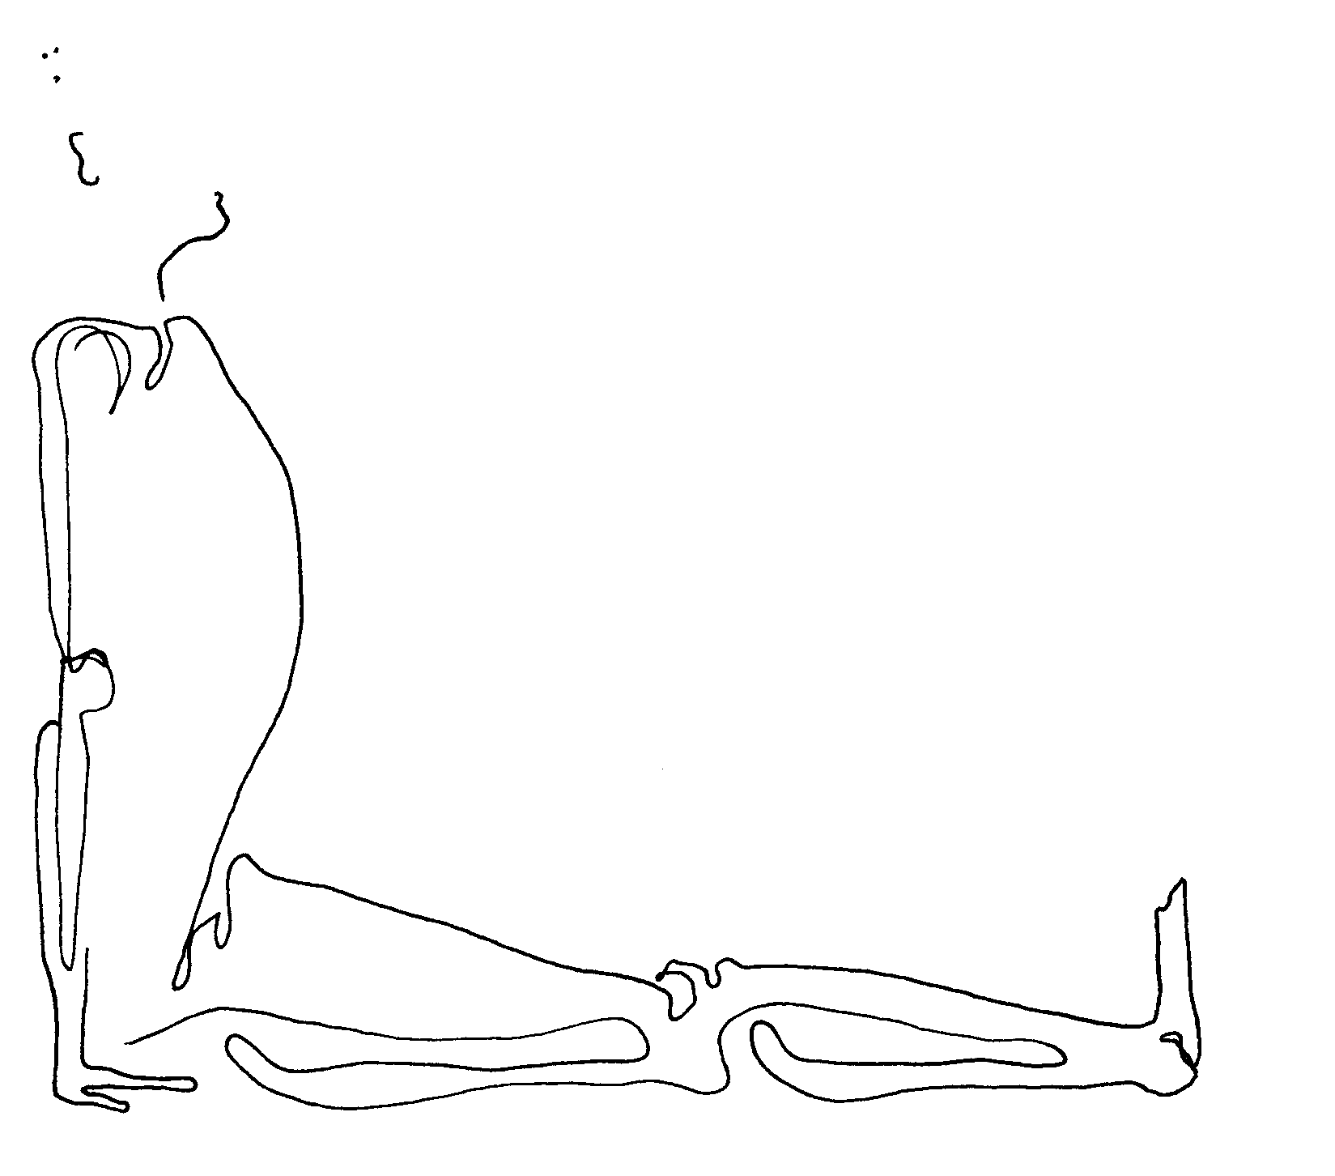

pascimottanasana (posh-ee-mo-tan-a'-san'a) or "forward back stretch." Sit in dandasana (staff). Reach up with your hands, lengthening and even arching your spine. Look up. Bending at your hips, not waist, come forward with your arms and torso. Bring your belly to the tops of your thighs. Reach your fingertips for your toes. The upper part of your chest may continue reaching forward, until your face comes closer to your legs. Or it may reach its limit before this. The important parts of this are your long spine, and your belly squeezed toward your thighs. If your fingers reach past your toes, wrap your hands around your feet. Your toes always point upward. Breathe.

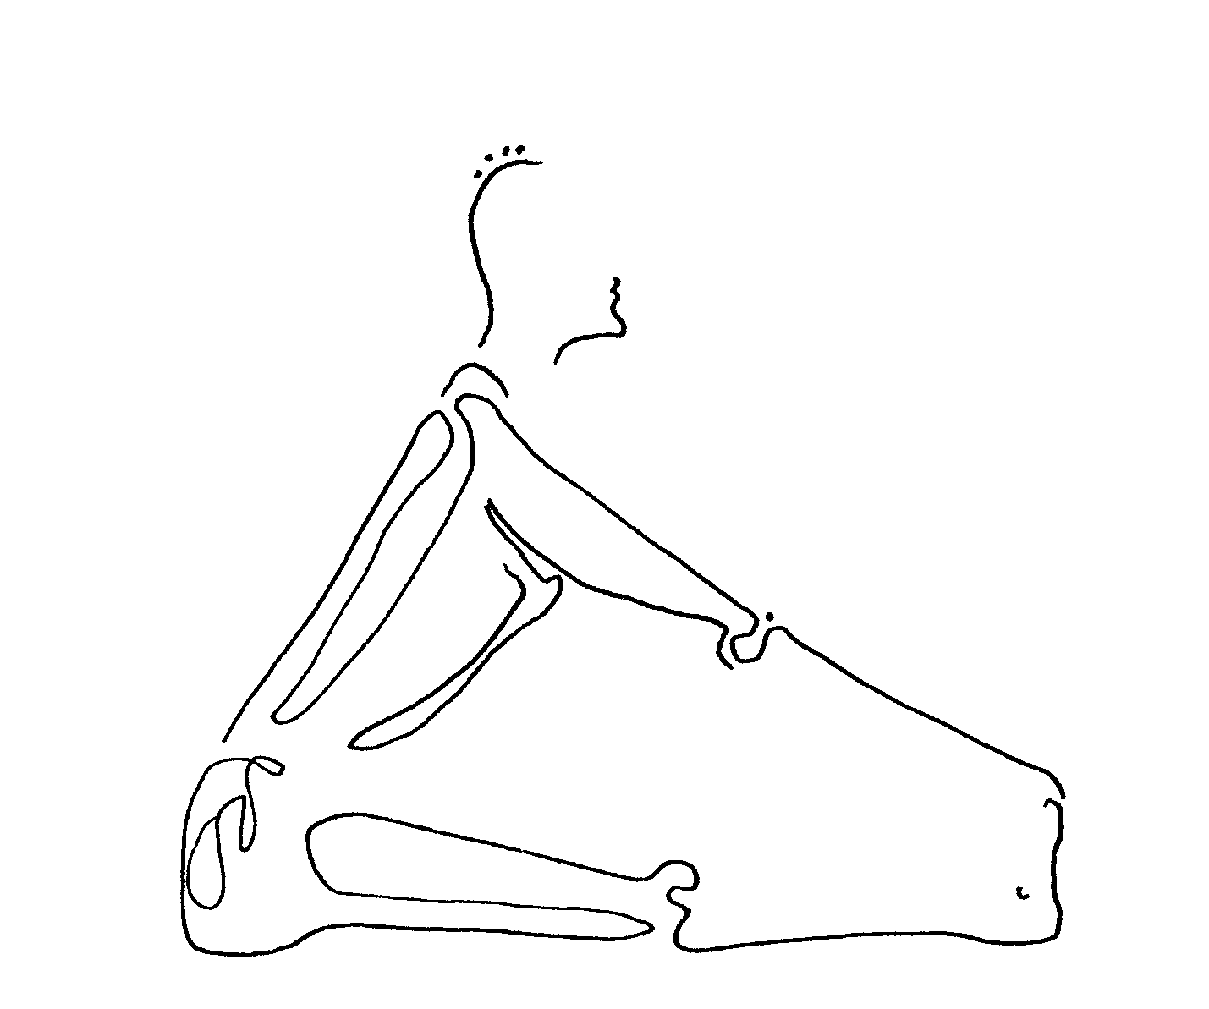

more pranayama.

Breathing practice (or pranayama) is an awareness we can feel, that respiration carries more than oxygen in and out of our bodies -- that it transports that energy we've talked of. You'll notice that the name "pranayama" holds the word "prana," and that means lifeforce. When we control our breath and draw it out longer, or expand it, this virtually charges us with this energy. Many people feel a euphoria, or 'high,' with this practice. It may be something you notice while you practice, just after you finish practicing, or even later in the day when you're not expecting it.

viloma kumbhaka (vil-o'-ma koom-bak'-a) or "sequenced holding breath." This takes our basic ujjayi (mastery) and ujjayi kumbhaka (mastery holding) breaths, and adds to them. First feel your whole torso. When air comes in through your nose, it flows right down to the base of your belly, like water would, and fills you from the bottom up. Imagine that you'll divide your torso space into three levels: your deep belly, then your middle, then your upper chest. Your inhaled breath will fill these levels one at a time.
Breathe in to your deep belly to the count of three. Hold; (no breath in or out). Now breathe into your middle, feeling your ribs widen. Hold. Now breathe into your upper chest, all the way up beneath your shoulders. Hold. Release. Regular breath. Repeat 3x.

chi gung.

Self massage (or this type of chi gung) is done sitting, and is especially helpful to people who have to stay in bed, or a wheelchair, or anyone who doesn't want to stand up for exercise. Remember how we feel inner movement as health-giving to our bodies, and recognize potential illness in those places which feel stuck? In chi gung, inner movement is fueled both in obvious, physically measurable ways such as pounding and rubbing, and in subtler, less-seen ways such as visualizing and intuiting. Chi gung is an ancient Chinese healing practice.

We do this practice sitting on the floor with crossed legs, or on a chair. We will learn a whole series in coming weeks; several to begin with are this:

clicking teeth: Our teeth are linked to our inner organs. So when they vibrate from this clicking, vibration is sent into all of our organs. Click, or bite them up and down, 9, 18, or 27 times. Ancient tradition values the number 9 and its multiples as embodiments of change. So this change may be regeneration, the inner movement which dissolves stagnation.

stir tongue: Slide your tongue around between teeth and lips, in circles one way (9x), then the other (9x). Our tongue is linked to our heart. So in doing this we send energy to our heart.

draw circles: With the tip of your tongue draw circles on the roof of your mouth, 9 in one direction, then 9 in the other.

wash face: Rub your palms in wide circles over your cheeks. Our cheeks are linked to our lungs. You'll notice that often when people have a lung illness, their cheeks will be red or another color. This exercise sends good energy to the lungs to break up congestion.

more meditation.

body travel (through our muscles and organs). Begin by lying on your back, relaxed, with eyes closed.

Now bring your mind, your focus, to the tips of your toes on the right foot. Simply feel them. (You may imagine you feel warmth there, or that you feel them tingling, or even that you bring your breath there. Please let your instinct guide you on this.)

Now feel the ball of your right foot. And your right heel. Now travel into your ankle, and then up the muscle of your right calf. Through your knee. Up your thigh muscle, to your right hip.

Travel across your lower belly to your left hip. Move down your left thigh, deep in its muscle, to that knee. Now down that calf, through your ankle, and into your heel. Feel the arch of your left foot. And move into your toes.

Move to the tips of your left fingers, feeling the pads of your fingers, and across the palm of that hand. Feel your wrist. Travel up your lower arm, into your elbow, and then up the muscles of your upper arm. Go deep into your left shoulder. Move into your shoulder blade on your back.

And travel over into your right shoulder blade. Then into your shoulder joint. And down your upper right arm, feeling its muscle, through your elbow, down that lower arm, into your wrist. Feel the palm of your right hand. Feel your fingertips.

Drop back down to your lower belly. Feel your reproductive organs. Feel your small intestines as they coil and bundle from the bottom of your belly upward. Now move with your mind into your liver, tucked partly under your ribs on the right side. Just feel it, big and heavy. Move across to the same place on your left side and feel your spleen, smaller than the liver. Your spleen is near your stomach, which sits closer to the center of your belly though still on the left side. Feel your stomach. Now move your focus around to your back. Feel your two kidneys, protected by your lower ribs in the back. Feel them warm. Move up now to where your heart is and feel this. Feel its shape and power. Maybe you can feel it beating. Now move outside the heart to your lungs, and feel their great size from bottom to top. Feel their upper tips way up near your collar bone.

Now move up through your throat and feel your whole skull, protecting so many soft organs. Feel your tongue. Feel your nose. Feel your ears, even deep within your skull. Feel your eyes, deep within your skull. Feel your brain.

Finally, imagine that there is an open space at the very top of your head, as there is in baby's skulls when they are first born. Imagine that you can breathe in and out of this space like a whale does. Take several breaths this way. And then return to your regular breath. And, slowly, open your eyes.

Remember from all of our work with our lifeforce, how joining our mind to any part of our body -- by focusing on it -- generates energy in that part of us. There's a saying in chi gung: where the mind goes, energy follows; where energy goes, blood follows. We have just brought new blood into every part of our body we thought of.

You may also notice how when your mind is on your body in the present moment, it does not run off to thoughts of the future or the past as easily. This mindfulness can help ease anxiety, depression, pain, and drug and alcohol cravings.

finish class. (Closure same as last, and every, week).
Namaste (to the spirit in all of us).

second class that week. Overlay of first class. May use verse as point of focus:

The entire cosmos is in communion.
The calcium in our bodies is the same calcium
that we find in the sea …and both …derive from heaven,
from the calcium that is contained in the stars …
(Ernesto Cardenal, 1972, Nicaragua)

Noticing lifeforce in us, in the air and in everything around us, helps us feel how interconnected we all are. We also feel how we all are in constant motion. Nature gives us many guiding examples in its constant movement of wind, water, and daily cycles. Our ancestors, no matter what culture they were from, looked to nature as a wise teacher.

week four.

our major organs. To increase our self knowledge, and thus our potential for recognition and healing of illness, we will familiarize ourselves with five of our major internal organs. Ancient Chinese medical tradition teaches us that our organs not only perform vital functions to keep us living, but that they also reflect our emotions.
So, a healthy or unwell organ can show up for us in the form of the particular positive or negative emotions associated with it. As an unwell organ begins to heal, we may notice that certain negative emotions which were our habit to feel now lift. We can help any organ's healing by trying to supply ourselves, and thus this organ, with its corresponding positive emotion. Likewise, we can heal from a troublesome emotion, like uncontrollable anger or fear, by addressing its corresponding inner organ.
Illness may have originated for us, even back in childhood, if we were bombarded with an emotion that is damaging to a particular inner organ. Of course drugs and alcohol can also do a lot of damage to our inner organs. But not to worry if this is so; there is always, always, something we can do ourselves to begin a healing of this injured organ. Simply feeling where each organ is inside of us begins this healing; remember where the mind goes, energy goes …
This week we'll focus on our heart. Our heart cleanses and circulates our blood. Before we begin yoga postures, let's just feel our heart, with eyes closed. A good way to feel our heart is to imagine that we breathe air into and out of it. So when we inhale, it inflates like a balloon, and when we exhale, it empties. Feel its shape and size and place inside your body.

more yoga.

utkatasana (oot-ka-ta'-san-a) or "mighty." Stand in tadasana (mountain), and raise your arms overhead, parallel to one another and palms facing each other. Bend your knees slowly, as little or much as feels right to you. When you come to a good bend, your hips should be straight above your ankles. Look up, past your fingertips. Now, imagine that your heart is the very center of you. All energy from above you, whether you think of it as scientifically measurable light from the sun and stars, or as unseen lifeforce, will pour into your fingertips and travel to your heart. Likewise, all energy from below you, whether your think of it as physical heat from the molten core of this earth, or chi, ki or prana, will be absorbed through the soles of your feet and flow upward to your heart. So your heart receives energy from above and below at the same time. And it is flooded with healing.
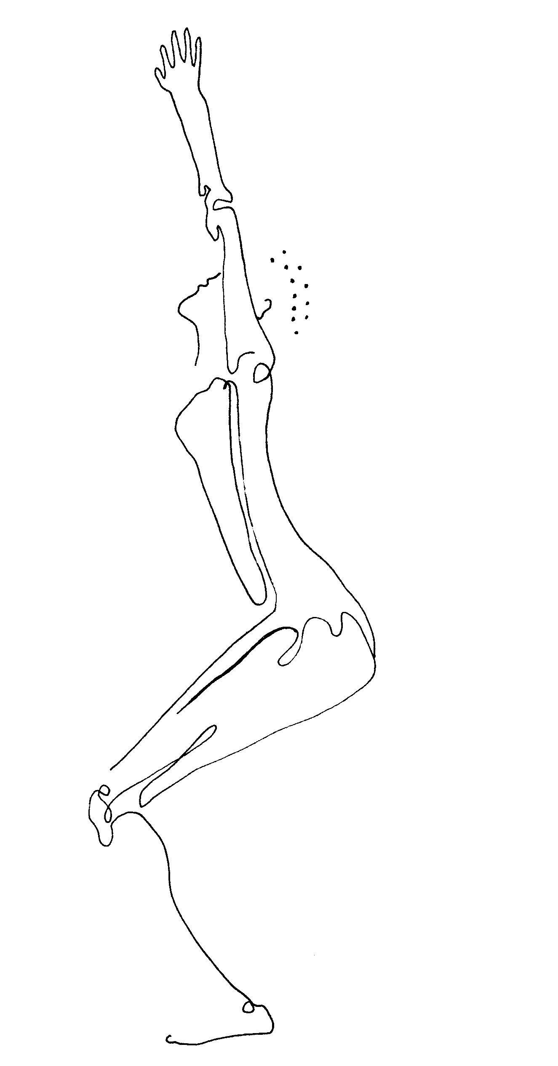

parsvottanasana (pars-vo-tan-a'-san-a) or "sideways extension": Stand with your feet a leg's length apart. Your palms are pressed in 'namaste' -- prayer to all of us -- behind your back. Simply hold opposite forearms behind you if your palms don't meet. Your hands back there are a reminder of the rear face of your heart, maybe the part of our heart we hide away because of hurt in the past. So our awareness on this part of our body can help our whole heart come alive.
Turn to the right, arch long and slow from left heel to upward reaching chin, your front body shining. Breathe for a while. Then, chest leading, bend at your hips and with a long spine come forward until it's the back side of your back body that opens forth. Breathe. Other side.

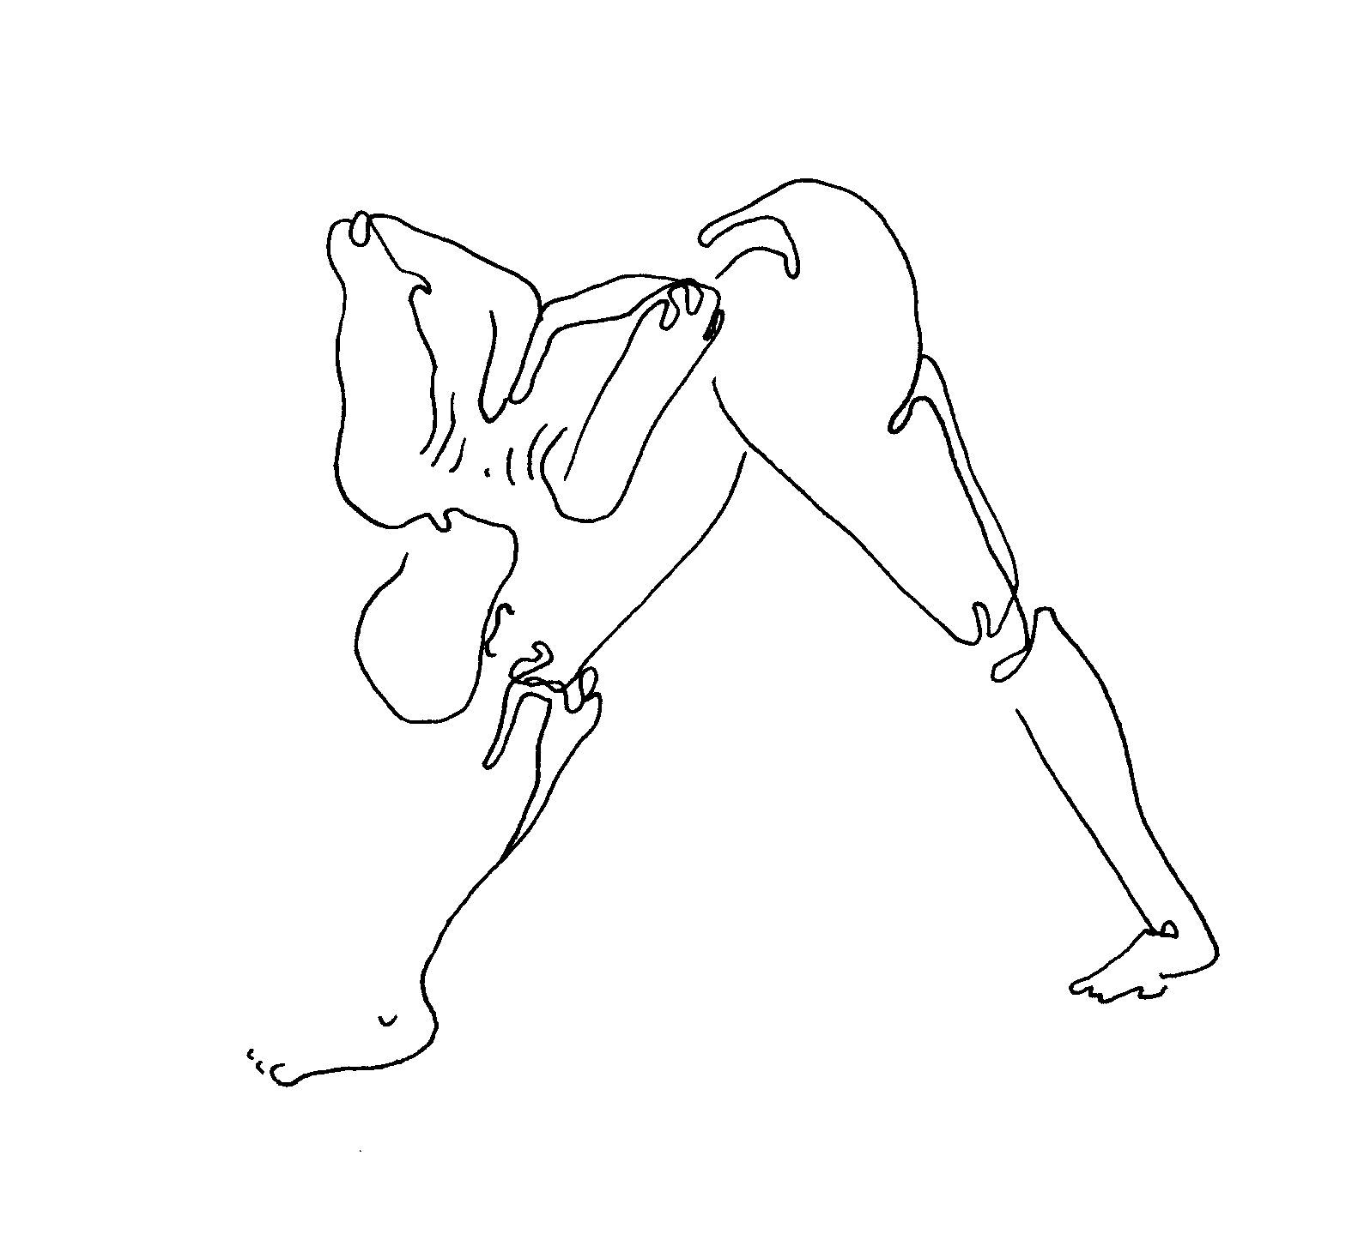
ajnaneyasana (an-ya-nay-a'-san-a) or "crescent moon." Kneel, step your right foot forward so that it's on the floor under your knee, then step it twelve inches on the floor beyond that. Let your pelvis drop by itself, drawn by gravity. Don't push -- remember non-harming, beginning with ourselves, is at the center of yoga. Intertwine fingers and hold your front knee. Feel your chest is wide, your heart is stretching. Then reach hands skyward, palms together, first above, and then behind, your head. Eyes look forward. Feel your body in the long curve of a new moon. Feel your heart is wide open. Breathe. Other side.

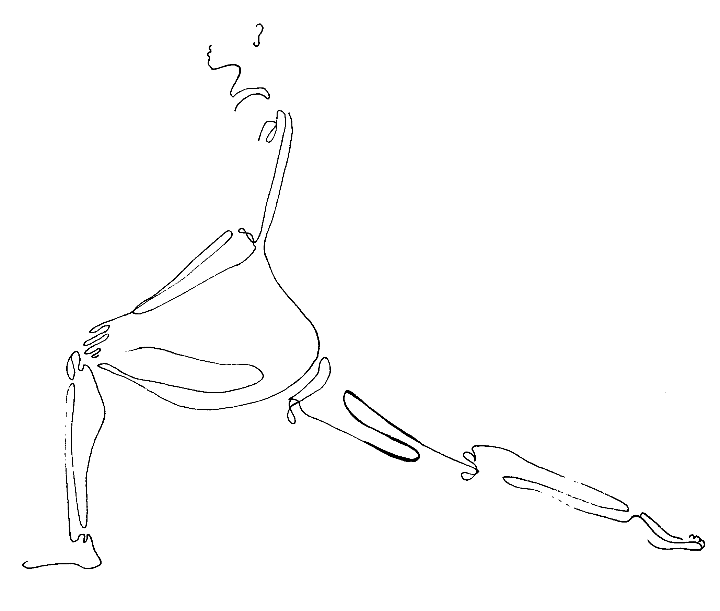

more breathing.

This is from Taoist breath tradition, probably three thousand years old.

chi gathering breath. Inhale into your heart; then exhale this air into your belly. Repeat 9x. Our heart and our belly are considered two centers of chi, or lifeforce, energy. This breath builds up and intensifies this energy so it may then spill out and circulate throughout us.

more chi gung.

tap scalp. With the ends of your fingers, tap everywhere over your scalp, feeling the sensation reach below your hair into your skull. Our skin is a vital organ of cleansing, and we awaken it to action by stimulation such as this.

move eyes. Look straight up with both eyes, as if, when facing a huge clock dial, you were focusing on the number 12. Now move both eyes slightly to the right and focus, as if on the number 1. Now focus on the number 2. And so on, moving eventually around the entire dial. Our eyes are linked to our liver.

brush throat. Tip head back and in quick succession brush your palms from chin to chest over your throat. This stimulates your thyroid gland, helping balance metabolism.

slap chest. With palms slap chest, breasts, belly, and down underside of arms, over ribs, one at a time. Unseen energy channels, in this tradition called meridians, as well as larger ones, veins and arteries, are stimulated. Feel your heart vibrate as this energy ripples inward.

more meditation.

forgiveness meditation. Forgiveness of others who we feel have hurt us, and forgiveness of ourselves for actions we regret, are difficult concepts. The weight we carry around in our hearts, keeping certain people out of them, can be huge. But how to forgive and really feel it? We can allow someone back into our heart without condoning their hurtful actions. This practice lets our heart do most of the work, so that our mind is barely involved.
Begin by feeling your heart, and breathing in and out of it. Feel its reality in your body. This is where our meditation will be centered. First, bring up an image of someone who you feel has done you wrong. This can be someone who mildly annoys you, or someone whose actions you feel have badly altered your life. Place this image of them in your heart. Let them stay there for a moment; your heart has its own healing power and wisdom. Let your heart communicate with this person's heart. Chances are that their inconsiderate action came from having been treated badly by people in their own lives, maybe when they were children.
The energy it takes you to keep this person out of your heart is much more draining on you than simply letting him or her in. Your heart has done this work for you. Now let that image fade.
Feel your strong heart. Now bring up an image of someone else, someone who you may have hurt, someone who won't forgive you. Place their image in your heart. Again, let your heart's own wisdom convey to them your desire to be forgiven. Let your heart communicate with this person's heart. Feel the softening of their heart which allows you back in. Now let that image fade.
Feel your soft heart. Now bring up an image of yourself, and see and feel it inside your heart. Many of us hold on to anger at ourselves, or disappointment in ourselves, for mistakes we made in the past. Know that we have learned from those mistakes, that we won't repeat them, but now we can let them go. Let your own heart do this letting go. Now let the image of yourself fade.
Finally, feel the power of your heart. Imagine the whole world, and put this image in your heart. Feel your heart's power to forgive all people for all of the mistakes they make, in their blindness, in their clumsiness, in their greed. Imagine the whole world interacting from a place in their hearts, just as you have been doing now. Imagine connection with everything through our hearts. And then let that image fade. Simply feel your heart. Breathe in and out of your heart. Then slowly open your eyes.

finish class. There is a word in the ancient language of Sanskrit called "bodhicitta" (bode-ee-chit'-a), which means "wise heart." In other words, it means a heart that thinks, or a heart and mind that are the same thing. Imagine how this world would be if everyone made decisions based not only on their mind or their senses, but on their hearts. This idea shows in the gesture we do at the end of class, which looks and feels like taking our hands and sweeping everything in the world together, right in front of our hearts. Namaste (to the spirit in all of us).

second class that week. Overlay of first class. May use verse as point of focus:

Out beyond ideas of wrongdoing and rightdoing
there is a field. I'll meet you there.
When the soul lies down in that grass
the world is too full to think about.
Ideas, language, even the phrase each other
doesn't make any sense.
(Jalal al-Din Rumi, c. 1200, Afghanistan)

Think of our hearts as this field.

week five.

energy flow. We are trying to open our inner body to movement, or energy flow, which we know can prevent disease or help heal illness and injuries we already have. Last week we focused on our heart, on refreshing it, and this week we will focus on our lungs. When these organs become cleaner, fresher, more supple, then they can do their jobs better. They can better pump our blood, or feed our cells with oxygen, or filter toxins out of us.
Yoga postures give us so many ways to soften inner organs or to bring energy into them. You will begin to feel, by intuition and through your own practice, how this works. Some postures press on and squeeze our inner organs. Some twist an inner organ, like the way you might wring water out of a wet sponge. Some stretch an inner organ. Some postures encourage us, when our arms or legs are reaching out in a long line, to feel energy pass through our inner organs like a rushing river. In some postures where our hand or foot touches our torso, this touch stimulates an inner organ.
Today we will focus on our lungs. Our lungs bring oxygen to our cells. See if you can feel the aliveness brought to your lungs in one of these ways each time we practice a yoga posture. Before we begin, let's just feel our lungs with our eyes closed. Feel the size and shape of your lungs as you breathe air into and out of them.

adho mukha svanasana (ad'-o moo'-ka shva-na'-san'a) or "downward dog." Kneel, with your hands on the floor directly underneath your shoulders, and your knees directly underneath your hips. Curl your toes onto the floor, then straighten your legs. Your tailbone will swing up to become the peak of the triangle-shape your body makes. Roll your shoulders away from one another and toward your tailbone. Feel your shoulder blades flat on your back. Press the entire surface of both palms into the ground. Let your heels sink as low as they want to go. If they touch the ground, imagine you are on sand, and they can sink deeper, below the ground. Breathe fully in and out of your nicely stretched lungs.

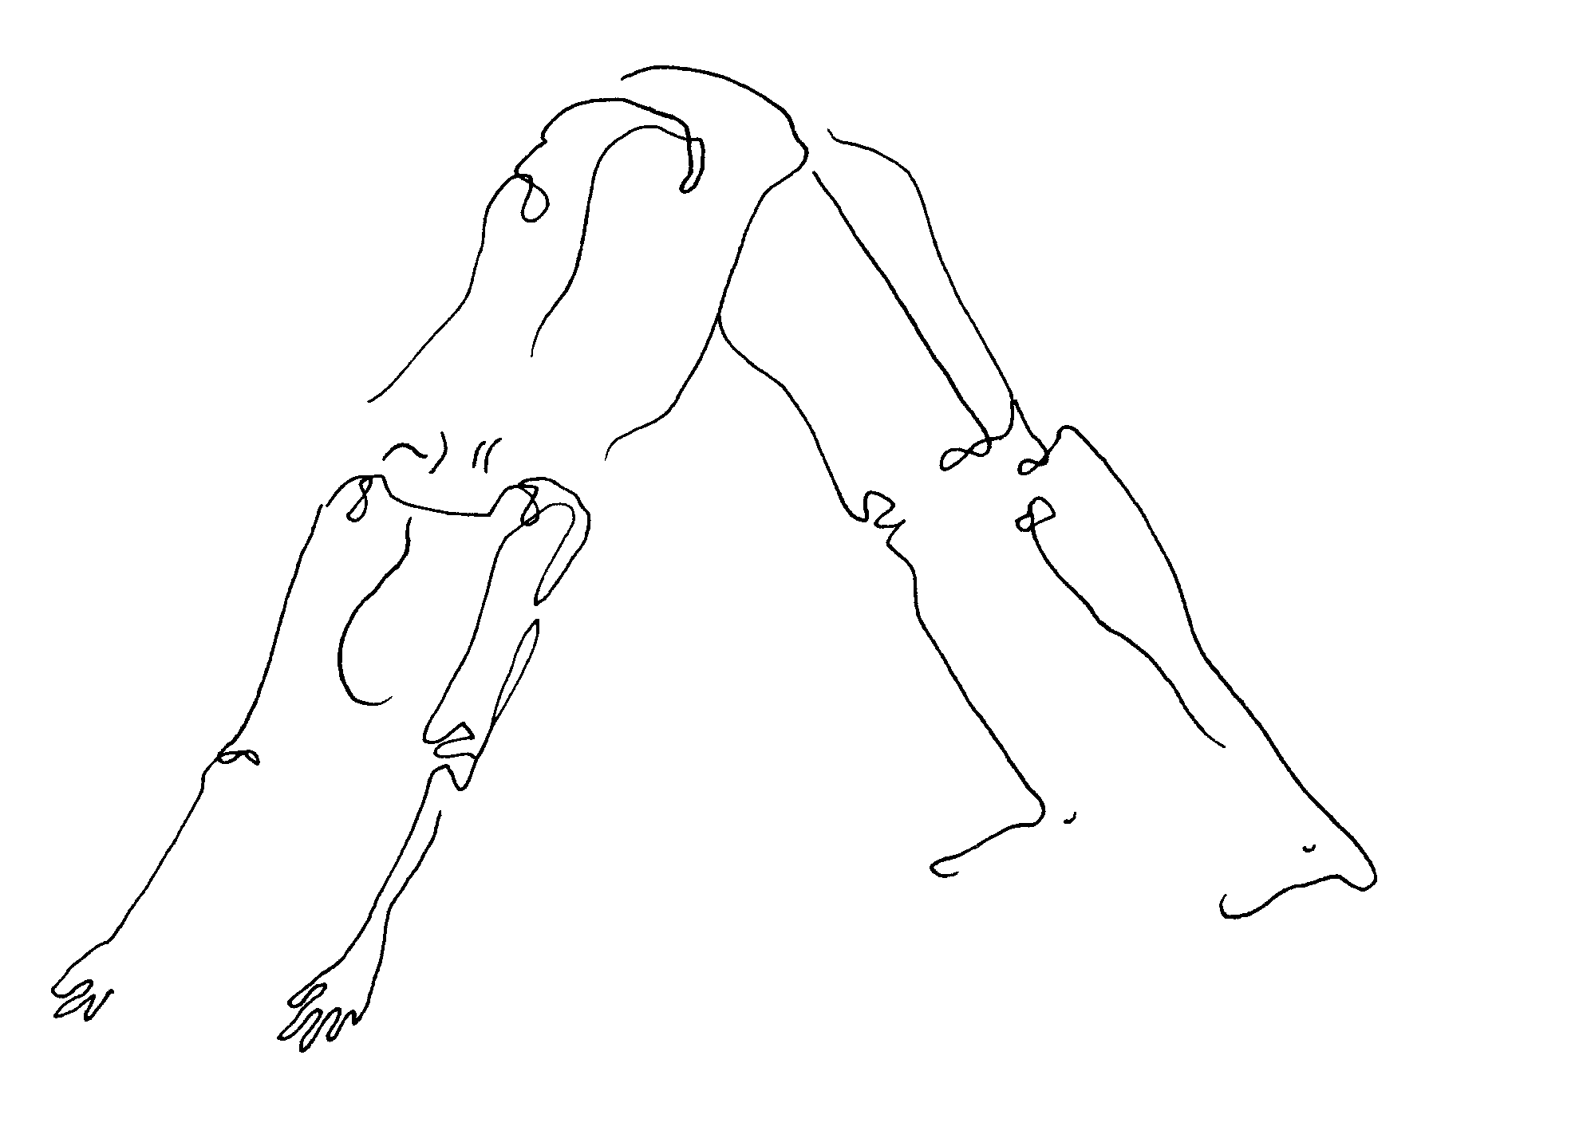

cataranga dandasana (chot-a-rong'-ga dan-da'-san-a) or "four limbed rod." Begin in adho mukha svanasana (downward dog). Swing yourself forward so that your arms are vertical, your shoulders are above your hands, and your body is long and straight. We call this "plank" position, like a plank of wood. Now, bending your elbows, lower yourself. Hug your elbows into your sides, along your ribs and lungs. Look at the ground. When you are a few inches above the ground, stop. Hold yourself in one long, strong line. Keep breathing. Feel your steady breath give you energy to go on. Then relax, and rest on the floor.

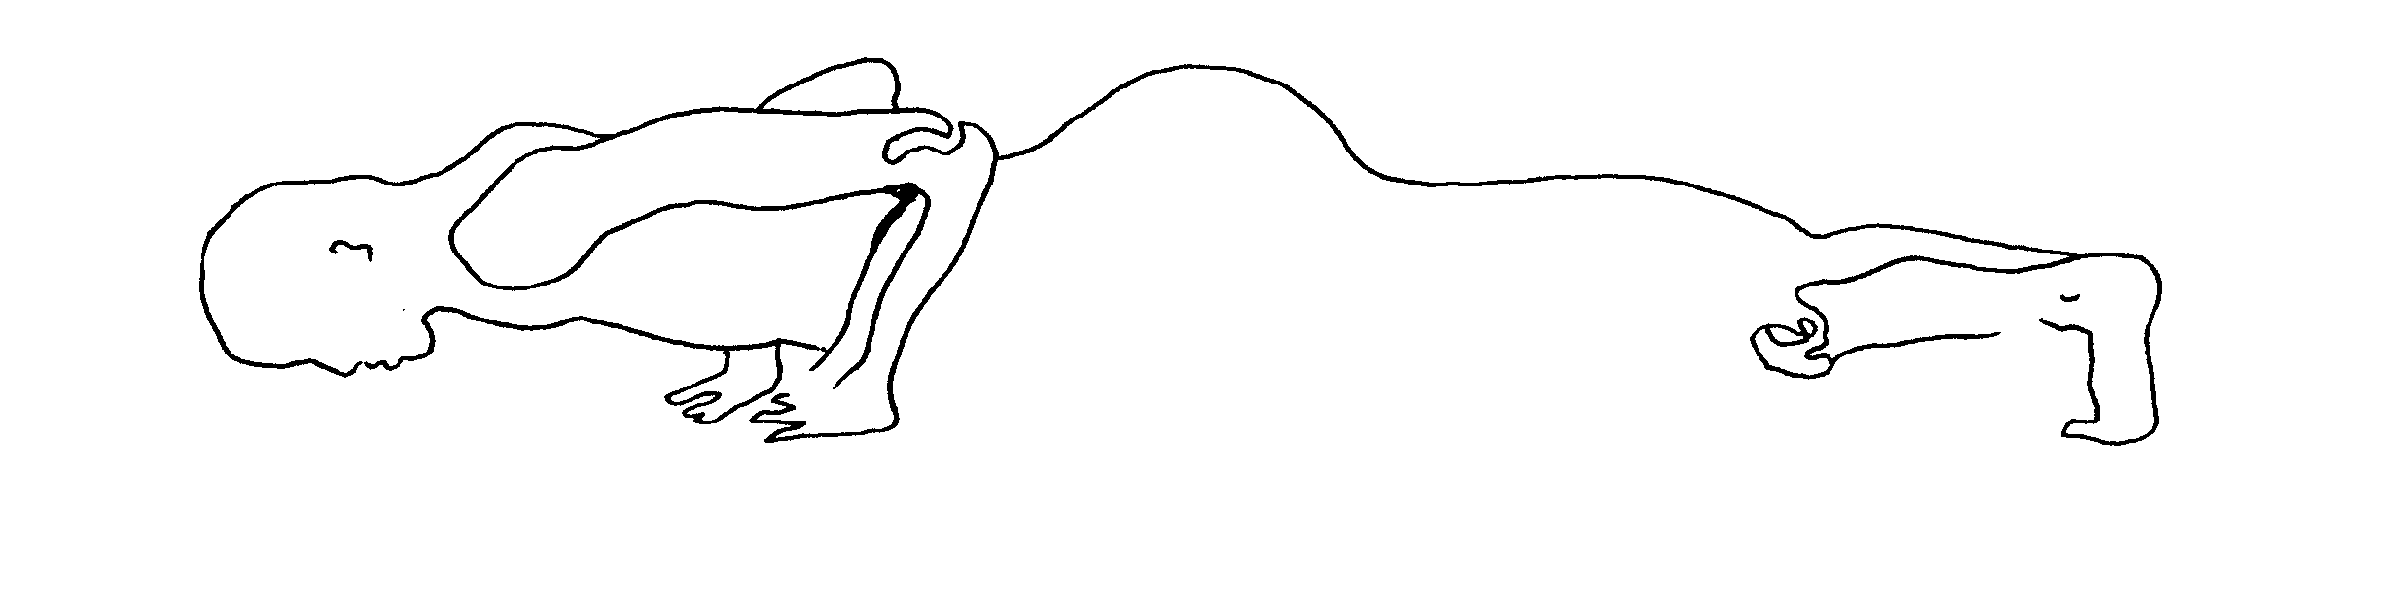

vasisthasana (vos-ee-sta'-san-a) or "sage." Begin in adho mukha svanasana (downward dog). Swing yourself forward into plank position, so that your arms are vertical, your shoulders are above your hands, and your body is long and straight. Now, roll yourself onto the outside edge of your left foot, taking your right hand off the ground. You are now facing sideways, resting entirely on your left palm, and that outer edge of your left foot. The right leg and foot lie right on top of the left. Your right hand now reaches up, palm facing forward. Your spine is long, your limbs are long, your lungs are stretched. Breathe. Come down as you got up, back down to adho mukha svanasana (downward dog). Other side.

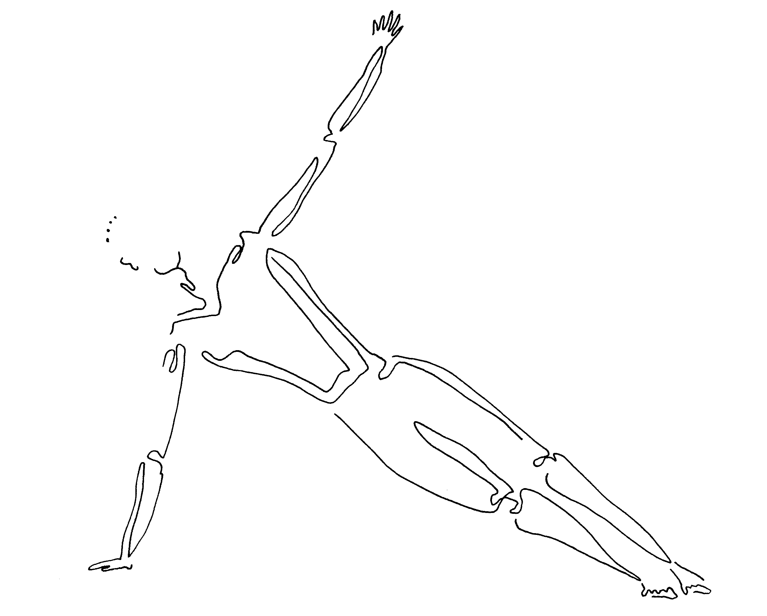

balasana (ball-a'-san-a) or "child's pose." Kneel, with your thighs parallel, or if it's more comfortable, with your knees apart. Bend forward and reach forward with your fingers on the ground. Lower your back until your forehead touches the ground. Touching your forehead like this helps our mind become still. Rest there, breathing. Feel the enormous stretch across the back side of your lungs. Feel them fill with air, and then empty.

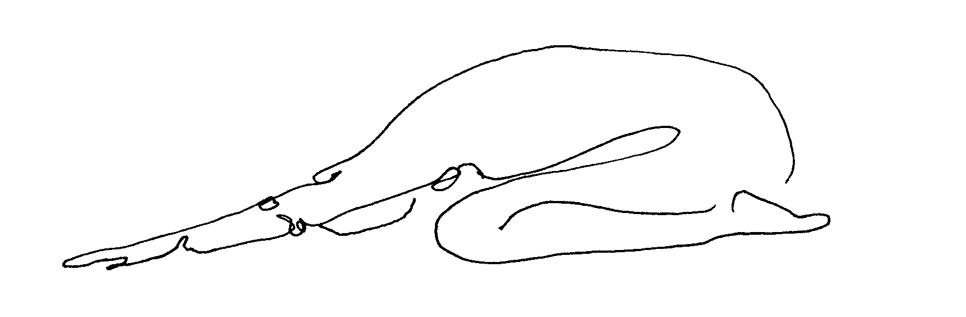

more pranayama.

ida & pingala ( ee'-da and ping-goll'-a) or "moon and sun." Here we will practice alternate nostril breathing. If you have a cold today, this may not work, so just imagine using your left and right nostrils alternately along with us. Use your right hand. Fold the fore and middle fingers into your palm and lift your hand above your nose. Rest your thumb over your right nostril, then your little fingers over your left nostril. As you breathe through one nostril now, the other will be gently closed by the finger resting above it. Inhale through your right nostril to the count of six, exhale through your left nostril to the count of six. Repeat 3x. Regular breath. Now reverse this. Repeat 3x. Regular breath.
The right side of our bodies corresponds to pingala, or sun, or masculine energy; the left side to ida, or moon, or feminine energy. You could also say that our right side is our active, physical, assertive side. And that our left is our quiet, intellectual, nurturing side. All of us, whether we're men or women, have both sides, and are at our best when both are alive and well. This work awakens and balances the two.

more meditation.

From the chi gung tradition, as from many others, comes the practice of bringing life, energy and healing deep inside ourselves with our mind. Let's try to see for ourselves how that works.
Sit with your hands resting one on each knee, palm up, and relaxed. Now begin to clench and unclench your left hand, making a fist and releasing it over and over and over. Do this at least thirty times, then rest that hand back on your knee. Feel inside of this left hand. Notice how it feels, and now, without moving either hand, bring that same feeling into your right hand. Feel your right hand.
If you felt any heat, or buzzing, or sensation at all which spread from your left hand into your right hand, you did this with your mind. Your attention began the movement of energy, and even blood, to this part of your which was laying still the whole time.

organ jewels meditation. Begin by following your breath, then breathing in and out of your heart. Imagine that each breath brings bright red light, or mist, into your heart. As you exhale, this mist is a darker red; it is dirtied by whatever needs cleansing from your heart, whether toxins, illness, or emotional pain (which in the heart may be numbness, or cruelty). After several breaths like this your heart is filled with red light and remains bright red, glowing.

Now, following your breath, breathe in and out of your lungs. Imagine that each breath brings pure white light, or mist, into your lungs. As you exhale, this mist is grayer; it is dirtied by whatever needs cleansing from your lungs, whether toxins, illness, or emotional pain (which in the lungs may be grief, or longing for someone). After several breaths like this your lungs are filled with white light and remain pure white, glowing.

Now, following your breath, breathe in and out of your liver, under your lower ribs on the right side. Imagine that each breath brings deep green light, or mist, into your liver. As you exhale, this mist is a darker green; it is dirtied by whatever needs cleansing from your liver, whether toxins, illness, or emotional pain (which in the liver may be anger). After several breaths like this your liver is filled with green light and remains deep green, glowing.

Now, following your breath, breathe in and out of your spleen, under your lower ribs on the left side. Imagine that each breath brings clear yellow light, or mist, into your spleen. As you exhale, this mist is a darker yellow; it is dirtied by whatever needs cleansing from your spleen, whether toxins, illness, or emotional pain (which in the spleen may be worry). After several breaths like this your spleen is filled with yellow light and remains bright yellow, glowing.

Finally, following your breath, breathe in and out of your kidneys, under your lower ribs on your back. Imagine that each breath brings clear blue light, or mist, into your kidneys. As you exhale, this mist is a darker blue; it is dirtied by whatever needs cleansing from your kidneys, whether toxins, illness, or emotional pain (which in the kidneys may be fear). After several breaths like this your kidneys are filled with blue light and remain bright blue, glowing.

Now as you return to following your breath deep into your belly, imagine your five major inner organs glowing like jewels within you. Your heart is a ruby, red; your lungs are diamonds, white; your liver is jade, green; your spleen is a topaz, yellow; your kidneys are lapis, blue. Feel the vibrancy, and the preciousness, of these jewels, your inner organs.

finish class. Namaste (to the spirit in everything).

second class that week. Overlay of first class. May use verse as point of focus:

Pain plants the flag of truth within a rebel fortress.
(C.S. Lewis, 1944, England)

Often, attention to our suffering allows us both insight into parts of ourselves we have walled away, and, ironically, dissipation of that pain.

week six.

ancient medicine. Thousands of years ago, all around the world, different groups and cultures of people practiced their own versions of very simple medicine. These many versions weren't so different after all. All were based in treating the whole being of a person, a person's body, their mind, and their spirit, altogether. All acknowledged that we humans are part of nature and that we can learn a lot from plants and animals and rocks and oceans. All recognized the importance of including wisdom and power that is beyond human comprehension. For some, this took the form of the wisdom of plants and animals. For others, it was a divine being, a god or goddess. For others still, it was the unnamable connection between all things in the universe. When we work with "prana," or "chi," we are including this more-than-human power in our own practices and in our own body.
Today, surgery for injuries and illnesses is very common. So is the use of chemical formulas in the form of pills. Both are very expensive. Both, while helping one particular aspect of our illness, may harm our body in other ways. For example, our skin must be cut and sewn for surgery. And every pill has its "side effects." Also, both surgery and pills focus on the symptom of our illness, say a tumor or an ache. Ancient medicine believes that deeper than that symptom, there are roots of that illness. And those roots affect our whole being in some way and can best be healed by addressing our whole being.
Long before surgery, before chemical pills, even before acupuncture or herbal medicines, was healing that fit right into the way people lived each day. Their choice of food was their medicine, and their choice of how to move or rest their body was their medicine. Their connection to nature's seasons and to their own sense of spirit was their medicine. This class is about getting back to that kind of medicine. It is so based on intuition, on what we already know deep inside us, that most of what we need to do is re-awaken that intuition.
Think of how welcoming this kind of healing is. No painful treatments, no high medical costs. And in the process, we strengthen our belief in ourselves, and in our knowledge of our own body and emotions. So ultimately, though healing help from other people is nice, we don't have to rely on it. And ultimately, we know enough to help other people in our lives to empower themselves. Maybe this will be our family, and maybe we can think of widening our 'family' -- those we help -- to include others. Others could be the teens in our neighborhood we see heading for trouble, or other inmates here who are in pain, or the elderly in our communities outside who seem so forgotten.
Now for some of us, our modern medical care feels necessary and comforting, and this is fine; no need to abandon that. Here we are simply increasing and feeding our own abilities to balance or heal our physical and emotional selves. This can work hand-in-hand with modern medicine as well.
Ancient healers knew also that deep healing requires faith, persistence, and often time. That, in the case of illness in our physical body, its healing requires that first we go right to the center of what hurts or is diseased, as we have been doing, for example, with the twisting and stretching of yoga, and the mind travel of meditation. Second, the healing requires that the ill energy exit our body, and that on its way out we will probably experience an intensification of pain or painful emotion. This is called "discharge" or a "healing crisis," and may be a headache, fever, trembling, or fear, bad dreams, anger. This is the point where many people quit, and think things are getting worse. If, at this point, you reach for a pain pill, as so many television commercials tell us to do, you will slow the healing process. Instead of the ill energy exiting your body, it will be stuffed back down inside the organ where it has been trapped for so long.
In the case of illness in our emotional selves, our depression, our anxiety, our addictions, this healing process is much the same. The meditations we will move into next week allow us to go right to the center of what hurts us emotionally, by simply becoming aware of it. And just as this releases ill energy physically, it also starts to diffuse ill energy emotionally. Before it will leave us, though, we need to look right at it.

We've been working for several weeks now on familiarizing ourselves with our inner organs. This week we will focus on our liver. Our liver stores fat and cleans our blood. Let's go to our liver with our mind. It sits on our right side, tucked somewhat under our ribs. It is big and heavy. Feel it. Breathe in and out of it.

more yoga.

salabhasana (sha-la-boss'-an-a) or "locust." Lie on your belly, hands reaching out in front of you on the ground, palms down. Looking forward, lift your chest up off the ground. Now lift your pelvis and legs up off the ground. Your toes are stretched behind you, your fingers reach in front of you, and your liver is pulled in two directions at once. This energizes it. Feel the equal curve your entire body makes. Breathe. Relax and lower your arms and legs to the ground.

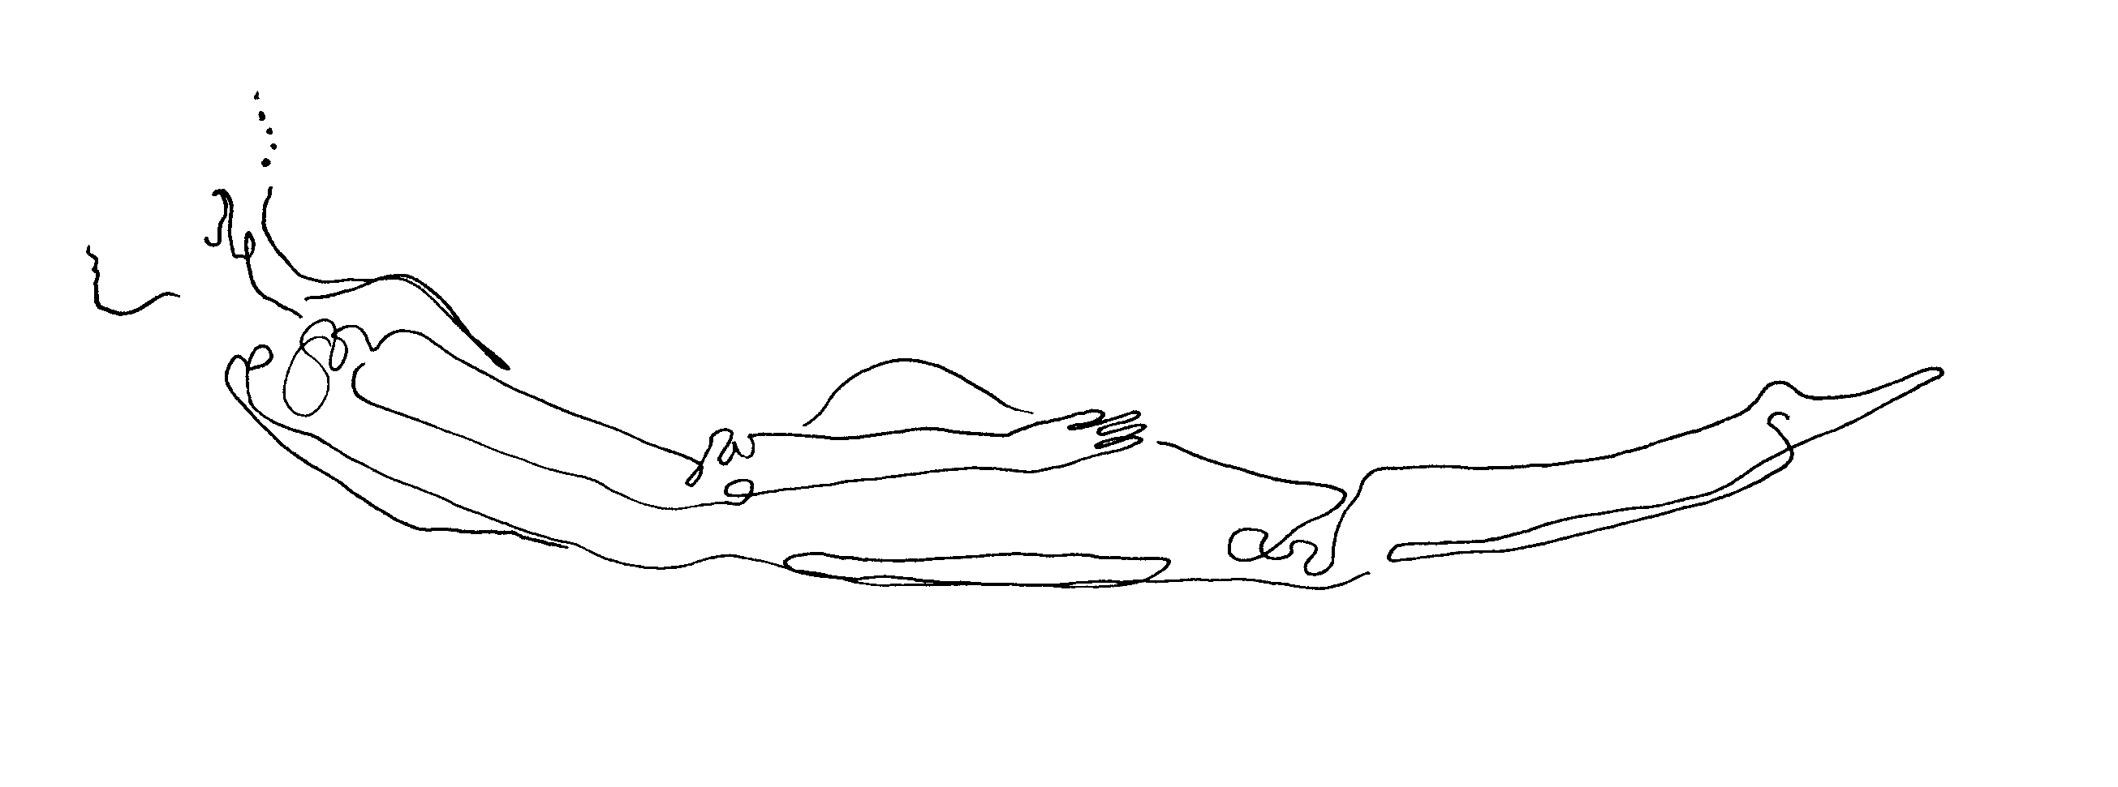

urdhva mukha svanasana (erd'-va moo'-ka shva-na'-san'a) or "upward dog." Lie on your belly, feet and toes outstretched. Bend your elbows and place palms alongside your chest on the ground, fingers facing forward. Look forward. Now straighten your arms, rolling your shoulders back, and widening your chest. Except for the tops of your feet which rest on the ground, there may be a slice of air underneath your legs. If holding yourself this way is too much, let those legs rest entirely. Breathe.

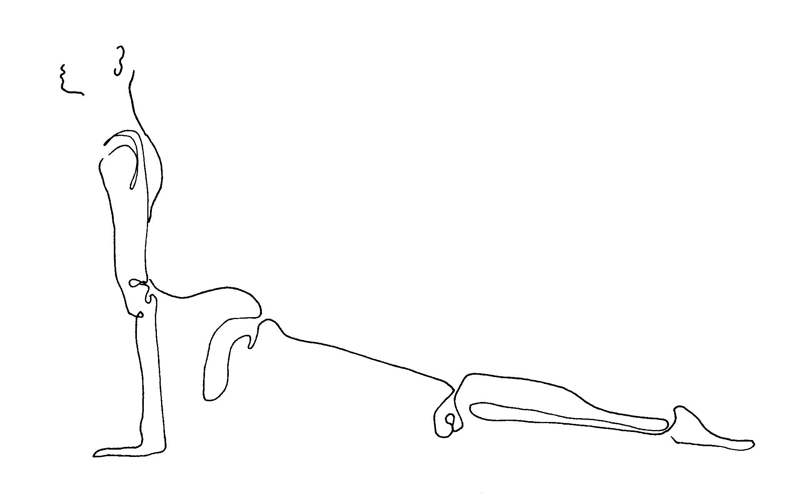

bhujangasana (boo-zsang-ga'-san-a) or "cobra." Lie on your belly on the ground, feet and toes outstretched. This starts much like urdva mukha svanasana (upward dog), but results in a more intense backbend. So at this point, place your palms on the ground just alongside your waist. As you straighten your arms this time, your legs will remain on the ground. Now, gently, straighten your arms. Let your eyes travel, as your back takes on a very deep curve. Look up toward the sky. Shoulders are back and low, chest is very wide. Breathe. Feel your liver stretched.

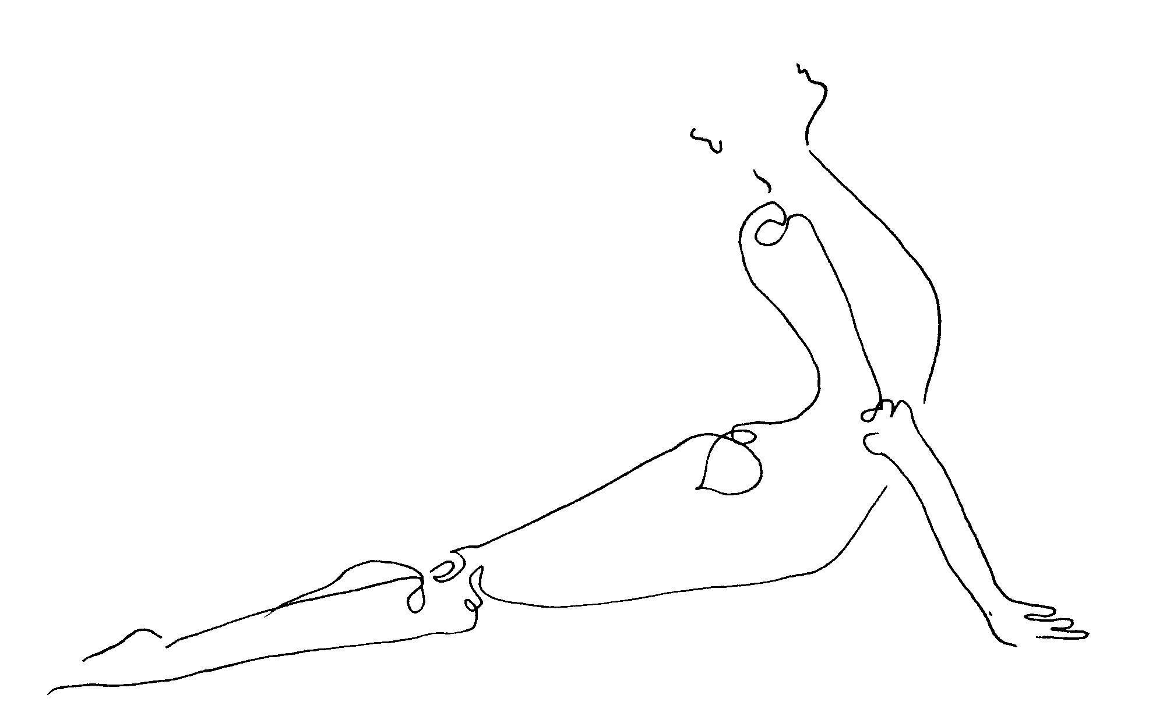

jathara parivartanasana (zsa-tar'-a par-ee-var-tan-a'-san-a) or "belly twist." Lie on your back, arms outstretched at a right angle to your body, palms down. Bend your knees, your feet on the ground, heels up close to your sit bones. Cross your left leg over your right thigh. Keeping your back and arms on the ground, let your legs tip together over to the right, as far as they would like to go. When they stop moving, you may feel that your left shoulder blade is well off the ground. Lift your whole upper back slightly off the ground, twist your upper body a little more deeply, and then let it gently re-settle. Now your shoulder blades should feel more balanced, closer to the ground. Turn your head to look out over your left hand. Breathe, and feel your liver squeezed as it twists like this. Our liver is like a sponge that hardens with dirt over time. Now we are twisting it clean. Feel the toxins, old alcohol, old fats, loosen. As you untwist now, feel your liver refreshed. Other side.

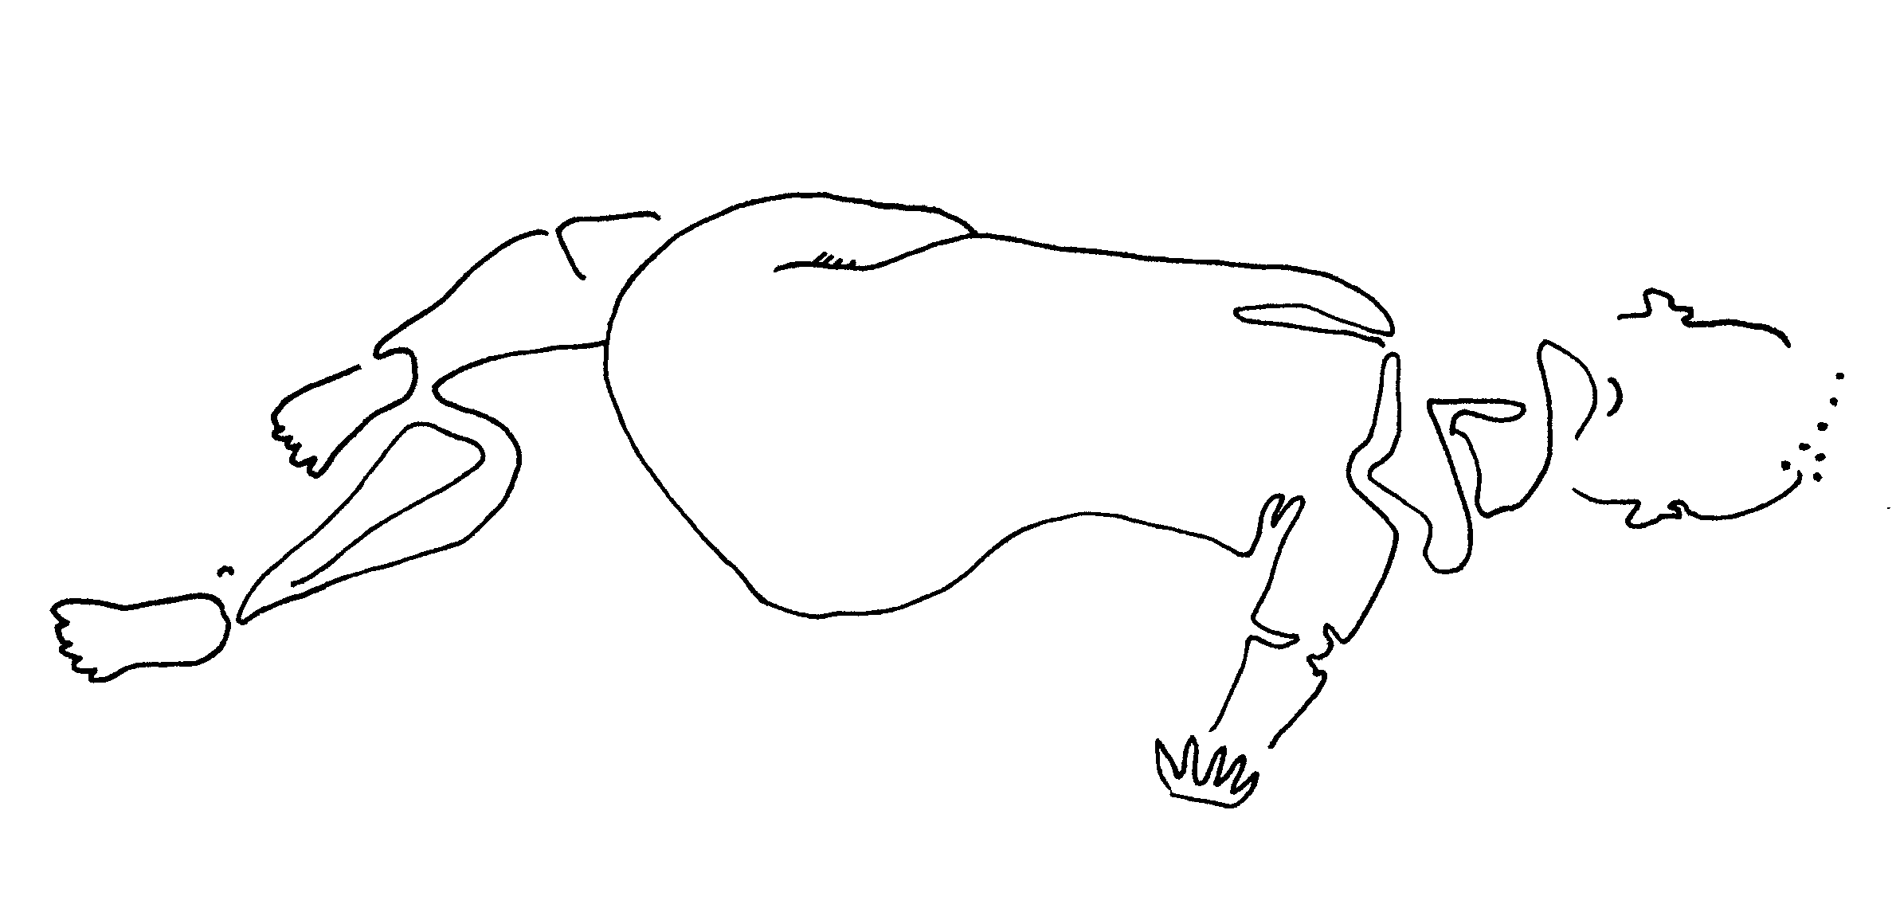
more pranayama.

kapalabhati (ka-pall-a-bot'-ee) or "breath of fire." Breathe quickly in and out, emphasizing your out-breath, with your belly acting as bellows to force are and energy out of the nose. Try for twenty or thirty breaths. Then in stillness notice how you feel. Next time, add ten more breaths to your count.

more meditation.

Meditation helps us feel our center, which is more timeless and constant than the events of our life or even our thoughts. Meditation teaches us, over time, that although our thoughts are nearly continual, we can learn to let them come and go without consuming us. Meditation helps us connect with, be mindful of, the physical and emotional and mental parts of ourselves without getting caught up in any one of them for very long. Our practice of choosing not to be carried away by our thoughts and feelings frees us from quick reactions to them, which we may later regret.

simple meditation, in three stages.

1. Sit comfortably. Close your eyes, or gaze at the floor. Follow your breath. Come back to your breath each time you are distracted by a thought, noise, feeling or body sensation. A body sensation is anything like an itch or an ache you may feel. We will keep this focus now for two minutes. (At the two minute mark): Now we will add something to the practice we have begun. You're welcome to open your eyes gently for a moment now as I explain, or to simply keep them closed.

2. Continue to follow your breath. When you realize that your mind is on a thought, feeling, body sensation or noise, rather than on your breath, silently say to yourself "thinking." We can include all types of distractions under the label "thinking," as it is our mind that moves to notice them. Thinking isn't bad or good, it's just something to notice in yourself. Notice how often you are thinking. We will practice this now for two minutes. (At the two minute mark): Now we will add one more thing to our practice. You're welcome to open your eyes gently for a moment now as I explain, or to simply keep them closed.

3. Follow your breath. Acknowledge when you are "thinking." If it helps you to notice and silently label for yourself the type of thinking you are doing, you are welcome to do that. For example: "planning," "wishing," "anger," "worry," "joy," itch," "ache," "hearing noise outside," "smelling food." Alternately, keep it very simple and say only "thinking" for everything. These thoughts, emotions, noises and sensations aren't bad or good. We aren't trying to get rid of them. Instead we just want to notice them, to notice our patterns of thinking and feeling. We do this both to know ourselves better, and to see how easy it is to get wrapped up in obsessing about a distraction -- which results in losing our present-moment awareness, losing our soothing center. We will practice for two final minutes. (At the two minute mark): Please let your eyes open gently. Notice your steady breath.

Over time, as we practice this, you may notice your patterns of thought, and also how you can choose whether to participate in that thought or not. Look at each thought as a cloud passing briefly over the sun, which is you and your breath. That cloud is only temporary and will pass on if you let it.

finish class. Namaste (to the spirit in all of us).

second class that week. Overlay of first class. May use verse as point of focus:

Do we relate to our circumstances
with bitterness or with openness? …
Whatever occurs can be regarded as the path and …
all things, not just some things, are workable.
(Pema Chodron, 1997, United States)

Think of how our illnesses, our life tragedies, can provide exactly the invitation inward that we need.

week seven.
centering (and mindfulness). Centering means focusing in the present moment. Mindfulness is another name for the same thing. Such focus will get stronger as we practice. Our inner focus can bring all the parts of our mind that are moving farther away from us, off into the past or future, back inside of us. We are the center of these thoughts, and the more we learn to bring our mind back to join our body, here in this room in this present moment, the more integrated and whole we become. Some of us, when we experienced danger or extreme difficulty in our lives, maybe as children, learned that the only way to handle it was to let our minds leave our body. Our imagination may have been the only comfort we had in bad situations. Here, though, we are safe. It's time to let our mind come home to our bodies. This is centering, or mindfulness. This is where inner peace can begin.

You've heard me mention body, mind and spirit. So where does this spirit come into centering? How do we control spirit? One yoga master, a man named Iyengar, says that we don't consciously bring spirit into ourselves. He says that when our body and mind are working in perfect focus together, our spirit appears. Our centered mind and body create a home where spirit can live.

Centering is something we can do continually, throughout all of the practices we do in class. When it becomes familiar, then it's something we can do all day outside of class as well, whether we're doing chores or handling a crisis. When we approach even a daily task from a centered place, it can become more meaningful, a place to practice excellence in all we do. When we handle a crisis from a centered place, we can utilize our whole selves to meet or solve this problem, our body and mind and spirit altogether.

For today, we will center ourselves by following our breath throughout class. If our mind follows our breath, it will return again and again to our body. When your mind does wander, though, and you forget about your breath, don't worry. Simply come back to it when you can.

We've been working for several weeks now on familiarizing ourselves with our inner organs. This week we will focus on our spleen. Our spleen cleans our lymph system. Let's go to our spleen with our mind. It sits on our left side, tucked somewhat under our ribs. It is much smaller than our liver is. Feel it. Breathe in and out of it.

more yoga.

kneeling garudasana (gaar-oo-da'-san-a) or "eagle." Begin by kneeling on the ground, or if this is uncomfortable, sitting in any way you can. Center yourself with your steady breath. Lengthen your spine, though your shoulders stay low. Lift your arms straight out in front of you and bend your elbows so that your hands reach up, palms toward your face. Now cross your right upper arm as tightly as you can below your left upper arm. Let your lower arms continue the spiral twist that has begun, wrapping around one another until your palms, or fingers touch. With your arms wrapped together like this, lift them upward. Feel the nice stretch across the muscles of your upper back and neck. Remember this one when you wake up with a kink in your neck someday! Center with your breath. Untwist your arms now, and re-twist them the other way.
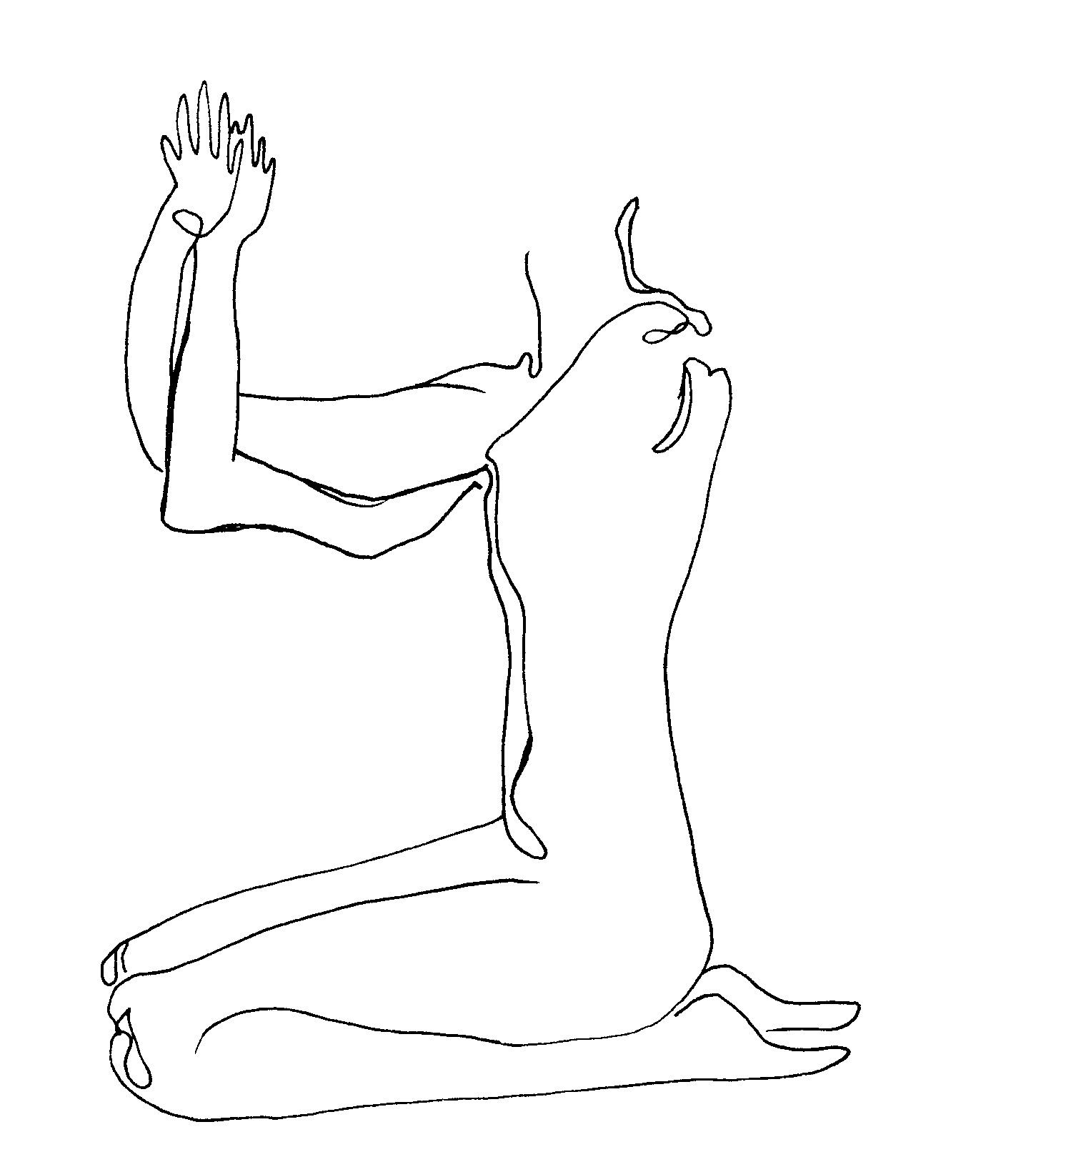
setu bandha (set'-too bond'-a) or "bridge." Lie on your back, arms palm down at your sides, knees bent, feet on the floor hip width apart, and near your sit bones. Center yourself. Take your mind inside your spine. Beginning with the base of your spine, press it first into the floor and then lift it skyward. You will feel the bones of your back, your vertebrae, rolling up sequentially, until your belly is lifted fully. Stay here. Breathe. Roll each back bone down again, feeling the flexibility of your spine. Practice 3x.
Later in this class or another day you can include your arms in this way: first time, roll your back up, then down, with arms at your sides; second time, roll your back up, clasp your hands underneath your back and reach them, touching the ground, down toward your feet, shoulders back, release; third time, roll your back up, clasp hands, then with upper arms rooted to the floor unclasp hands, bend elbows, and support your back with your palms, fingers facing your spine and thumbs at your waist, release.

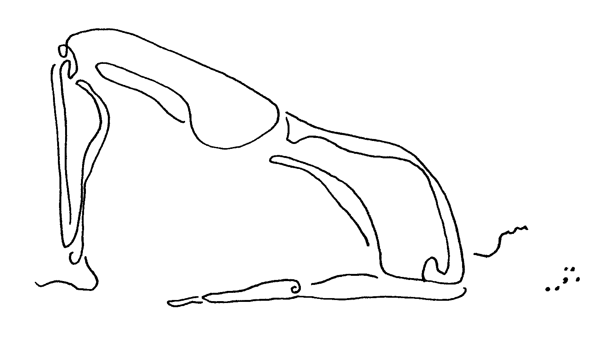

belly massage. This is a practice taught to me by my first yoga teacher which takes us into our inner belly organs through the pressure of our own fingertips. Besides softening these inner organs it can help unblock energy, lymph fluid, or even digestion that is stuck. This kind of practice helps take the mystery out of our own bodies, so that we no longer have to rely only on doctors or x-rays to tell us where we need healing. This belly massage also centers us in our belly, which is the core of our energetic self according to many ancient cultures.

Lie on your back, feeling your body (your shoulder blades, your legs, your arms) balanced, left to right. Place the fingertips of both of your hands over your liver. Press into your liver, making small circles on it with your fingertips. Press hard enough to really feel the pressure, yet not enough to make it uncomfortable for yourself. Remember, non-aggression, starting with how we treat ourselves, is at the center of our practices. You may feel a little ache, or nausea, as toxins are released from your liver. This can be a sign that you got something moving that was stuck.
Now move your fingertips over slightly to the left. Press into your belly there, making little circles as your intestines are massaged. Now move your fingertips further to the left. And press. Soon, you'll come to your spleen. Press deeply enough so that you feel this inner organ. Steady breath. And then continue to move your fingertips around the wide circle that is your outer belly, pressing with circles every few inches, and breathing steadily. Imagine that whatever toxins or stiffness your pressing releases are washed clean with your steady breath.
As you move around the left of this circle you'll trace parts of your small intestine. As you reach the lower half of this circle you'll push into your reproductive organs, your prostate or ovaries. As you climb again with your fingers up the right edge of the circle you'll massage your large intestine. And as you reach your liver once again, move your fingertips inside of the first path they traced, to begin a spiraling path slowly toward the center of your belly.
On this spiraling path, your fingers will reach into and feel your stomach. And more and more of your small intestine. Your breath is steady, adding softness or relief to places that are hard or sore.
Finally, your fingertips end up in the center of your belly, on your belly button (or navel). Lay your hands over this place and breath into this part of you, your center in this practice. Feel the power of having your mind and your hands and your breath all be working together, and focused on your belly.

more meditation.

three-minute breathing space. Sometimes we need a meditation which centers us, and at the same time we know is very brief. Here's one which takes just three minutes … and is an array of mindfulness practices now used even in modern clinics to help people find relief from depression or anxiety or substance abuse or chronic pain. After thousands of years of existence, many ancient healing practices are now being noticed by the medical world of doctors and psychotherapists who find that they help people heal and feel better. This next one was outlined in a book by some doctors (Segal, Williams & Teasdale, 2002), and I am putting it into my own description.

This practice has three parts, and you don't need to time them, but rather estimate a minute for each part.

The first part, or minute, is called "awareness." Sit tall. Close your eyes or look downward at a spot on the floor, and ask yourself, or become aware of:
"What am I thinking right now?"
"What am I feeling right now?"
"What are my body sensations right now?"

The second part, or minute, is called "gathering." Here you simply gather all of your attention onto your breath. Attention on your breath means attention on the present moment; it means centered attention.

Then the third part, or minute, is called "expanding." Let your attention expand from your breath, outward, to sense your entire body.

Now open your eyes and look up again. That's it.

The simplicity of this one means it's easy to weave into any part of your day, whether you are alone or around other people. Try it several times a day, both when you feel good, and also when you don't feel good. See if it may help calm anxiety, or lift you a bit out of a depressed mood or drug craving.

finish class. Namaste (to the spirit in everything).

second class that week. Overlay of first class. May use verse as point of focus:

The Master observes the world
but trusts his inner vision.
He allows things to come and go.
His heart is open as the sky.

.........

Nothing in the world
is as soft and yielding as water.
Yet for dissolving the hard and inflexible,
nothing can surpass it.
The soft overcomes the hard;
the gentle overcomes the rigid.
Everyone knows this is true,
but few can put it into practice.

(Lao Tzu, c. 500 B.C., China)

These lines speak of centering, of the quiet power of nonviolence, and of the strength of the softness we aspire to inside ourselves.

week eight.
our most vital inner organ. In ancient Chinese medicine, our kidneys are seen as the center of our health. When they are vibrant, our health is good; when we suffer anywhere in our body, be it from headache, sore joints, or cancer, we must strengthen our kidneys to help dissipate this illness. The kidneys are considered to be 'keeper of our life force.'

Our kidneys filter toxins from our body, and are likewise worn down or clogged over the years by this process. These toxins range from pollutants we breathe in, to foods sprayed with chemical pesticides, to drugs we buy on the streets or in pharmacies. Sugar is damaging to the kidneys over time. So is extreme cold. Our kidneys also maintain our internal water metabolism. Maybe you have heard that our bodies are in large part water. So you can understand that keeping this water system balanced and clean is crucial to our health.

With our kidneys, as with each of the five major inner organs we've focused on in past weeks, there is always much we can do to heal ourselves. And in healing ourselves, we understand how we might help others who suffer from pain or illness.

Let's start by going into our kidneys with our mind. They sit just below and behind our lower ribs on our back. Breathe into and out of them. Feel their compact size and shape.

more yoga.
maricyasana (mar-ee-chee-a'-san-a) or "sage twist." Sit with your legs forward and bend your right knee upward, that heel on the floor close to your body. Plant your right hand on the floor behind that hip, fingers facing behind you. Stretch your left hand skyward, stretching, too, your spine. Imagine the base of your spine, your tailbone, as the root of a tree in the earth. From that place follow your spine upward as you turn slowly to the right, twisting that tree trunk gently. When looking out to your right side, lower your left arm outside of the bent knee, catching there to give you more leverage in turning. Feel and visualize the twist rising in your spine, the growing tree. Finally feel the twist in your neck and head; look over your right shoulder to see behind you.
Breathe into your belly. Feel your kidneys like planets in orbit around your spine, your right kidney moving backward, your left kidney moving forward. Both are squeezed. Release the twist; feel inner organs refreshed. Other side.

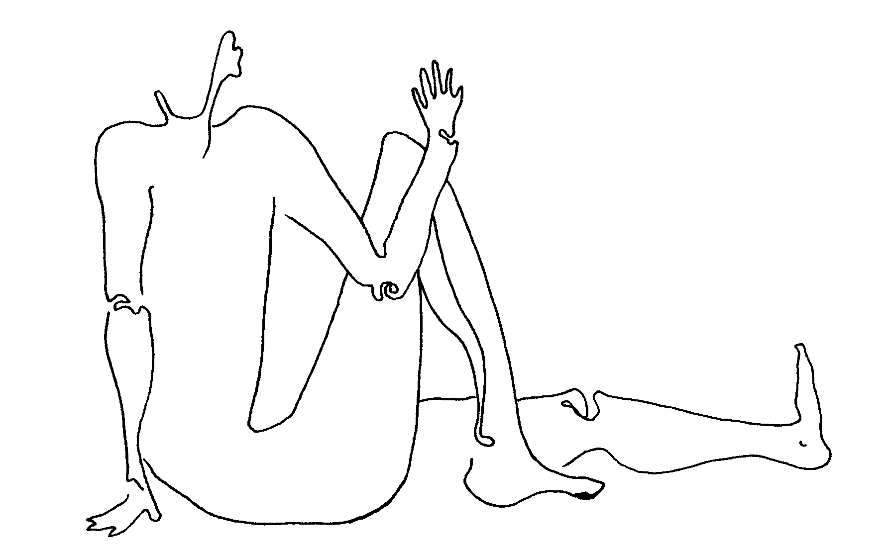
halasana (hall-a'-san-a) or "plow." Lie on your back, arms at your sides with palms down. Press your arms into the ground to lift your legs and hips up and over your head. This doesn't work for everyone, so please remember to do what's comfortable for you. If your legs come over your head, you may intertwine your fingers and stretch them away from your body. You may rock yourself slightly from side to side to ease your shoulder tops more securely underneath you. Now release your fingers, bend your elbows, and place your palms on your back, right over your kidneys. This supports you in many ways. Feel the warmth in your kidneys. Breathe.

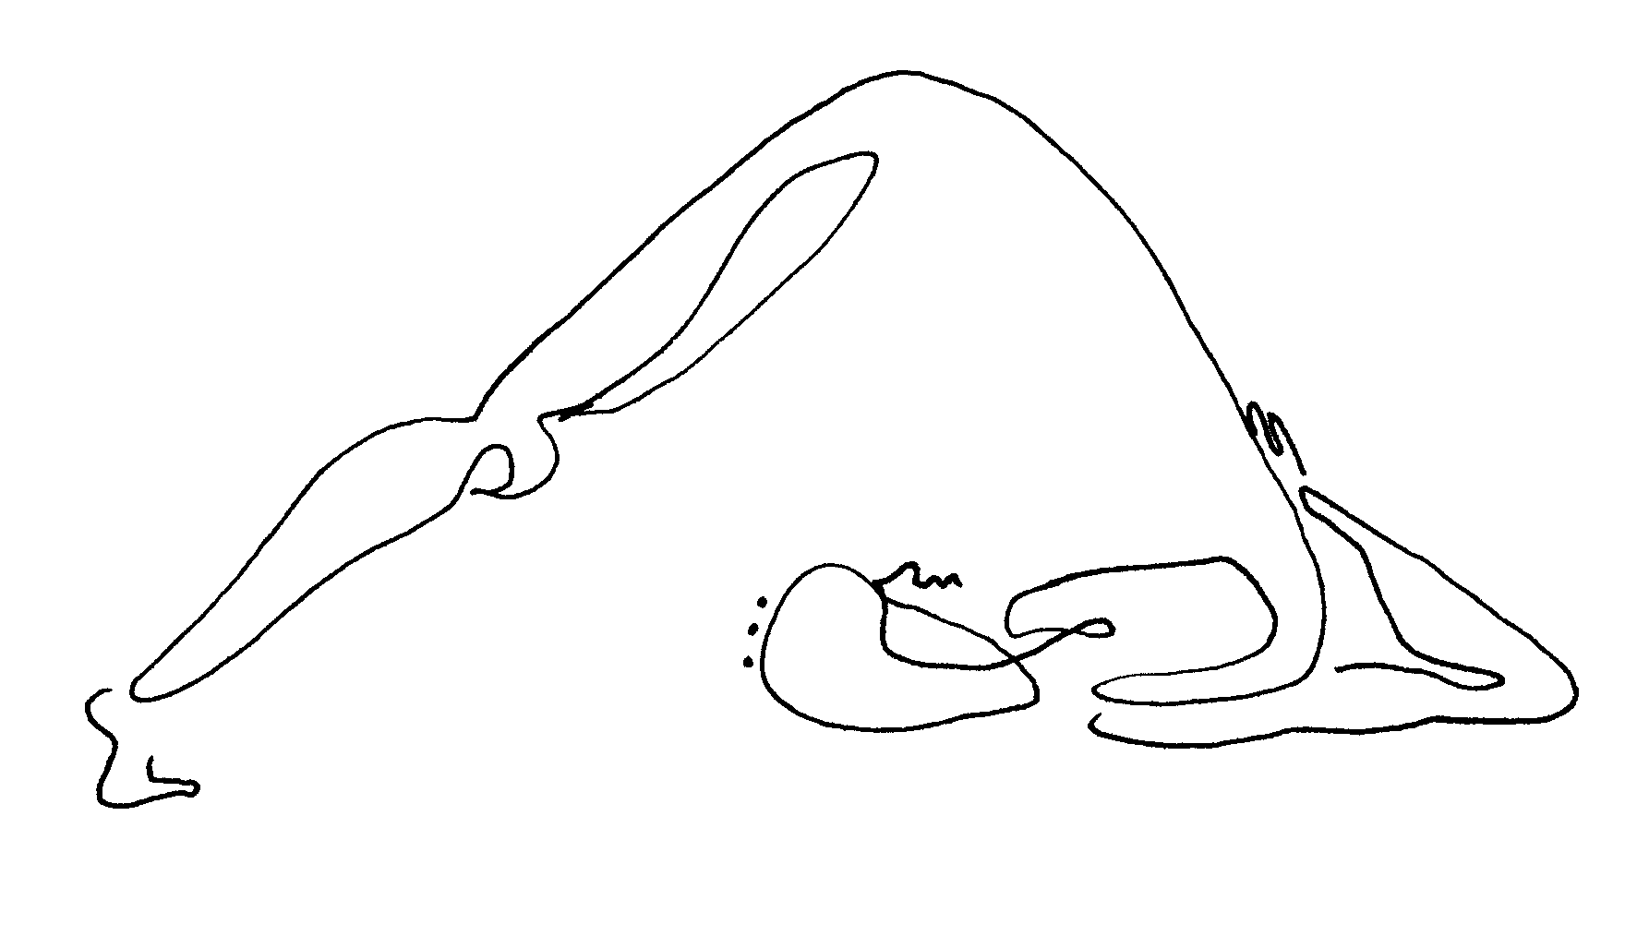

sarvangansana (sar-vang-ga'-san-a) or "shoulder stand." Come into halasana (or plow). Try to rest as squarely on your shoulder tops as possible; they will be the base for your airborne bones. Your base is also in your arms as they support your back. Try to keep your upper arms parallel to one another. Now lift your legs together until your feet soles reach for the sky. Gaze at your heart. Feel blood flow into your chest and head. Feel your strong kidneys against the palms of your hands. Breathe. When ready, drop your feet over your head once more, back into halasana (plow). Take your hands off your back and reach them overhead on the ground. Now slowly lower your legs, together, to the ground. Breathe steadily.

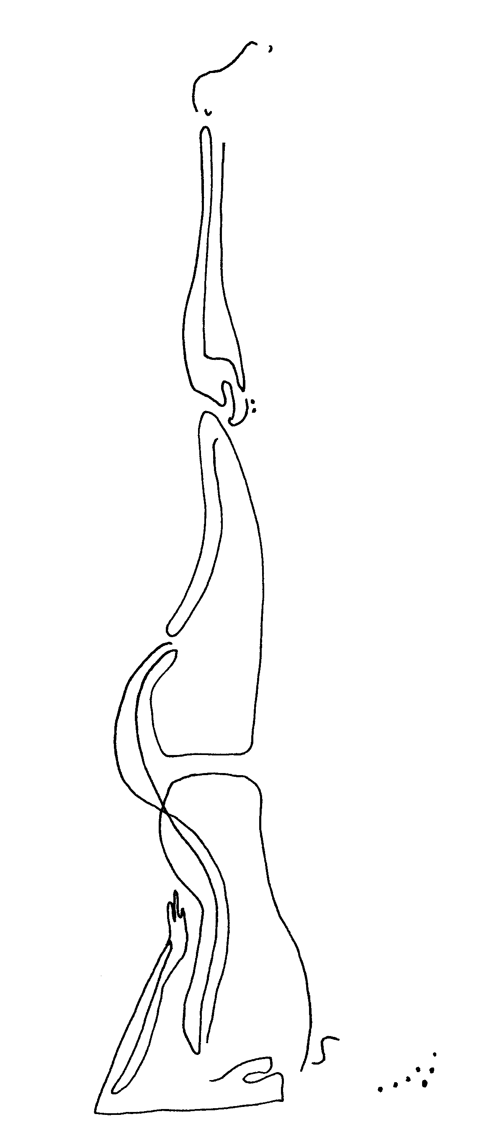

more chi gung.
rub neck. With your right hand under your left palm, rub the back of your neck until you feel heat sink into your skin there. Now switch the layering of your hands so that your left hand is under your right. Rub again. The heat that sinks beneath your skin energizes the many meridians, or energy channels, that are bundled along the back of our neck. Remember how these meridians access your inner organs and bring life deep inside them.

beat the heavenly drum. Hold your hands in front of you and practice for a moment snapping your middle finger over your fore finger. Now hold your palms tightly over your ears, fingers facing back, and snap your middle finger over your fore finger onto the back of your neck. You'll hear an internal drumming sound. Feel and listen to this inner vibration. The ears are a path to the kidneys; this vibration is sent right to them. After 18 beats stay still. Listen to the quiet.

warm the ears. Pull on your ear tops; pull on your ear edges to both sides; pull on your ear lobes downward. Make a 'V' of your fingers and rub the side of your head (with your ears inside of those 'V's) until heat is felt. Your kidneys receive that heat.

kidney fire. With your hands in fists, rub the skin directly over your lower back ribs and kidneys. Feel heat arise and sink in. Remember that cold can damage our kidneys, and heat, like this, can heal them.

hold the ball. Your left hand, palm up, sits in your lap. Your right hand, palm down, floats twelve inches above it. As if the energy radiating from your belly is tangible, hold this unseen ball. Then roll it, by orbiting hands, with palms facing center, around this space.

more meditation.
Some people feel an immediate effect of meditation, while they are practicing or right afterward. Many people, though, don't feel this. I encourage you to look not so much for an instant effect as for an 'in-your-life' effect.

After you have practiced meditation for several weeks or a month, check out how your life is going. Notice any shifts in how it is working for you, in here just as much as if you were on the outside. Notice your relationships with and reactions to other people. Notice how you sleep at night. Notice your illnesses and injuries. Notice your moods. Notice your energy level. Notice your motivation.

See whether meditation, or any of these practices for that matter, really 'walk their talk.' If meditation works for you, it is yours for a lifetime to use and share. If it doesn't help in any way, forget about it, and notice what does help you. You can always try it again at another time in your life.

To deepen any meditation practice in ourselves, try it every day. Notice how it reminds us of the choice we always have: to stay with our center rather than following the whims of our thoughts, our emotions, and the world around us. Talk about real power.

transforming unpleasant feelings. Here's a nice way, through a brief mindful meditation, to transform uncomfortable feelings -- for example, anger, which so many of us struggle to control. This practice is suggested by a very peaceful, powerful man named Thich Nhat Hanh. Here's what he says about how this can work: "If we become angry at our anger" (or, in other words, afraid of our anxiety, or sad about our depression, then ..) "we will have two angers … We only have to observe it with love and attention. If we take care of our anger in this way, without trying to run from it, it will transform itself .."

So here is his simple meditation doing this, in a combination of his description and mine:

Use mindfulness. Identify a feeling, (or one at a time) which you'd like to transform.

Invite that feeling in, and if it doesn't appear, think of a situation which aroused that feeling in you.

Use mindfulness. Recognize the feeling as it arises.

Greet the feeling, with curiosity, and kindness.

Calm the feeling, with conscious breathing.

Release the feeling. Let it go. Smile.

Look deeply into and around that feeling; clues to its transformation may then come to you.

I describe this process of gently acknowledging our uncomfortable feelings as like picking up a crying baby. Anyone who has cared for a small baby knows that if a crying baby is shut out, or ignored, chances are good that it will cry longer and harder than ever. Yet, if that baby is simply, gently, picked up and held for a moment … often it will quiet. Your feelings are crying babies who simply want a moment of your gentle attention to become soothed.

finish class. Namaste (to the spirit in everyone and everything).

second class that week. Overlay of first class. May use verse as point of focus:

You, darkness, of whom I am born --

I love you more than the flame
that limits the world
to the circle it illumines
and excludes all the rest.

But the dark embraces everything:
shapes and shadows, creatures and me,
people, nations -- just as they are.

It lets me imagine
a great presence stirring beside me.

I believe in the night.

(Rainier Maria Rilke, 1934, Germany)

What an inroad to darkness, to its and our spaciousness, is meditation. What a neglect of this depth in each of us it is to leave it unexplored, or unacknowledged.

week nine.
balance. Balance in our selves brings us inner peace. Balance is that use of our body, mind and spirit altogether that we've practiced every time we do a yoga posture. It is using both the left and right sides of our bodies. It is that use of our more assertive and our more nurturing sides. It is the combination of healing ourselves, which we've worked on up until now, and helping other people, which we will focus on in upcoming weeks. Balance is our work inside prison with an eye to how we might contribute to society outside. Now even with a life sentence, there's a terrific amount any of you can do to help people both in and outside of here.

This week, we'll talk about the creation of a yoga practice which is your own. Inclusion of this kind of practice in your day, or of any other which we're learning here, will help bring an inner peace to any situation arising for you. If you can meet a crazy situation with a balanced self, you can bring some peace to it.

Every one of us has at some time in our lives wished for less violence in the world, or in our families, or on our streets. We probably felt helpless in situations that seemed to be outside of us. A great, powerful, peaceful leader in India, a man named Gandhi, once said this: "be the change you want to see in the world." He knew that we can bring balance to others by living it ourselves.

more yoga.
We create our own yoga practice simply by doing what we are drawn to. This may be just one posture, done with full attention, and lasting several minutes. This may be a series of particular postures which we like or feel intuitively are good for us. This series can stay the same for the next fifty years of your life. Or it may change every day.

One way your combination of postures might change is to reflect, or balance, your mood that day. Different yoga postures prompt different emotions and qualities in people. You can practice the postures that provide you with an emotional quality you would like at any particular time.
Standing postures, for instance, like tadasana (mountain) and virabhadrasana (warrior), call up our energy. They build our strength to face challenge. These are best to start a practice with.
Back-bending postures might come next in a practice, because now that you've stretched your own spine somewhat in standing postures, you are ready to bend it. These postures, for example salabasana (locust) and ajnaneyasana (crescent moon), lift our mood. They can make our outlook brighter. They open our heart.
After bending our backs, we may twist our spines, nourishing them by squeezing. Maricyasana (sage twist), and jathara parivartanasana (belly twist) are examples of postures that deeply cleanse our inner organs and spine this way. Twisting postures feed us with resilience and flexibility.
Inverted postures might come next. These include anything in which our head is low, from adho mukha svanasana (downward dog) to sarvangasana (shoulder stand). These postures provide nurturance, like the care of a loving mother. They are an important way to renew your immune system, or just to soothe yourself.
Later in a practice would come forward bending postures. Pascimottanasana (forward back stretch) and janu sirsasana (head to knee bend) are two such postures. These are quieting postures. They bring our energy back to a calm place, from which we're ready to meet our day if it's morning, or to go to sleep if it's night.
Finally in our practice are restorative postures, one of which we will learn next week. These deeply rest our bodies, and give us time of heightened awareness of all that we sense and feel.

This week we will learn a group of postures that is already linked together in what is called vinyasa (vin-ya'-sa), or "series." These postures are each held for only the length of one breath in or out, although as we first learn the series we may hold them longer. When we join them together, adding our steady breath in and out, the whole movement flows. Most of these postures are already familiar to us from past weeks. Just let your full, ujjayi (mastery) breathing syncopate your movements, lending rhythm and timing to this flow. Generally, inhale when you arch back and exhale as you fold forward. Feel the quiet steadiness of your breath at the center of all this motion. You can do one series, or in time you may want to do three or more in a row.

surya namaskar (sir'-ya na-ma-skar') or "salute to the sun." Imagine that you're on a mountain top in ancient times, at dawn. You face the rising sun, and welcome it into your body and mood this way:
Stand in tadasana (mountain). Look up toward the sky, reach up, and inhale.
Cliff-dive forward with a long spine as you exhale, reaching now for the ground. Pause in uttanasana (standing forward bend).
Bend your knees enough to put your hands on the ground. Step your right foot back, far back, as if you are a runner starting a race. Inhale, with a long spine from tailbone to the crown of your head.
Step your left foot back to the ground alongside your right foot. With an exhale, swing your hips into the air for adho mukha svanasana (downward dog). Long legs, long back, long arms.
Inhaling, move your shoulders over your hands, with straight arms and now a long body, in plank pose. Look at the ground for a moment.
As you exhale, bend your elbows and lower your body toward the ground, hugging those elbows into your sides. You may need to rest your belly on the ground here, or you may simply brush your chin on the ground without touching anything else. Then straighten your arms with an arching back, and look forward. Your shoulders are wide and your chest is open. You are in urdhva mukha svanasana (upward dog) now, and inhale fully here.
You now begin to pass through most of the postures already done, in reverse order. Exhaling, swing your hips up for adho mukha svanasana (downward dog).
Inhaling, step your right foot forward into the runner's lunge. Feel your long left leg, and reach that heel further back.
Exhaling, step your left foot forward alongside your right, and hang in uttanasana (standing forward bend), pretending your head is heavy with sand, and its weight pulls your whole spine longer.
Inhaling, stand and reach up with a long spine. Hands on hips, and slightly bent knees, might help here. Reach your fingertips and eyes skyward.
Exhaling, lower your arms to your sides, back to tadasana (mountain). Feel the life in all of your cells, and the whole-body balance you experience.

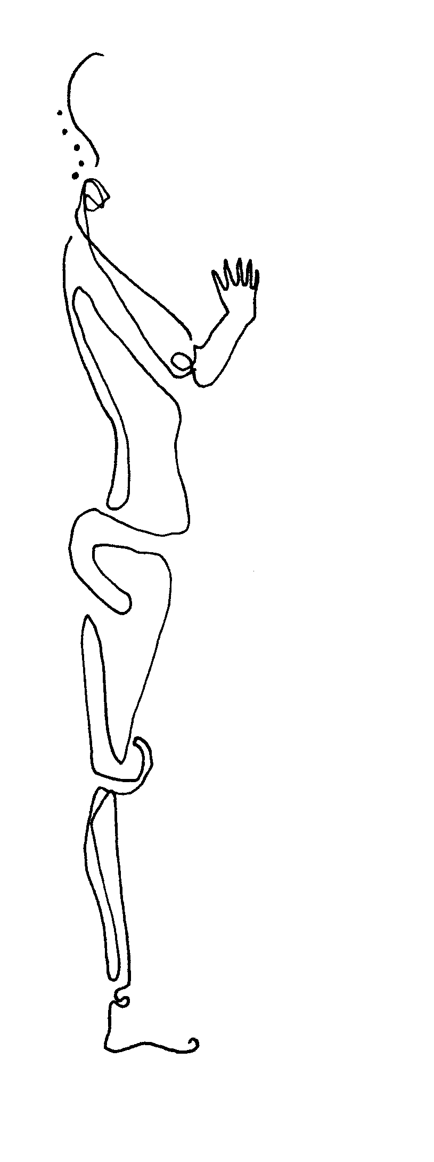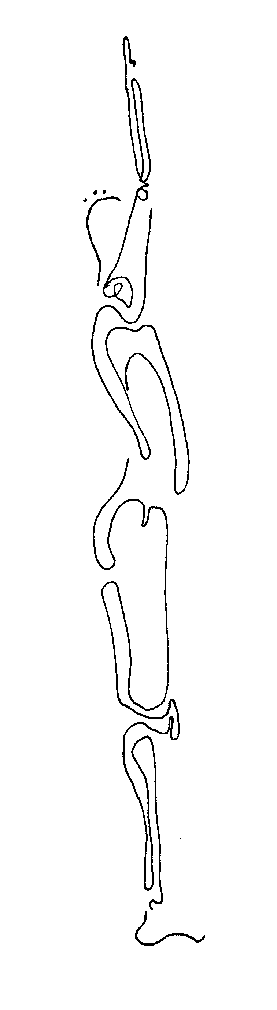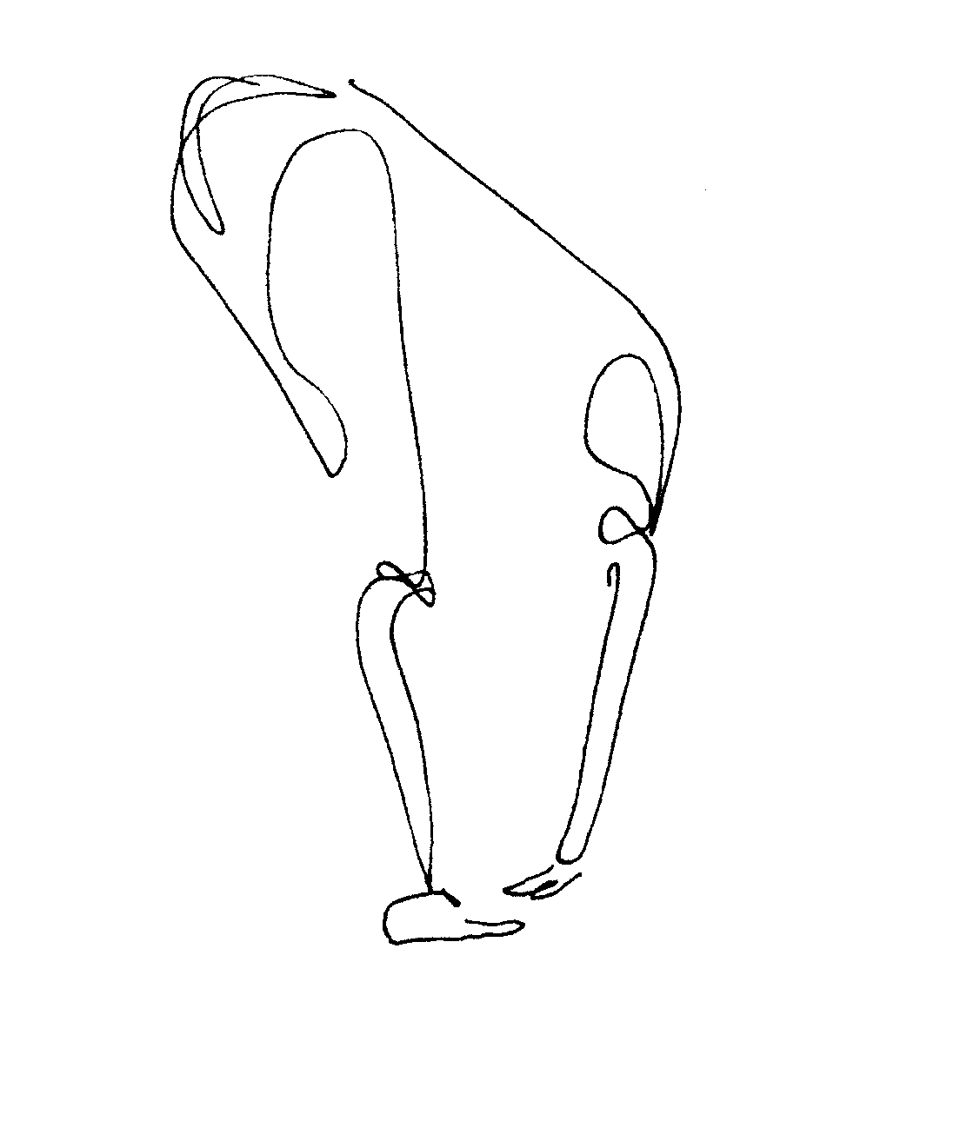

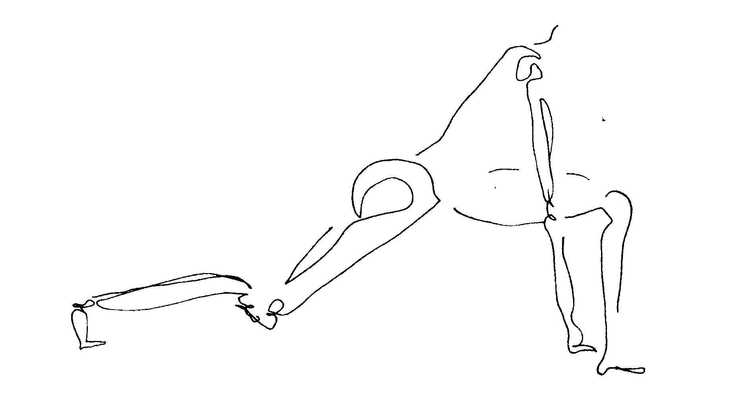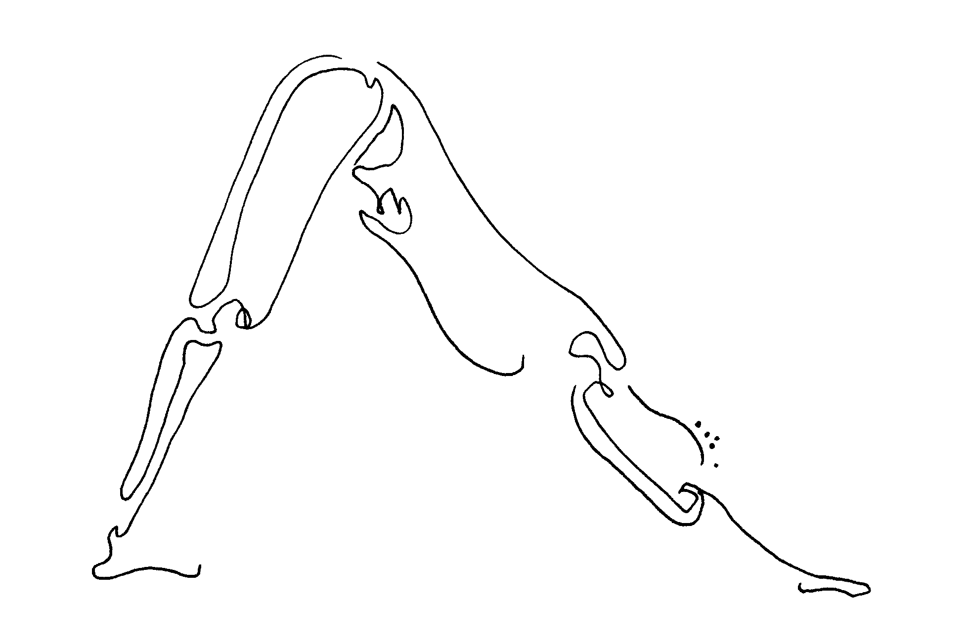

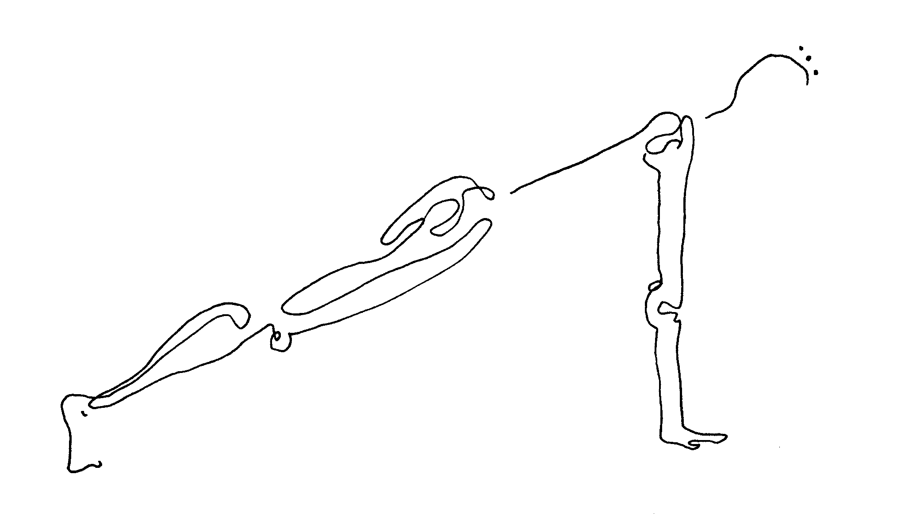

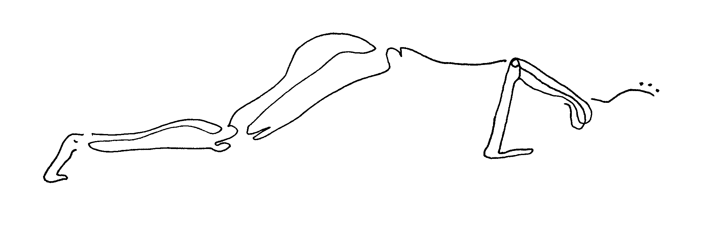
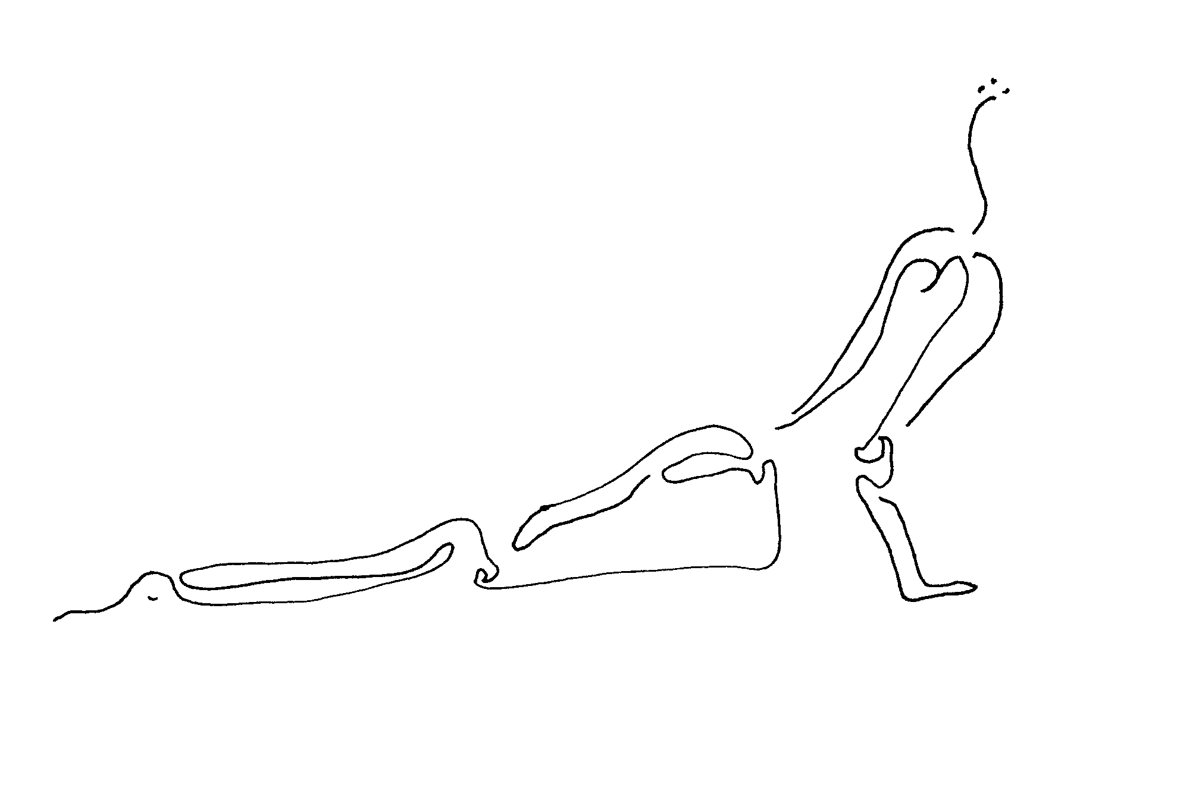

more meditation.
An important aspect of balance in our lives is in our connection to nature, which we are very much a part of. We can keep this connection here in prison, by feeling it through cement floors and walls, or seeing it, even in window-less cells, in our mind.

special rock meditation. This is a Native American meditation, taught by a Cherokee elder. We will start with closed eyes. Please take some full, even, breaths. There is so much power in our Earth, and we are connected to it. If we open our awareness to it, this power increases, and feeds and heals us.
Bring to your mind an outdoor place that you know of where there are rocks around you. Imagine that you walk around in this place. You are drawn to a special rock, one that you can pick up in your hand. Hold this rock. Fell its weight. See its shape. Notice its color. Sense its temperature, cold or warm. Ask it if you may keep it with you for awhile.
Now just hold this rock and ask it what its history has been, what it has experienced. See what pictures come to your mind, as this rock shares its wisdom with you. After awhile, let these pictures fade. Notice how you feel. Did this rock give you a sense of calm? A feeling of strength? When you need this feeling that the rock helps you with, go back, anytime, to it. And hold it some more. It is always there for you.
Now return the rock to the place you found it. Say "Wah Doh" to the rock, which means "thank you" in the Cherokee language. And come back, in your awareness, to this room. Take a few more full, even, breaths. Let your eyes slowly open.

finish class. Namaste (to the spirit in everything).

second class that week. Overlay of first class. May use verse as point of focus:

The gold of compassion (is) in the dark stone
of suffering.
(Joan Halifax, 1982, United States)

So often it is after we acknowledge our own pain, weakness, mistakes, that we can empathize when other people stumble through the same.

week ten.
simplicity and rest. Our society places great emphasis on acquiring things that cost money. This mad rush and push toward goals that are materialistic, besides ending in feelings of emptiness for everyone who reaches the goals of ownership, results in the constant busyness of trying to get there.

Throughout time, many wise people have told us that non-materialism is freeing. These wise people, who may be our own grandparents or people we've read of, tell us that simple living in which we take care of as many of our own very basic needs as we can is the most rewarding life. We pay a very high price when we keep the achievement of success and money-making as priorities. First, we most likely hurt other people, somehow, someway, in getting there. Maybe we run a big corporation that uses child labor in a foreign land to insure its profits. Maybe we sell drugs or steal what isn't ours. Or maybe we carry two jobs, ignoring time with our kids to keep up the car payments on our fancy truck. There are many ways our pursuit of one goal means neglecting other more important goals. And for what? For the ownership of objects which even many wealthy people would agree is no guarantee of happiness?

Even in practices like yoga or meditation, it is easy to get caught up in the achievement mindset. So it is important to remember simplicity even in our practice. It is important to rest sometimes, to allow ourselves to simply 'be,' without achieving anything that is visible.

more yoga.
savasana (sha-va'-san'a) or "corpse." The simplicity of this posture frustrates some of us who are used to measuring our accomplishment against signs we can see and feel, like straining muscles. Yet experienced teachers say that if they were to recommend just one yoga posture each day to enrich anyone's life and health, this one should be it.
Lie on your back, arms at a natural distance from your sides, palms up. Balance the right and left sides of your body in these ways: Stretch both legs and feet fully, and then relax them. Lift your upper back slightly and then let it re-settle, so that both shoulder blades feel equally melted on the ground. Lift your chin toward your chest, feeling your neck stretching, and then lower your head gently. Close your eyes.
Like a corpse, your body is still. Yet your awareness is constant and alive. You are open to sounds in the room, though they pass through and then out of you like thoughts do when we meditate. You are in a state of restful awareness.
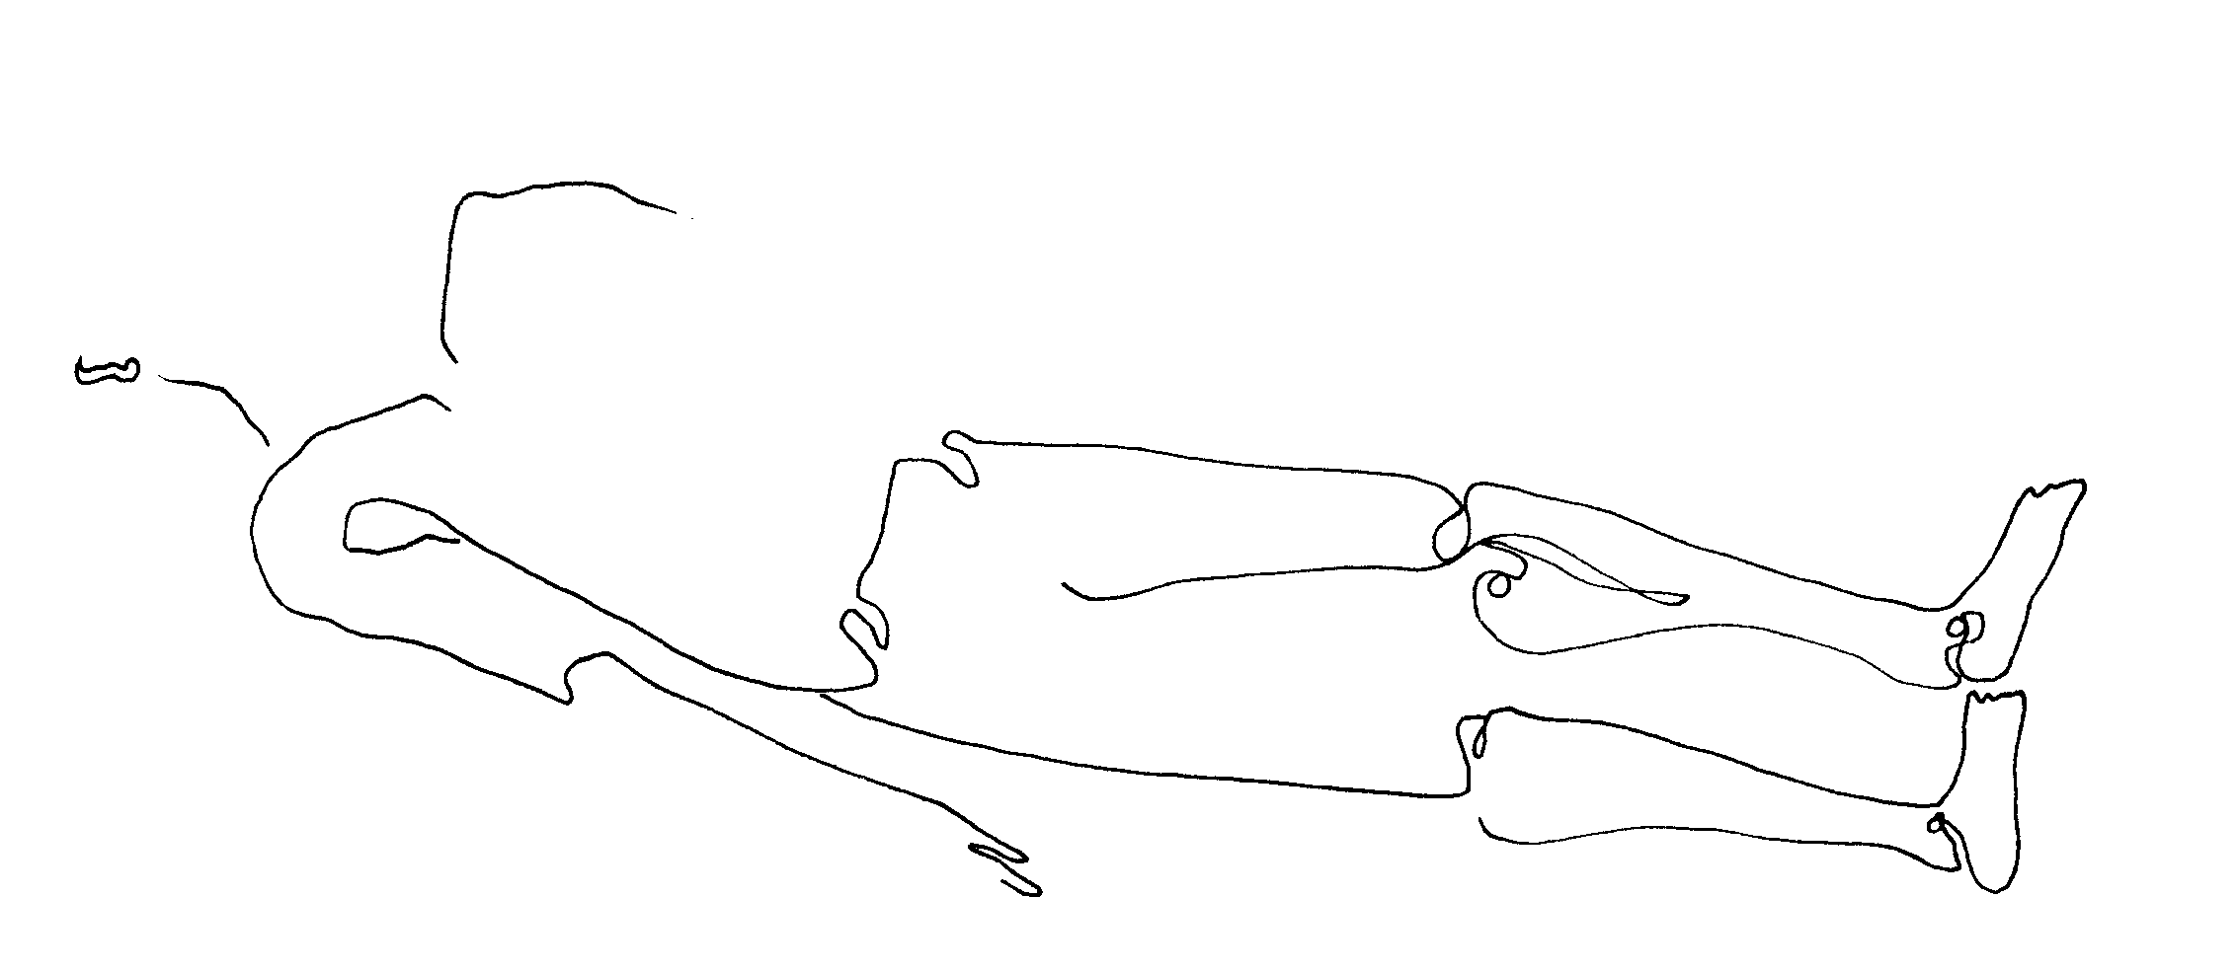

This is called a "restorative" posture, and in fact you can modify other postures we have learned to be restorative as well. For example, if you do pascimottanasa (forward back stretch) with a pile of pillows or blankets on your legs, your head will rest on them, and your body will rest as you stay in the stretch.
more breathing.
This breath is a deeply restful one from the Chinese Taoist tradition. The Taoists saw themselves in constant communion with nature. Here we join with the gentlest wind, and with our own first breathing movements before birth.

embryonic breath. Close your eyes, or gaze downward. Imagine yourself as still and as safe and warm as a baby in the womb. Inhale and exhale so that your belly fills and empties, fully. Yet let your breath become so subtle that if a feather floated just below your nostrils, it would not move with your breath. (After two to five minutes) now let your normal breath return. Open, or lift, your eyes.

more meditation.
connection meditation. Each week we have ended class with the word "namaste," telling eachother that we honor the spirit in each other. Well, seeing the spirit, the sacred, the good in each other helps us feel connected to one another. In the same way we can begin to feel, as we did in last week's "special rock meditation," the spirit in every other person, every animal, every plant, every rock or natural part of this earth. We are all connected.

Of course this can be difficult, because most of us have felt very let down or hurt by some people in the past. (And by the way, in the case of people who we have been hurt by, we can feel connection energetically without having to ever be near them, if we are safer at a distance.) If we can start to love other people, just as we might love animals or parts of nature, simply because they exist, then we don't have to get hung up on whether or not we think they deserve love. We can feel our connection rather than analyze it.

Here is a simple connection meditation we can practice.

Close your eyes, or look downward, and bring your attention to your breath. Notice how your breath travels inside you and then out of your into the room. Other people breath in that breath, and you breathe in theirs. This is powerful connection already.

Now bring to mind some of the people you love. Visualize saying "namaste" to them, even if you say it silently. You are honoring the spirit in them.

Next bring to mind a group of animals. If you have pets, they can be in this group. Visualize saying "namaste" to them, even if you say it silently. You are honoring the spirit in them.

Then bring to mind a forest of trees, or a garden or flowers. Visualize saying "namaste" to them, even if you say it silently. You are honoring the spirit in them.

Now bring to mind the ocean, or a river you have seen. Visualize saying "namaste" to it, even if you say it silently. You are honoring the spirit in it.

Then bring to mind a special rock, or an entire mountain of rock. Visualize saying "namaste" to it, even if you say it silently. You are honoring the spirit in it.

And then come to another group of people, this time people you have had difficulty with in the past. Visualize saying "namaste" to them, even if you say it silently. You are honoring the spirit in them. (And if this feels impossible to you, visualize them as small children, which they all were once.)

Finally, bring to mind a group of strangers, like people housed here you don't yet know, and say "namaste" to them. You are honoring the goodness inside everyone, even when it may be buried very deep and doesn't show on the outside.

Knowing that everything is connected, it becomes easier to understand how miserable we are when we impose our idea of separation on things. We are created as unified beings, so when we place walls between our hearts, we go against the natural order of our universe. It's no surprise that this can never make us happy.

finish class. Namaste (to the spirit in everything).

second class that week. Overlay of first class. May use verse as point of focus:

We are brought to a crisis of conscience
through our hunger for union.
( M.C. Richards, 1962, United States)

Think of the connections that in our modern lives have been sacrificed. Connections to nature, to our inner selves, to our own sense of the spiritual. Deep down, we hurt from this disconnection. What if we found ways to reconnect, rather than to lash out with destructive despair at our loss?

week eleven.
helping others. Service, or helping others in need, is the next step beyond feeling our connection to them. It is a way to take the self healing and inner peace we've cultivated in ourselves and spread it outward. It is a way to devote our lives to something bigger than ourselves. Wise people throughout the ages all agree that it is the key to real fulfillment in life, to true happiness. Look around you to who really looks fulfilled, and you will most likely see someone who tastes the honor and the joy of helping the world in some way.

In this class, beyond the practices we will review from other weeks, we add two more. One which helps heal physical illness in others near to us, in a very simple ancient way. And one which helps heal emotional imbalance between us and other people, even when we are far from them.

reiki.
Reiki (ray'-kee) is from the Japanese healing tradition, but is nearly identical to practices from all around the world. "Laying on of hands" from the Christian and western medical traditions works in the same way. Many native shamanic practices likewise use healing energy channeled in this way.

Healing energy, as we know, travels throughout our universe. We've experienced feeling such lifeforce in many ways in class, in the air we breathe, from the sun in the sky, in a rock we imagine holding, in other people.

This energy likewise travels throughout our bodies by many means. Unseen energy channels, which in class we've called meridians or nadis, carry energy from head to toe in us.

Reiki channels that energy so that we can direct it toward a part of someone's body which needs healing. The palms of our hands can become like faucets out of which this lifeforce pours, when our mind joins into our efforts and we imagine this fully.
To perform reiki on someone simply center yourself. Feel your own energy and the constant food of universal energy passing through you. Feel the earth through the soles of your feet; feel the stars through the top of your head.
Then hold your hand, your right hand if that's your most comfortable one, over the ill or injured part of person you want to help heal. Hover your palm about six inches from their skin, and move it in circular motions. You may move it slightly closer and then farther from their skin. Your motions are slow. You are very conscious of feeling energy flow from your center, from your heart and belly, through your arm and out of your palm. You imagine this energy penetrating their skin, and traveling into their body to bring it new life. They, too, might imagine the new life, the new movement, the dissipation of stagnation that this energy brings.
This technique might relieve a baby of bronchitis, or dissolve a tumor in a sixty year old. Once shown, it becomes a tool which the person you helped can use. We can use it on ourselves as well.

yoga. Choose from practices already learned.

breathing. Choose from practices already learned.

chi gung. Choose from practices already learned.

more meditation.

tonglen meditation. Tonglen meditation from the Tibetan tradition is a practice rich in gifts for both us as the practitioners, and all people around us. Tonglen takes our modern-day tendency to avoid pain and hoard pleasure and reassures us that these patterns breed unhappiness, and are unnecessary. That we are deep and strong enough to look at pain without annihilation by it; that we are regenerative enough to give even the good stuff, pleasure, away. In doing this we take responsibility both for processing (thus dissipating) our pain, and releasing to those around us pleasant energy rather than our waste. Empathy for our own darkness and that of others runs through this exercise.

In a fifteen-minute practice we do this:

1. focus on our breath, then:

2. give our outbreath the qualities of lightness, airiness,
our inbreath the qualities of heaviness, stickiness;
(notice how we are capable of breathing one sensation in and a changed, transformed, and different one out);

3. our outbreath becomes a moment of pleasure we have in fact experienced -- recently or distantly, maybe in our childhood -- a moment in which we felt content with our world;

4. our inbreath becomes that which experience as difficult, starting with physical pain;
pain in, relief, pleasure, peace out;
(notice how our inhaled pain does not overcome us because we internally transform it into tangible pleasure);

5. then emotional pain (anger, jealously, sadness … ) in,
same peace out;
(notice how our exhaled pleasure does not get used up; it is a never- ending resource);

6. minutes later, in with the pain of someone loved,
same peace out, bathing both us and them;
(notice how another person's pain need not take over our reality; again, we can dissolve it with our shift to familiar peace, which we exhale);

7. later, in with the pain of someone disliked, even hated,
same peace out;
(notice how this, first, lightens the burden we carry of remembered dislike, freeing us from control by this other person, and how it, second, sends relief to this person in acknowledgement that their inconsiderate treatment of us is rooted somewhere in the pain they feel, just as we feel pain; in sending peace their way we may prevent others from being hurt as we were);

8. finally, in with the pain of strangers, maybe war-torn, or disease-plagued, people we do not know …
and always, out with peace, sent to them.
(Notice how helping others is the most healing experience we can have for ourselves.)

Pain, yes, is part of our world and is asked in regularly in this exercise. Yet peace, our own, is resilient, and pervasive.

finish class. Namaste (to the spirit in everyone).

second class that week. Overlay of first class. May use verse as point of focus:

It is with our capacity of smiling, breathing,
and being peace
that we can make peace.

(Thich Nhat Hanh, 1987, Vietnam)

The great humanistic task of the oppressed
is to liberate themselves, and in doing so
to liberate their oppressors as well.
(Paulo Freire, 1995, Brazil)

What if our new, inner explorations spread to those who have hurt us? What if they, too, deeply understood how connected we all are?

week twelve.
compassion.
Compassion could be called the crown jewel of this entire program. Far from a new discovery, though, and just like the qualities of self healing, and inner peace, it is something we all know well in our deep selves. Our lives and difficulties may have helped us stray from feeling or practicing continual compassion. Yet our knowledge of it never fully left us.

Compassion could be called the crown jewel of humanity, our strongest and most vital feature. We are created with this ability to feel for the pain of other people, animals, even plants. We are able to relate to their challenges and joys through our constant energetic connection to them. If we practiced compassion world wide, imagine how safe, cared for, respected, and loved everyone and everything would feel. What is it that has historically prevented so many of us in the world from being in constant touch with our compassion?

Certainly it is hard to treat the world and its people kindly when we have been treated badly ourselves. Many of us are born into poverty, born into racial prejudice, or born to violent or absent parents. How can we give to others when we are so hungry for love or life's comforts, and angry because we've never had them?

Well, as we've begun to do in class, we can start by giving to ourselves. We can give ourselves the respect for our health and bodies we may never before have had. We can give ourselves the mental and emotional soothing we always longed for. We can open ourselves up to the profound love around us, both in human, animal, and environmental form, and in the unseen form of whatever we know as spirit.

And then, when we feel like the voids in us have begun to fill from our connection to ourselves, and our connection to spirit, we can overflow. We can share our health and sense of peace with others. This is where life's truest riches will be found.

How to share and help? There are as many ways as there are human faces. There is help you can give on the outside, after release, if that is your path. There is also lots of help you can give here on the inside, both to other inmates, and through calls and letters and meditations to people on the other side of these walls.

Remember, you have the unique and very special experience of having reached a place in your life where superficial materialistic success didn't work out for you. Somehow, through drug use or some criminal shortcut to power or money, each of us bottomed out and saw the flaws in that definition of 'high,' or 'strength.' So each of you are wiser in a way than are those who haven't fallen down yet, those who are still chasing that easy 'high.' So, because you're coming from experience, you can offer real help to people who are hurting and haven't seen a way out of it yet.

The adolescent youth of our communities are a great place to start. They could use your guidance and insight, and you can be with them in many ways. Some may need a sports coach, some a 'big brother' to fish with, others simply someone to talk to at the skate park or in the streets. Youth centers might use your volunteer efforts. So might soup kitchens that feed the homeless. Or elderly, bed-bound residents of nursing homes or hospitals would love to be read to from a book. And yes, giving to others means generally unpaid work. Yet, if you recognize that you want days full of helping and still need to pay the rent, you might go to school for a social work degree. The heart of social work is in helping disadvantaged people to survive and thrive.

From here inside prison you can reach outward in many ways. Write and call your family to share your new discoveries with them and help in their health and wellbeing. Become part of an educational program for troubled youth on the outside who might come close to their own incarceration unless they can be reached through connection with someone like you. Draw pictures and write poems and produce an insider journal so that people on the outside may see and feel your humanness and talents. Or simply send your energy outward, through meditation or prayer.

From here in prison you can reach your fellow inmates with compassionate treatment daily. You can start a practice group or share healing techniques when you see a need, and desire to learn, in someone. Remember, you can spread peace even to those who hassle you, changing any bad energy to good, as we do in tonglen meditation. There is great power in treating the prison staff with compassion. See how your peace affects them, how it may, over time, change the way you are treated. Feel how it empowers you more to treat people kindly regardless of their actions or attitude.

Back again to Gandhi's words:

Be the change
you want to see in the world.

yoga. Choose from practices already learned.

breathing. Choose from practices already learned.

chi gung. Choose from practices already learned.

meditation. Tonglen meditation. The power of this meditation is tremendous. Because it is rather advanced, we
will do it again now and one last time as well, for our final class.

finish class. Namaste (to the spirit in everything and one).

second class that week.
ceremony. This is the final class in the series and a good time to have a little ceremony. Invite prison administrators, other staff such as social workers, and of course every inmate student. You may get permission to bring snacks along: something simple and fairly healthy, like fruit or healthy cookies is still a shining light for inmates tired the same old thing each day at meals.

I have begun each ceremony day with the practice of tonglen meditation, and this practice will include all guests who would like to participate. Folding chairs provided for guests may make them more comfortable.

Beyond this whole-group meditation, and the offering of certificates of completion, one by one, to every inmate in the room, please create whatever you would like in terms of ceremony. For example, I asked one inmate (and got his agreement ahead of time) to read aloud a poem he had written about his meditation experience. Another time I read from several pieces of ancient wisdom and verse, some familiar from class and some new. Here's one that speaks of dormant potential in every person:

If each day falls
inside each night,
there exists a well
where clarity is imprisoned.
We need to sit on the rim
of the well of darkness
and fish for fallen light.
(Pablo Neruda, 1904-73, Chile)

And another, which reminds us of perseverance, of using time such as prison time to prepare ourselves for future opportunity:

Invisible lines. The fisherman repairs his net,
and the fish are nearly caught.
Deng Ming-Dao, 1992, China)

You may choose, or be guided by prison protocol, to simply hold a shorter, review class, and then pass out the certificates.

Best to keep things simple, and as always, to fully respect the administrator's wishes and rules. This will be an important part of the impression you and this program make upon prison staff.

Namaste (to the spirit in everyone).

sustainability of Free Inside practice is encouraged in three ways:

1. A community Free Inside class is begun wherever possible. Ideally, this is a weekly, one-hour class on the outside of (though not far from) prison, offered at no cost to released inmates and their friends and family. This allows the inmate participants to have steady outside support in their practice. Also importantly, it introduces Free Inside practices to that ex-inmate's own human support system, to the people in their 'home' environment. Understanding and encouragement for continued practice is then sure to grow. And the insight gained by each new practitioner helps shape the entire environment in which they, and the ex-inmate, live.

2. A staff class is begun whenever possible. When corrections officers and administrators are involved in the same inner exploration and growth that their inmates are, everybody wins. Interactions will no doubt improve and mutual understanding will surely grow. Additionally, prison work can be very stressful, and therefore job turnover high. The inner peace accessed through Free Inside practices can be a life- and job-saver for many prison employees. Finally, it is likely that at least one staff member will take an interest in teaching Free Inside him- or herself, and this is vitally important when funding is non-existent for outside teachers, or volunteers are scarce.

3. Copies of a Free Inside practice guide may be made and given to inmate participants, just before their release if mid-session, or at the end of a twelve week session. With this guide and the experiential knowledge already absorbed by their minds and bodies, they are in a good position to deepen their own practice and to pass it on to others. This person-to-person sharing of such ancient and global healing techniques is at the heart of their strength, effectiveness, and historic longevity. Please note that even without this printed guide, most participants will be quite able to continue, and teach others, to practice.
This practice guide, ready for copy-machine reproduction, follows here:

